CORE BANKING & TRANSACTION MANAGEMENT SYSTEM

PROJECT REPORT REVIEW 2
Submitted by

MIRZA MOHAMMAD ABBAS (24BDS0202)
ADITYA KUMAR SAHU (24BAI0128)
RISHAV MANJHI (24BAI0001)

Prepared For

DATABASE SYSTEMS (BCSE302P) -Lab PROJECT

Submitted To

Dr. Anand Bihari

School of Computer Science and Engineering



Abstract
The Core Banking & Transaction Management System is a banking laboratory built in PostgreSQL around twelve related operational entities. It supports customer KYC onboarding, accounts across branches, positive-valued transaction events, loan origination and repayment, fixed deposits, saved beneficiaries, employee records and independent audit events. Shared postal and bank details are kept in separate directories. Primary keys, unique keys, foreign keys, domain constraints and date constraints enforce the declared data model.
The database layer brings together thirty-five standard SQL demonstrations, ten managerial business queries, three views, two business functions, two core procedures, two triggers and two explicit cursor batches. Before posting a fund transfer, the system locks both accounts. It then commits the account updates, transaction history and audit effects together. A validation error or later SQL failure rolls back the enclosing transaction. A trigger reduces outstanding debt after a successful loan repayment, while stored generated expressions calculate EMI and deposit maturity from the product terms.
A Python FastAPI service and a React 19 interface provide the customer and bank-official workflows. The six customer sections cover account ownership, statements, transfers, beneficiaries, loans, deposits and KYC. The seven official sections cover analytics, customer 360-degree inspection, account controls, loan sanctioning, fixed-deposit books, infrastructure and batch audit evidence. The interface supports both light and dark modes.
Review 2 covers the schema, SQL demonstrations, programmability, transactions, indexing and role grants. Review 3 builds on that work with final test results, an observed lock conflict between two sessions and application input/output descriptions. This is a university demonstration with simulated portal identity selection; database roles are verified separately. The historical fixtures illustrate events and opening balances and do not form a complete double-entry ledger.

Table of Contents
1 Introduction 4
2 Project Scope 4
3 Key Contacts and Stakeholders 4
4 Project Resource Requirements 5
5 ER Diagram 6
6 Tables and Constraints 11
7 SQL Implementation 24
8 Advanced SQL Implementation 60
8.1 Complex Business Queries 60
8.2 Database Views 71
8.3 Stored Procedures 74
8.4 User Defined Functions 79
8.5 Triggers 81
8.6 Explicit Cursors 85
8.7 SQL Security Implementation 88
8.8 Transactions Indexing and Query Optimization 93
9 Work Breakdown 97
10 REVIEW EVALUATION 98

1 Introduction
Banks hold related information about customers, servicing branches and financial products. Putting all of it in one large table creates update anomalies and makes ownership, debt and audit history difficult to trace. Our system separates these responsibilities into twelve relations and carries out financial changes within database transactions.
PostgreSQL enforces the declared keys, relationships, generated amounts, triggers and workflow validation. FastAPI sends parameterized Psycopg2 statements and handles failed requests by rolling back and cleaning up the connection. React shows the same underlying information to customers and officials, allowing a constraint failure, successful commit or trigger-generated event to be observed during the viva.
The independently stored facts are organized for third normal form. Generated financial amounts are constrained derived projections: users cannot supply or update them independently. Section 6 explains the formal functional-dependency qualification for these stored outputs.

2 Project Scope
Area | Implemented scope
Customer lifecycle | Adult KYC record, unique identity/contact fields, approval state, searchable customer discovery and exact account ownership.
Banking products | Savings, Current and Salary accounts; five loan purposes; generated EMI; customer FDs with generated actual-day maturity.
Transactional workflows | Deposit, withdrawal, internal transfer, saved beneficiary transfer, EMI payment, funded FD creation and optional loan disbursement.
Operations and evidence | Branch/staff directories, aggregate views, cursor batches, balance audits, role grants, indexes, rollback tests and two-session row-lock proof.
System boundary | Local academic deployment. No real interbank rails, authenticated internet banking, regulatory NPA aging engine, joint-account model, general ledger, password store or repayment due-date calendar.

3 Key Contacts and Stakeholders
Name | Registration Number | Phone Number
MIRZA MOHAMMAD ABBAS | 24BDS0202 | 9451792098
ADITYA KUMAR SAHU | 24BAI0128 | 7870457312
RISHAV MANJHI | 24BAI0001 | 6287568398

Prepared for DATABASE SYSTEMS (BCSE302P) -Lab PROJECT. Submitted to Dr. Anand Bihari, School of Computer Science and Engineering.

4 Project Resource Requirements

4.1 Software Resource Requirements
Resource | Requirement and project use
Operating system | Windows 11, macOS or Linux; this evidence run used the local Windows project workspace.
DBMS | PostgreSQL 16 or later; live server reports PostgreSQL 18.6. PL/pgSQL, transactional DDL and stored generated columns are used.
Containerization | Docker; banking-postgres exposes PostgreSQL on localhost:5432.
Backend | Python 3.x (project requires >= 3.12), FastAPI, Psycopg2 and Pydantic; uv manages dependencies and execution.
Frontend | React 19, Vite, Tailwind CSS v4 with its Vite plugin, Axios, React Router, Recharts and Lucide Icons.
Database client | DBeaver for manual SQL execution, catalogue inspection and evaluator screenshots; psql for scripted execution.
System design tools | Mermaid.js flowcharts rendered in the browser as Chen rectangles, diamonds and ovals; source diagrams and PNG exports are retained in docs/diagrams. Draw.io can also edit a manually recreated version.
Report tooling | python-docx, live PostgreSQL catalogue/result capture, Word pagination and rendered-page quality checks.

4.2 Deployment and Reproducibility
uv sync
uv run uvicorn backend.main:app --reload
# In a separate terminal
cd frontend
npm install
npm run dev

FastAPI runs at http://localhost:8000 with interactive schemas at /docs. React runs at http://localhost:5173. The reports use .report_work/evidence.json, generated by collect_report_evidence.py. Report regeneration starts from immutable backups in report_backups/original, not from previously expanded reports.

5 ER Diagram
The Chen model below shows the twelve entities and eleven declared foreign-key relationships in sql/01_ddl.sql. The overview presents their relationships. Four attribute panels then show all 81 columns without overcrowding the main diagram.
Notation: rectangle = entity; diamond = relationship; oval = attribute; underlined label = primary key; dashed oval = generated derived value. 1:N labels give maximum cardinality. Each child foreign key is mandatory, while a parent can have zero or many children. FK suffixes in the attribute panels identify physical reference columns.
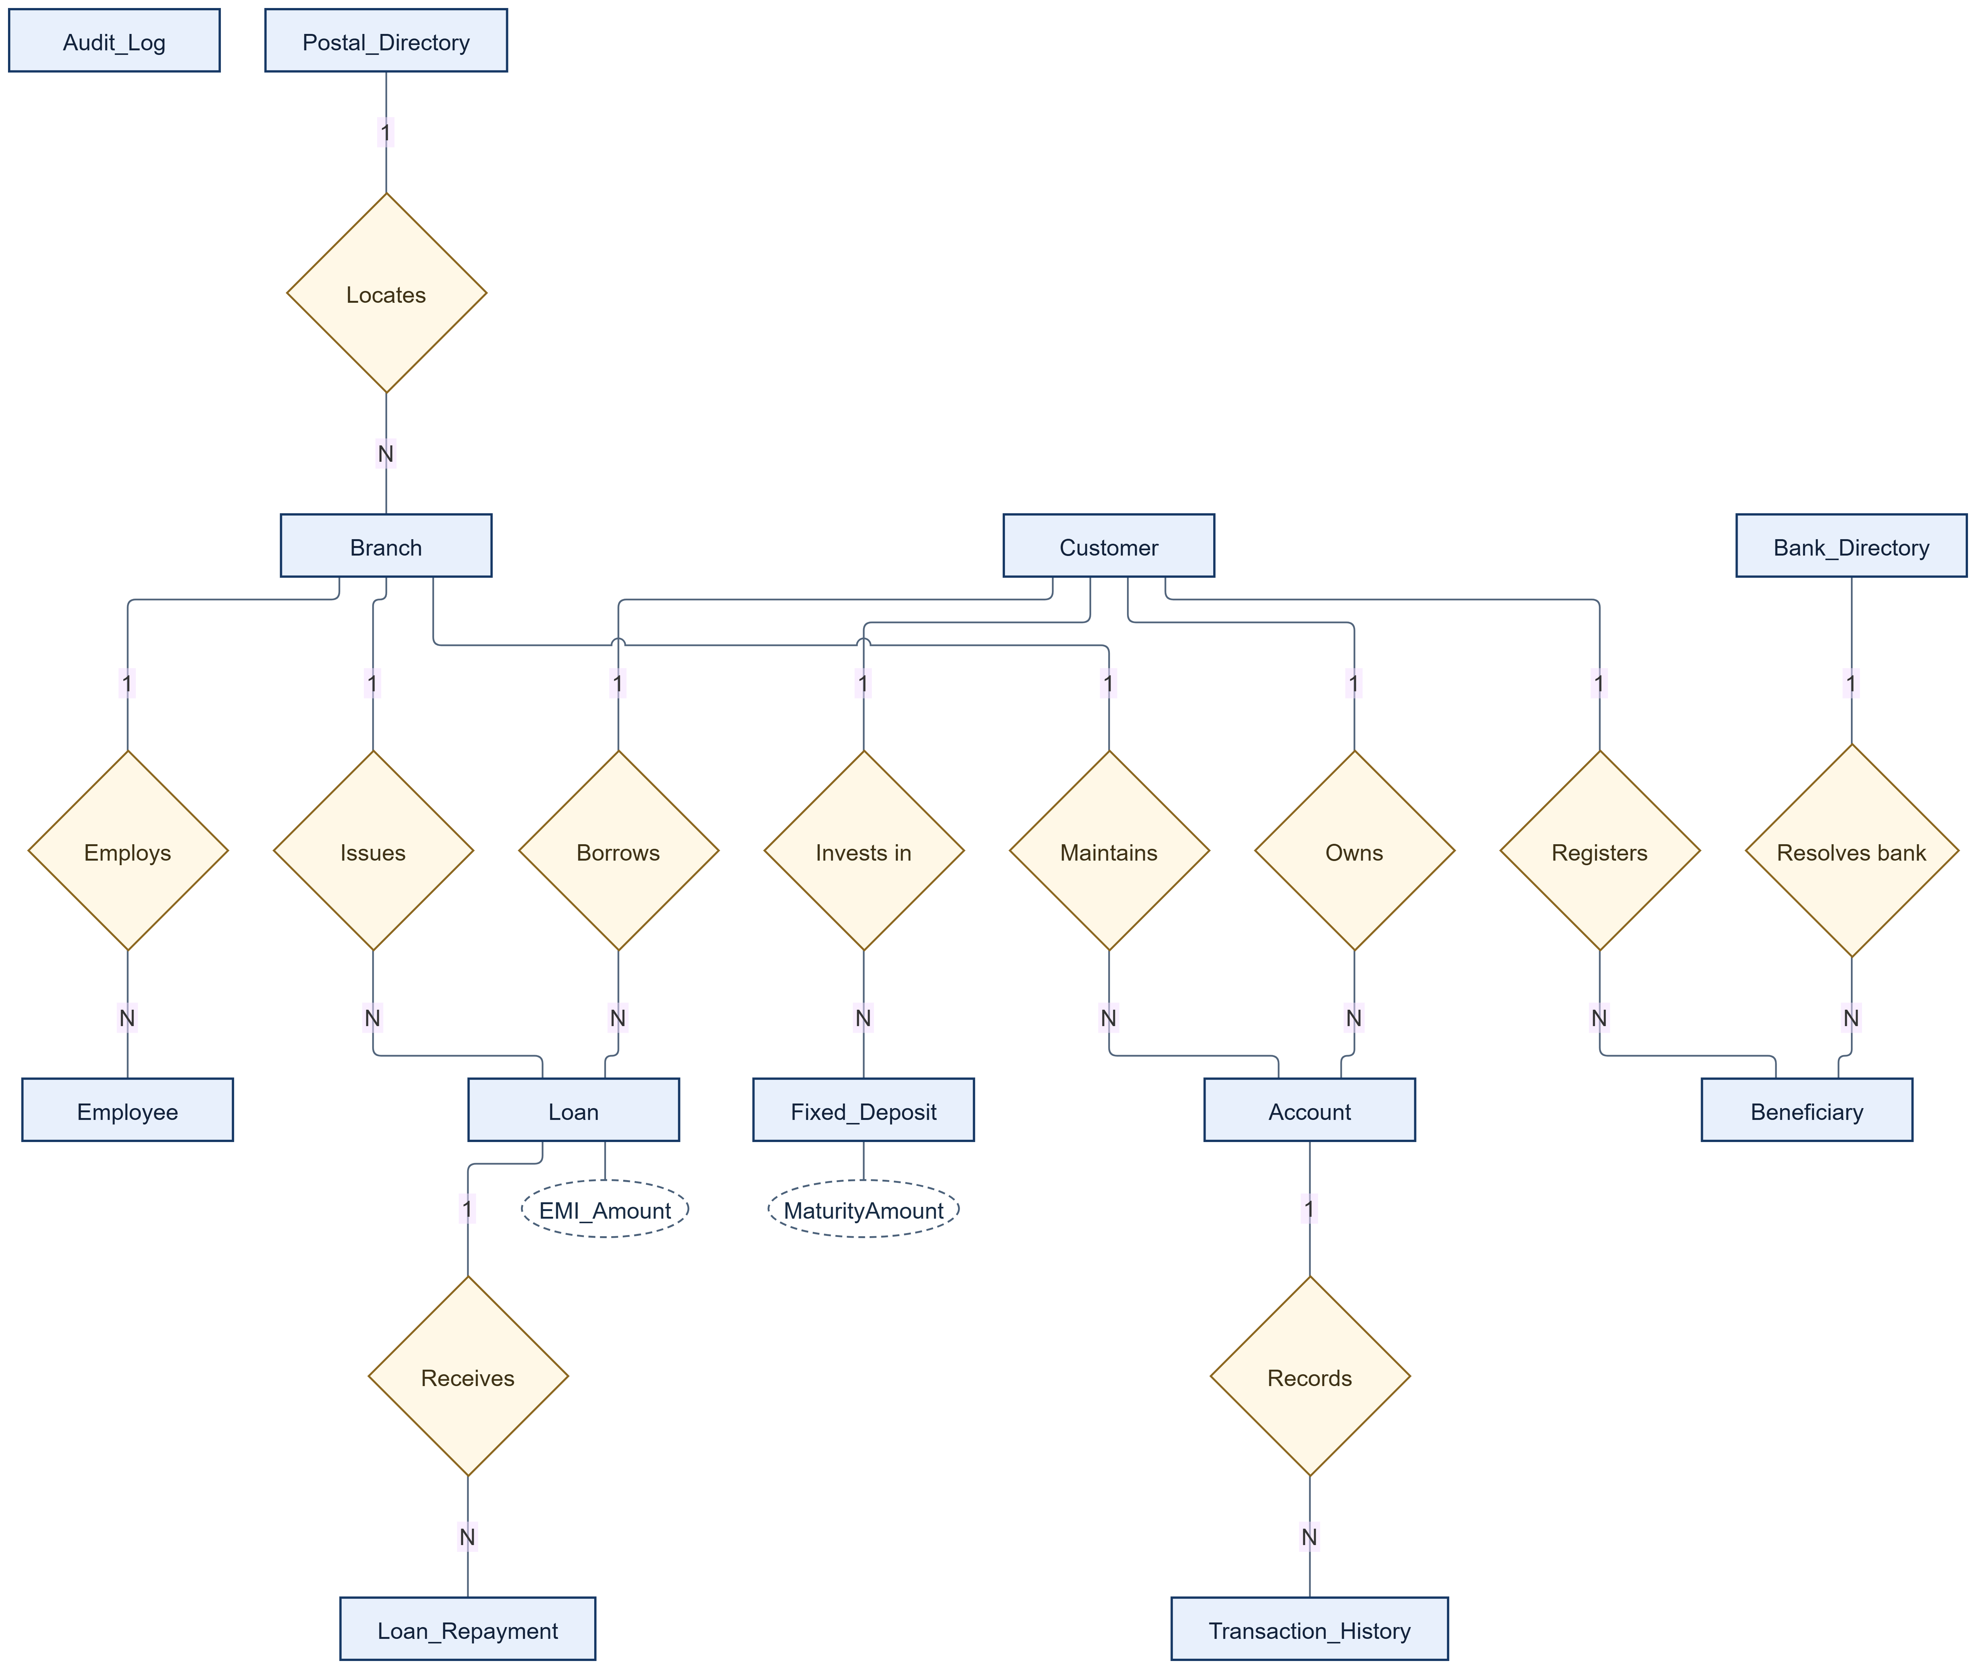
Figure 5.1 Chen relationship overview of the twelve-table banking schema
Audit_Log has no declared foreign key; TableName and RecordID identify the target of an audit event. Branch.IFSC_Code does not reference Bank_Directory, and Beneficiary.LinkedAccountNo does not reference Account, allowing external beneficiary destinations. A fixed deposit is attributed to a branch for reporting through the customer's account. There is no declared FD-to-Branch relationship.

5.1 Customer accounts and transaction attributes
Underlined oval labels are primary keys. FK identifies a physical foreign-key column; corresponding relationships are in the overview. Dashed ovals are generated derived values. All remaining columns appear as ordinary attribute ovals.
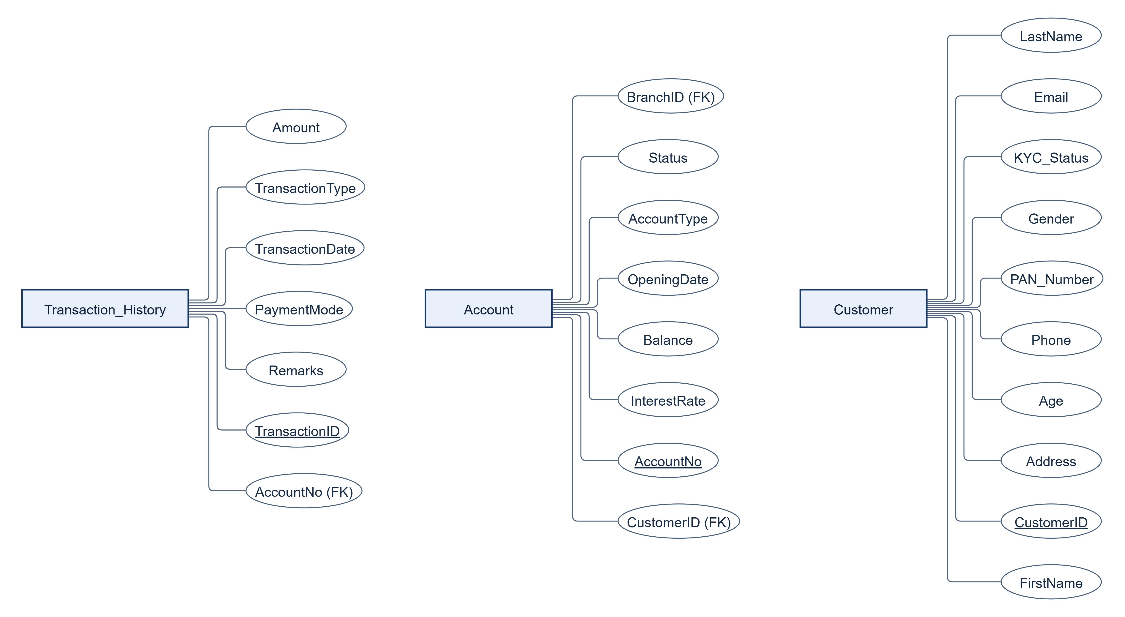
Figure 5.2 Customer accounts and transaction attributes

5.2 Loan repayment and fixed deposit attributes
Underlined oval labels are primary keys. FK identifies a physical foreign-key column; corresponding relationships are in the overview. Dashed ovals are generated derived values. All remaining columns appear as ordinary attribute ovals.
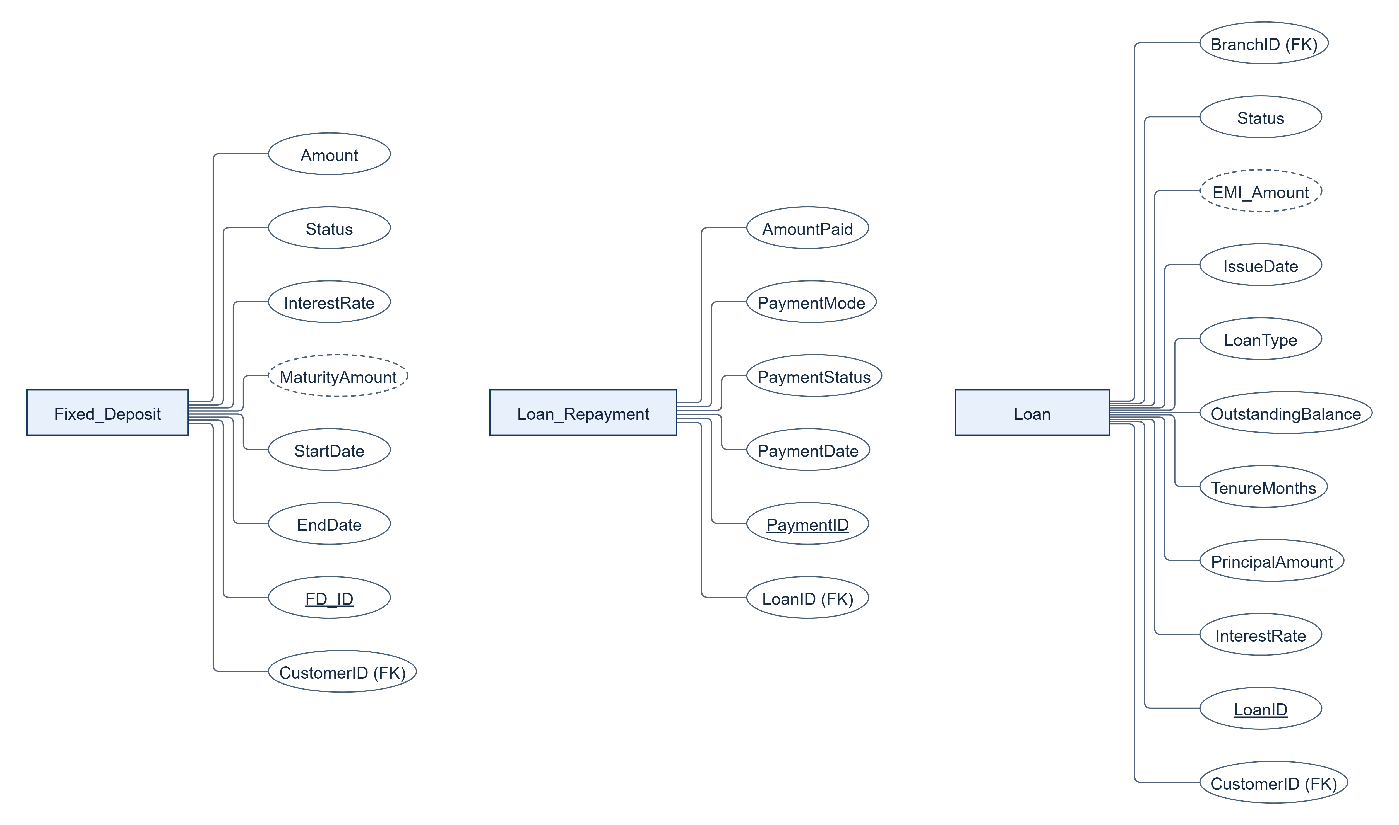
Figure 5.3 Loan repayment and fixed deposit attributes

5.3 Branch employee and postal attributes
Underlined oval labels are primary keys. FK identifies a physical foreign-key column; corresponding relationships are in the overview. Dashed ovals are generated derived values. All remaining columns appear as ordinary attribute ovals.
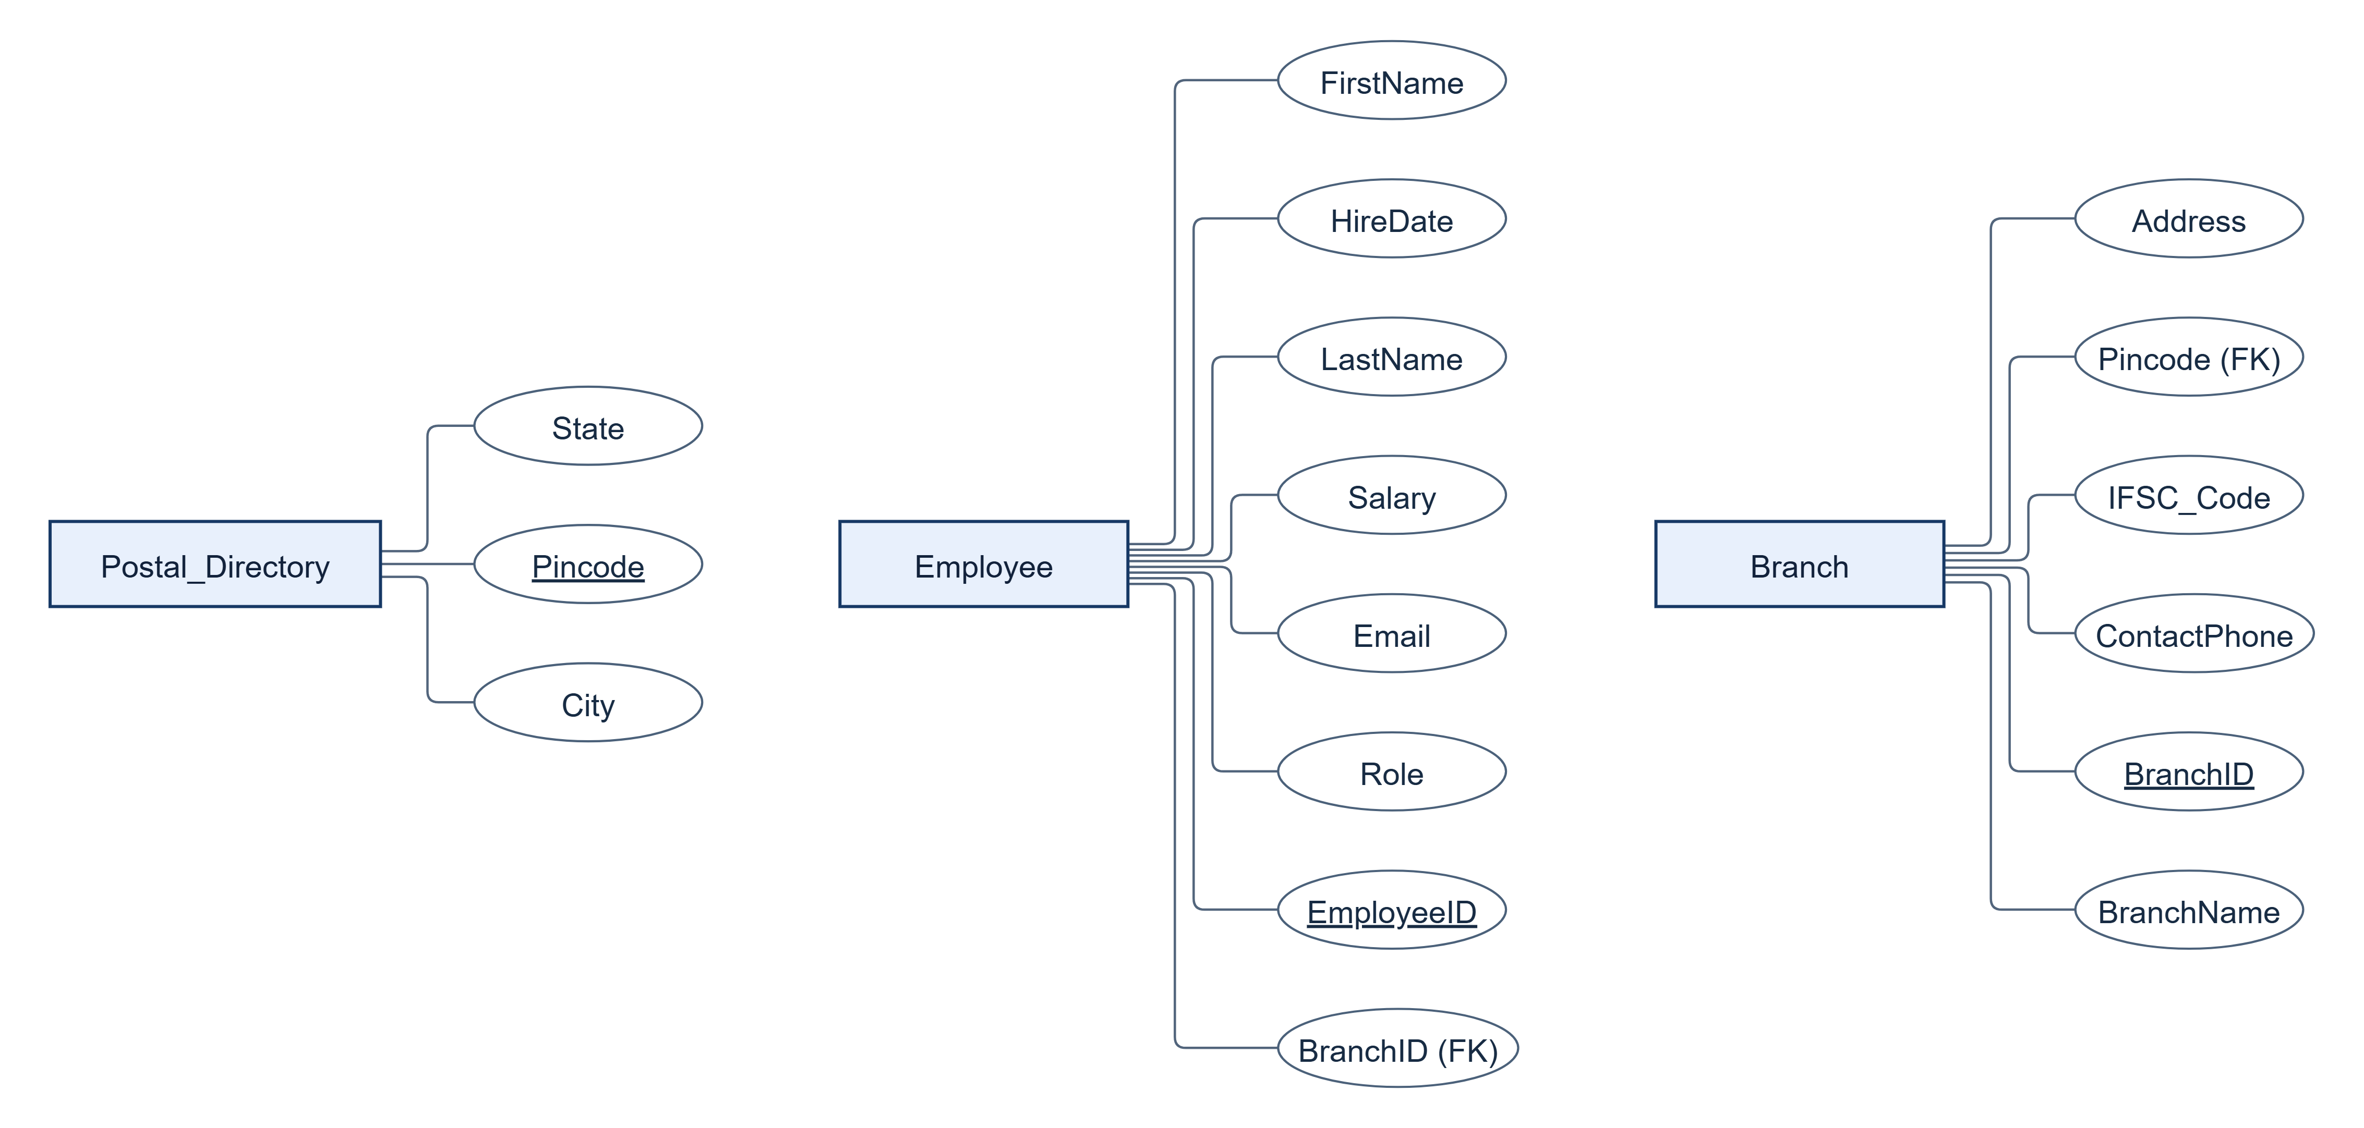
Figure 5.4 Branch employee and postal attributes

5.4 Beneficiary bank directory and audit attributes
Underlined oval labels are primary keys. FK identifies a physical foreign-key column; corresponding relationships are in the overview. Dashed ovals are generated derived values. All remaining columns appear as ordinary attribute ovals.
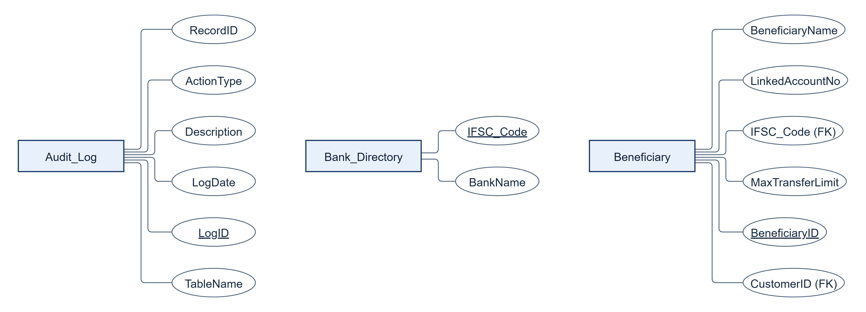
Figure 5.5 Beneficiary bank directory and audit attributes
EMI_Amount is derived from PrincipalAmount, InterestRate and TenureMonths. MaturityAmount is derived from Amount, InterestRate, StartDate and EndDate. PostgreSQL stores both as GENERATED ALWAYS expressions; their exact formulas and normalization qualification are documented in Section 6.

6 Tables and Constraints

6.1 Design Changes Since Review 1
The change log below records the requested Review 1 feedback baseline. Separating postal and bank lookups removes repeated directory facts. The added operational columns allow constraints and workflow results to be demonstrated. Refer to the current DDL for the exact implementation.
Changed component | Upgrade | Reason and integrity effect
Branch and Postal_Directory | Branch adds Address, Pincode and ContactPhone. Table 1 Postal_Directory stores City and State once per Pincode. | Removes Pincode -> City, State from Branch; avoids inconsistent edits to shared location facts.
Beneficiary and Bank_Directory | Beneficiary adds IFSC_Code and MaxTransferLimit. Table 2 Bank_Directory stores IFSC_Code -> BankName. | Separates a destination-bank fact from a customer-specific saved payee and cap.
Customer | Adds Gender, Age, Address and PAN_Number; Age >= 18 and allowed Gender CHECKs; PAN uniqueness. | Makes KYC attributes explicit and enforces adult ownership and identity uniqueness.
Loan | Adds LoanType, TenureMonths, IssueDate, OutstandingBalance and generated stored EMI_Amount. | Database computes EMI consistently from the current contract inputs; the generated value cannot be independently edited.
Fixed_Deposit | Adds StartDate, EndDate, Status and generated stored MaturityAmount. | EndDate must follow StartDate; the database enforces one maturity expression.
Other operational entities | Transaction_History adds PaymentMode and Remarks; Loan_Repayment adds PaymentMode and PaymentStatus; Account adds InterestRate and OpeningDate; Employee adds Email, Salary and HireDate; Audit_Log adds TableName and RecordID. | Makes channels, lifecycle states, product terms and audit targets available for demonstrable workflows.

6.2 Normalization and Derived Attributes
1NF: each relation has scalar attributes, one value per cell and a declared primary key; repeating products and payment attempts are separate rows. 2NF: every declared primary key is a single column, so no non-key fact depends on only part of a composite key. 3NF: owner, branch, postal and bank-name facts are separated according to the functional dependencies described for each relation below.
Formal qualification for generated attributes. In the independently stored Loan facts, LoanID determines the terms and state. However, (PrincipalAmount, InterestRate, TenureMonths) also determines EMI_Amount, and is not a superkey. Likewise (Amount, InterestRate, StartDate, EndDate) determines MaturityAmount in Fixed_Deposit. If those stored generated outputs are counted as ordinary relation attributes, strict textbook 3NF is not satisfied by that extension. The base business facts are normalized and the redundant outputs are controlled, immutable generated expressions. This is more precise than claiming that GENERATED ALWAYS automatically proves 3NF.
No additional normalization rule is silently enforced: CHECK constraints can allow NULL unless NOT NULL is also declared. Defaulted KYC/product statuses and some timestamps are nullable in the exact schema. Branch.IFSC_Code is unique but has no Bank_Directory FK; PAN format and interest-rate positivity outside Loan are principally application/domain decisions unless an explicit CHECK is listed.

6.3 Table Definitions and Creation Scripts

6.3.1 Postal_Directory
TABLE NAME: Postal_Directory
DESCRIPTION: Canonical postal location lookup shared by branches.
NORMAL FORM: 3NF. 1NF uses atomic values. 2NF follows from the single-column primary key. 3NF justification: Pincode determines City and State. Both are atomic facts about the whole postal key; neither City nor State determines a unique pincode in this model.
Attribute | Data Type | Constraint
pincode | VARCHAR(10) | NOT NULL; NOT NULL pincode; PRIMARY KEY (pincode)
city | VARCHAR(50) | NOT NULL; NOT NULL city
state | VARCHAR(50) | NOT NULL; NOT NULL state

CREATE TABLE source from sql/01_ddl.sql
CREATE TABLE Postal_Directory (
Pincode VARCHAR(10) PRIMARY KEY,
City VARCHAR(50) NOT NULL,
State VARCHAR(50) NOT NULL
);

6.3.2 Bank_Directory
TABLE NAME: Bank_Directory
DESCRIPTION: Bank-name lookup for a beneficiary destination IFSC.
NORMAL FORM: 3NF. 1NF uses atomic values. 2NF follows from the single-column primary key. 3NF justification: IFSC_Code determines BankName. A bank name may have many IFSC codes, so BankName is not a determinant of any other non-key fact in this relation.
Attribute | Data Type | Constraint
ifsc_code | VARCHAR(15) | NOT NULL; NOT NULL ifsc_code; PRIMARY KEY (ifsc_code)
bankname | VARCHAR(100) | NOT NULL; NOT NULL bankname

CREATE TABLE source from sql/01_ddl.sql
CREATE TABLE Bank_Directory (
IFSC_Code VARCHAR(15) PRIMARY KEY,
BankName VARCHAR(100) NOT NULL
);

6.3.3 Branch
TABLE NAME: Branch
DESCRIPTION: Servicing branch identity, contact details and postal reference.
NORMAL FORM: 3NF. 1NF uses atomic values. 2NF follows from the single-column primary key. 3NF justification: BranchID determines the branch facts; IFSC_Code and ContactPhone are additional unique candidate keys. City and State are looked up through Pincode instead of being repeated here.
Attribute | Data Type | Constraint
branchid | INT | NOT NULL; NOT NULL branchid; PRIMARY KEY (branchid)
branchname | VARCHAR(100) | NOT NULL; NOT NULL branchname
address | VARCHAR(200) | NOT NULL; NOT NULL address
pincode | VARCHAR(10) | NOT NULL; FOREIGN KEY (pincode) REFERENCES postal_directory(pincode); NOT NULL pincode
ifsc_code | VARCHAR(15) | NOT NULL; NOT NULL ifsc_code; UNIQUE (ifsc_code)
contactphone | VARCHAR(15) | NOT NULL; NOT NULL contactphone; UNIQUE (contactphone)

CREATE TABLE source from sql/01_ddl.sql
CREATE TABLE Branch (
BranchID INT PRIMARY KEY,
BranchName VARCHAR(100) NOT NULL,
Address VARCHAR(200) NOT NULL,
Pincode VARCHAR(10) NOT NULL REFERENCES Postal_Directory(Pincode),
IFSC_Code VARCHAR(15) UNIQUE NOT NULL,
ContactPhone VARCHAR(15) UNIQUE NOT NULL
);

6.3.4 Customer
TABLE NAME: Customer
DESCRIPTION: KYC identity and contact master for a bank customer.
NORMAL FORM: 3NF. 1NF uses atomic values. 2NF follows from the single-column primary key. 3NF justification: CustomerID determines the identity facts. Phone, Email and PAN_Number are declared unique candidate keys. No non-key determinant of another independent customer fact is assumed.
Attribute | Data Type | Constraint
customerid | INT | NOT NULL; NOT NULL customerid; PRIMARY KEY (customerid)
firstname | VARCHAR(50) | NOT NULL; NOT NULL firstname
lastname | VARCHAR(50) | NOT NULL; NOT NULL lastname
gender | VARCHAR(10) | NOT NULL; CHECK (((gender)::text = ANY ((ARRAY['Male'::character varying, 'Female'::character varying, 'Other'::character varying])::text[]))); NOT NULL gender
age | INT | NOT NULL; CHECK ((age >= 18)); NOT NULL age
address | VARCHAR(200) | NOT NULL; NOT NULL address
phone | VARCHAR(15) | NOT NULL; NOT NULL phone; UNIQUE (phone)
email | VARCHAR(100) | NOT NULL; NOT NULL email; UNIQUE (email)
pan_number | VARCHAR(10) | NOT NULL; NOT NULL pan_number; UNIQUE (pan_number)
kyc_status | VARCHAR(20) | NULL allowed; DEFAULT 'Pending'::character varying; CHECK (((kyc_status)::text = ANY ((ARRAY['Pending'::character varying, 'Approved'::character varying, 'Rejected'::character varying])::text[])))

CREATE TABLE source from sql/01_ddl.sql
CREATE TABLE Customer (
CustomerID INT PRIMARY KEY,
FirstName VARCHAR(50) NOT NULL,
LastName VARCHAR(50) NOT NULL,
Gender VARCHAR(10) NOT NULL CHECK (Gender IN ('Male', 'Female', 'Other')),
Age INT NOT NULL CHECK (Age >= 18),
Address VARCHAR(200) NOT NULL,
Phone VARCHAR(15) UNIQUE NOT NULL,
Email VARCHAR(100) UNIQUE NOT NULL,
PAN_Number VARCHAR(10) UNIQUE NOT NULL,
KYC_Status VARCHAR(20) DEFAULT 'Pending'
CHECK (KYC_Status IN ('Pending', 'Approved', 'Rejected'))
);

6.3.5 Account
TABLE NAME: Account
DESCRIPTION: A single-owner Savings, Current or Salary account at one branch.
NORMAL FORM: 3NF. 1NF uses atomic values. 2NF follows from the single-column primary key. 3NF justification: AccountNo determines CustomerID, BranchID and account-specific facts. Owner and branch descriptions remain in their own relations, removing identity and location transitive dependencies.
Attribute | Data Type | Constraint
accountno | INT | NOT NULL; NOT NULL accountno; PRIMARY KEY (accountno)
customerid | INT | NOT NULL; FOREIGN KEY (customerid) REFERENCES customer(customerid) ON DELETE CASCADE; NOT NULL customerid
branchid | INT | NOT NULL; FOREIGN KEY (branchid) REFERENCES branch(branchid); NOT NULL branchid
accounttype | VARCHAR(20) | NOT NULL; CHECK (((accounttype)::text = ANY ((ARRAY['Savings'::character varying, 'Current'::character varying, 'Salary'::character varying])::text[]))); NOT NULL accounttype
balance | DECIMAL(15,2) | NOT NULL; CHECK ((balance >= (0)::numeric)); NOT NULL balance
interestrate | DECIMAL(5,2) | NOT NULL; DEFAULT 3.50; NOT NULL interestrate
openingdate | DATE | NOT NULL; DEFAULT CURRENT_DATE; NOT NULL openingdate
status | VARCHAR(15) | NULL allowed; DEFAULT 'Active'::character varying; CHECK (((status)::text = ANY ((ARRAY['Active'::character varying, 'Dormant'::character varying, 'Frozen'::character varying, 'Closed'::character varying])::text[])))

CREATE TABLE source from sql/01_ddl.sql
CREATE TABLE Account (
AccountNo INT PRIMARY KEY,
CustomerID INT NOT NULL REFERENCES Customer(CustomerID) ON DELETE CASCADE,
BranchID INT NOT NULL REFERENCES Branch(BranchID),
AccountType VARCHAR(20) NOT NULL CHECK (AccountType IN ('Savings', 'Current', 'Salary')),
Balance DECIMAL(15, 2) NOT NULL CHECK (Balance >= 0),
InterestRate DECIMAL(5, 2) DEFAULT 3.50 NOT NULL,
OpeningDate DATE DEFAULT CURRENT_DATE NOT NULL,
Status VARCHAR(15) DEFAULT 'Active'
CHECK (Status IN ('Active', 'Dormant', 'Frozen', 'Closed'))
);

6.3.6 Transaction_History
TABLE NAME: Transaction_History
DESCRIPTION: Positive-valued account events with channel, narrative and timestamp.
NORMAL FORM: 3NF. 1NF uses atomic values. 2NF follows from the single-column primary key. 3NF justification: TransactionID determines one event. AccountNo can repeat and does not determine Amount, PaymentMode or TransactionDate; account and owner facts are not copied into the event.
Attribute | Data Type | Constraint
transactionid | SERIAL | NOT NULL; sequence default; NOT NULL transactionid; PRIMARY KEY (transactionid)
accountno | INT | NOT NULL; FOREIGN KEY (accountno) REFERENCES account(accountno); NOT NULL accountno
amount | DECIMAL(15,2) | NOT NULL; CHECK ((amount > (0)::numeric)); NOT NULL amount
transactiontype | VARCHAR(20) | NOT NULL; CHECK (((transactiontype)::text = ANY ((ARRAY['Deposit'::character varying, 'Withdrawal'::character varying, 'Transfer'::character varying])::text[]))); NOT NULL transactiontype
paymentmode | VARCHAR(20) | NOT NULL; CHECK (((paymentmode)::text = ANY ((ARRAY['UPI'::character varying, 'NEFT'::character varying, 'RTGS'::character varying, 'IMPS'::character varying, 'Cash'::character varying, 'Internal'::character varying])::text[]))); NOT NULL paymentmode
remarks | VARCHAR(255) | NULL allowed
transactiondate | TIMESTAMP | NULL allowed; DEFAULT CURRENT_TIMESTAMP

CREATE TABLE source from sql/01_ddl.sql
CREATE TABLE Transaction_History (
TransactionID SERIAL PRIMARY KEY,
AccountNo INT NOT NULL REFERENCES Account(AccountNo),
Amount DECIMAL(15, 2) NOT NULL CHECK (Amount > 0),
TransactionType VARCHAR(20) NOT NULL CHECK (TransactionType IN ('Deposit', 'Withdrawal', 'Transfer')),
PaymentMode VARCHAR(20) NOT NULL CHECK (PaymentMode IN ('UPI', 'NEFT', 'RTGS', 'IMPS', 'Cash', 'Internal')),
Remarks VARCHAR(255) NULL,
TransactionDate TIMESTAMP DEFAULT CURRENT_TIMESTAMP
);

6.3.7 Loan
TABLE NAME: Loan
DESCRIPTION: Borrower and issuing-branch loan contract, debt state and generated EMI.
NORMAL FORM: 3NF base facts with a controlled stored generated extension. 1NF uses atomic values. 2NF follows from the single-column primary key. 3NF justification: LoanID determines the independently stored contract and state facts. Borrower and branch descriptions are separated. EMI_Amount is an enforced generated projection of PrincipalAmount, InterestRate and TenureMonths; see the formal derived-column qualification below.
Attribute | Data Type | Constraint
loanid | INT | NOT NULL; NOT NULL loanid; PRIMARY KEY (loanid)
customerid | INT | NOT NULL; FOREIGN KEY (customerid) REFERENCES customer(customerid); NOT NULL customerid
branchid | INT | NOT NULL; FOREIGN KEY (branchid) REFERENCES branch(branchid); NOT NULL branchid
loantype | VARCHAR(30) | NOT NULL; CHECK (((loantype)::text = ANY ((ARRAY['Home'::character varying, 'Personal'::character varying, 'Auto'::character varying, 'Education'::character varying, 'Business'::character varying])::text[]))); NOT NULL loantype
principalamount | DECIMAL(15,2) | NOT NULL; CHECK ((principalamount > (0)::numeric)); NOT NULL principalamount
interestrate | DECIMAL(5,2) | NOT NULL; CHECK ((interestrate > (0)::numeric)); NOT NULL interestrate
tenuremonths | INT | NOT NULL; CHECK ((tenuremonths > 0)); NOT NULL tenuremonths
emi_amount | DECIMAL(15,2) | NULL allowed; GENERATED ALWAYS AS (...) STORED; full expression in DDL below
outstandingbalance | DECIMAL(15,2) | NOT NULL; CHECK ((outstandingbalance >= (0)::numeric)); NOT NULL outstandingbalance
issuedate | DATE | NOT NULL; DEFAULT CURRENT_DATE; NOT NULL issuedate
status | VARCHAR(20) | NULL allowed; DEFAULT 'Approved'::character varying; CHECK (((status)::text = ANY ((ARRAY['Pending'::character varying, 'Approved'::character varying, 'Active'::character varying, 'Closed'::character varying, 'Defaulted'::character varying])::text[])))

CREATE TABLE source from sql/01_ddl.sql
CREATE TABLE Loan (
LoanID INT PRIMARY KEY,
CustomerID INT NOT NULL REFERENCES Customer(CustomerID),
BranchID INT NOT NULL REFERENCES Branch(BranchID),
LoanType VARCHAR(30) NOT NULL CHECK (LoanType IN ('Home', 'Personal', 'Auto', 'Education', 'Business')),
PrincipalAmount DECIMAL(15, 2) NOT NULL CHECK (PrincipalAmount > 0),
InterestRate DECIMAL(5, 2) NOT NULL CHECK (InterestRate > 0),
TenureMonths INT NOT NULL CHECK (TenureMonths > 0),
EMI_Amount DECIMAL(15, 2) GENERATED ALWAYS AS (
ROUND((PrincipalAmount * (InterestRate / 1200.0)
* POWER(1 + (InterestRate / 1200.0), TenureMonths))
/ (POWER(1 + (InterestRate / 1200.0), TenureMonths) - 1), 2)
) STORED,
OutstandingBalance DECIMAL(15, 2) NOT NULL CHECK (OutstandingBalance >= 0),
IssueDate DATE DEFAULT CURRENT_DATE NOT NULL,
Status VARCHAR(20) DEFAULT 'Approved'
CHECK (Status IN ('Pending', 'Approved', 'Active', 'Closed', 'Defaulted'))
);

6.3.8 Loan_Repayment
TABLE NAME: Loan_Repayment
DESCRIPTION: A loan payment attempt, including pending and failed attempts.
NORMAL FORM: 3NF. 1NF uses atomic values. 2NF follows from the single-column primary key. 3NF justification: PaymentID determines LoanID and attempt-specific facts. LoanID can repeat across installments; loan terms and borrower identity are not redundantly stored with each attempt.
Attribute | Data Type | Constraint
paymentid | SERIAL | NOT NULL; sequence default; NOT NULL paymentid; PRIMARY KEY (paymentid)
loanid | INT | NOT NULL; FOREIGN KEY (loanid) REFERENCES loan(loanid) ON DELETE CASCADE; NOT NULL loanid
amountpaid | DECIMAL(15,2) | NOT NULL; CHECK ((amountpaid > (0)::numeric)); NOT NULL amountpaid
paymentmode | VARCHAR(20) | NOT NULL; CHECK (((paymentmode)::text = ANY ((ARRAY['Auto-Debit'::character varying, 'UPI'::character varying, 'NEFT'::character varying, 'Cash'::character varying])::text[]))); NOT NULL paymentmode
paymentstatus | VARCHAR(20) | NULL allowed; DEFAULT 'Success'::character varying; CHECK (((paymentstatus)::text = ANY ((ARRAY['Success'::character varying, 'Pending'::character varying, 'Failed'::character varying])::text[])))
paymentdate | TIMESTAMP | NULL allowed; DEFAULT CURRENT_TIMESTAMP

CREATE TABLE source from sql/01_ddl.sql
CREATE TABLE Loan_Repayment (
PaymentID SERIAL PRIMARY KEY,
LoanID INT NOT NULL REFERENCES Loan(LoanID) ON DELETE CASCADE,
AmountPaid DECIMAL(15, 2) NOT NULL CHECK (AmountPaid > 0),
PaymentMode VARCHAR(20) NOT NULL CHECK (PaymentMode IN ('Auto-Debit', 'UPI', 'NEFT', 'Cash')),
PaymentStatus VARCHAR(20) DEFAULT 'Success'
CHECK (PaymentStatus IN ('Success', 'Pending', 'Failed')),
PaymentDate TIMESTAMP DEFAULT CURRENT_TIMESTAMP
);

6.3.9 Beneficiary
TABLE NAME: Beneficiary
DESCRIPTION: Customer-owned destination record and configured transfer cap.
NORMAL FORM: 3NF. 1NF uses atomic values. 2NF follows from the single-column primary key. 3NF justification: BeneficiaryID determines the saved destination. IFSC_Code determines BankName only in Bank_Directory, preventing that transitive dependency here. LinkedAccountNo may be external and is not a local account foreign key.
Attribute | Data Type | Constraint
beneficiaryid | SERIAL | NOT NULL; sequence default; NOT NULL beneficiaryid; PRIMARY KEY (beneficiaryid)
customerid | INT | NOT NULL; FOREIGN KEY (customerid) REFERENCES customer(customerid) ON DELETE CASCADE; NOT NULL customerid
beneficiaryname | VARCHAR(100) | NOT NULL; NOT NULL beneficiaryname
linkedaccountno | BIGINT | NOT NULL; NOT NULL linkedaccountno
ifsc_code | VARCHAR(15) | NOT NULL; FOREIGN KEY (ifsc_code) REFERENCES bank_directory(ifsc_code); NOT NULL ifsc_code
maxtransferlimit | DECIMAL(15,2) | NOT NULL; DEFAULT 100000.00; NOT NULL maxtransferlimit

CREATE TABLE source from sql/01_ddl.sql
CREATE TABLE Beneficiary (
BeneficiaryID SERIAL PRIMARY KEY,
CustomerID INT NOT NULL REFERENCES Customer(CustomerID) ON DELETE CASCADE,
BeneficiaryName VARCHAR(100) NOT NULL,
LinkedAccountNo BIGINT NOT NULL,
IFSC_Code VARCHAR(15) NOT NULL REFERENCES Bank_Directory(IFSC_Code),
MaxTransferLimit DECIMAL(15, 2) DEFAULT 100000.00 NOT NULL
);

6.3.10 Fixed_Deposit
TABLE NAME: Fixed_Deposit
DESCRIPTION: Customer investment principal, term, rate and generated maturity value.
NORMAL FORM: 3NF base facts with a controlled stored generated extension. 1NF uses atomic values. 2NF follows from the single-column primary key. 3NF justification: FD_ID determines the independently stored deposit facts. Customer details are separated. MaturityAmount is generated from Amount, InterestRate, StartDate and EndDate; see the formal derived-column qualification below.
Attribute | Data Type | Constraint
fd_id | INT | NOT NULL; NOT NULL fd_id; PRIMARY KEY (fd_id)
customerid | INT | NOT NULL; FOREIGN KEY (customerid) REFERENCES customer(customerid); NOT NULL customerid
amount | DECIMAL(15,2) | NOT NULL; CHECK ((amount >= (1000)::numeric)); NOT NULL amount
interestrate | DECIMAL(5,2) | NOT NULL; NOT NULL interestrate
startdate | DATE | NOT NULL; DEFAULT CURRENT_DATE; CHECK ((enddate > startdate)); NOT NULL startdate
enddate | DATE | NOT NULL; CHECK ((enddate > startdate)); NOT NULL enddate
maturityamount | DECIMAL(15,2) | NULL allowed; GENERATED ALWAYS AS (...) STORED; full expression in DDL below
status | VARCHAR(20) | NULL allowed; DEFAULT 'Active'::character varying; CHECK (((status)::text = ANY ((ARRAY['Active'::character varying, 'Matured'::character varying, 'Closed'::character varying])::text[])))

CREATE TABLE source from sql/01_ddl.sql
CREATE TABLE Fixed_Deposit (
FD_ID INT PRIMARY KEY,
CustomerID INT NOT NULL REFERENCES Customer(CustomerID),
Amount DECIMAL(15, 2) NOT NULL CHECK (Amount >= 1000),
InterestRate DECIMAL(5, 2) NOT NULL,
StartDate DATE DEFAULT CURRENT_DATE NOT NULL,
EndDate DATE NOT NULL,
MaturityAmount DECIMAL(15, 2) GENERATED ALWAYS AS (
ROUND(Amount + (Amount * InterestRate * (EndDate - StartDate) / 36500.0), 2)
) STORED,
Status VARCHAR(20) DEFAULT 'Active' CHECK (Status IN ('Active', 'Matured', 'Closed')),
CHECK (EndDate > StartDate)
);

6.3.11 Employee
TABLE NAME: Employee
DESCRIPTION: A branch official with role, unique email and employment details.
NORMAL FORM: 3NF. 1NF uses atomic values. 2NF follows from the single-column primary key. 3NF justification: EmployeeID and the unique Email are candidate keys. Salary and HireDate are employee-specific; Role does not determine a fixed salary, and branch descriptions are not repeated.
Attribute | Data Type | Constraint
employeeid | INT | NOT NULL; NOT NULL employeeid; PRIMARY KEY (employeeid)
branchid | INT | NOT NULL; FOREIGN KEY (branchid) REFERENCES branch(branchid); NOT NULL branchid
firstname | VARCHAR(50) | NOT NULL; NOT NULL firstname
lastname | VARCHAR(50) | NOT NULL; NOT NULL lastname
email | VARCHAR(100) | NOT NULL; NOT NULL email; UNIQUE (email)
role | VARCHAR(30) | NOT NULL; NOT NULL role
salary | DECIMAL(12,2) | NOT NULL; CHECK ((salary > (0)::numeric)); NOT NULL salary
hiredate | DATE | NOT NULL; DEFAULT CURRENT_DATE; NOT NULL hiredate

CREATE TABLE source from sql/01_ddl.sql
CREATE TABLE Employee (
EmployeeID INT PRIMARY KEY,
BranchID INT NOT NULL REFERENCES Branch(BranchID),
FirstName VARCHAR(50) NOT NULL,
LastName VARCHAR(50) NOT NULL,
Email VARCHAR(100) UNIQUE NOT NULL,
Role VARCHAR(30) NOT NULL,
Salary DECIMAL(12, 2) NOT NULL CHECK (Salary > 0),
HireDate DATE DEFAULT CURRENT_DATE NOT NULL
);

6.3.12 Audit_Log
TABLE NAME: Audit_Log
DESCRIPTION: Independent chronological evidence of record-level database activity.
NORMAL FORM: 3NF. 1NF uses atomic values. 2NF follows from the single-column primary key. 3NF justification: LogID determines the event facts. TableName plus RecordID identifies a referenced business record but may appear in many audit events. Neither determines the event description or timestamp.
Attribute | Data Type | Constraint
logid | SERIAL | NOT NULL; sequence default; NOT NULL logid; PRIMARY KEY (logid)
tablename | VARCHAR(50) | NOT NULL; NOT NULL tablename
recordid | INT | NOT NULL; NOT NULL recordid
actiontype | VARCHAR(50) | NOT NULL; NOT NULL actiontype
description | TEXT | NOT NULL; NOT NULL description
logdate | TIMESTAMP | NULL allowed; DEFAULT CURRENT_TIMESTAMP

CREATE TABLE source from sql/01_ddl.sql
CREATE TABLE Audit_Log (
LogID SERIAL PRIMARY KEY,
TableName VARCHAR(50) NOT NULL,
RecordID INT NOT NULL,
ActionType VARCHAR(50) NOT NULL,
Description TEXT NOT NULL,
LogDate TIMESTAMP DEFAULT CURRENT_TIMESTAMP
);

6.4 Table Relationships
Parent | Child | Child foreign key | Cardinality and delete rule
branch | account | branchid | 1:N; NO ACTION (default)
customer | account | customerid | 1:N; CASCADE
customer | beneficiary | customerid | 1:N; CASCADE
bank_directory | beneficiary | ifsc_code | 1:N; NO ACTION (default)
postal_directory | branch | pincode | 1:N; NO ACTION (default)
branch | employee | branchid | 1:N; NO ACTION (default)
customer | fixed_deposit | customerid | 1:N; NO ACTION (default)
branch | loan | branchid | 1:N; NO ACTION (default)
customer | loan | customerid | 1:N; NO ACTION (default)
loan | loan_repayment | loanid | 1:N; CASCADE
account | transaction_history | accountno | 1:N; NO ACTION (default)
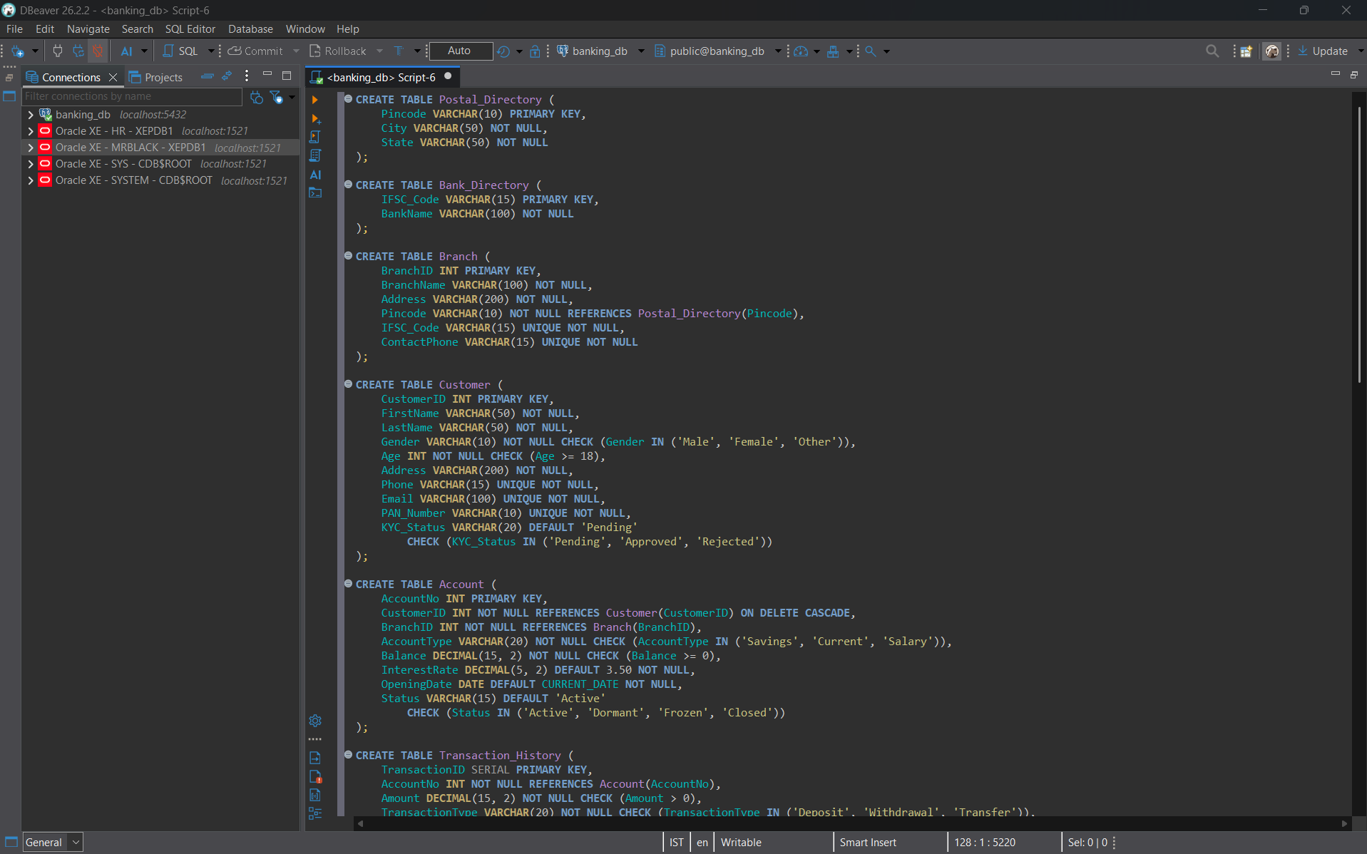
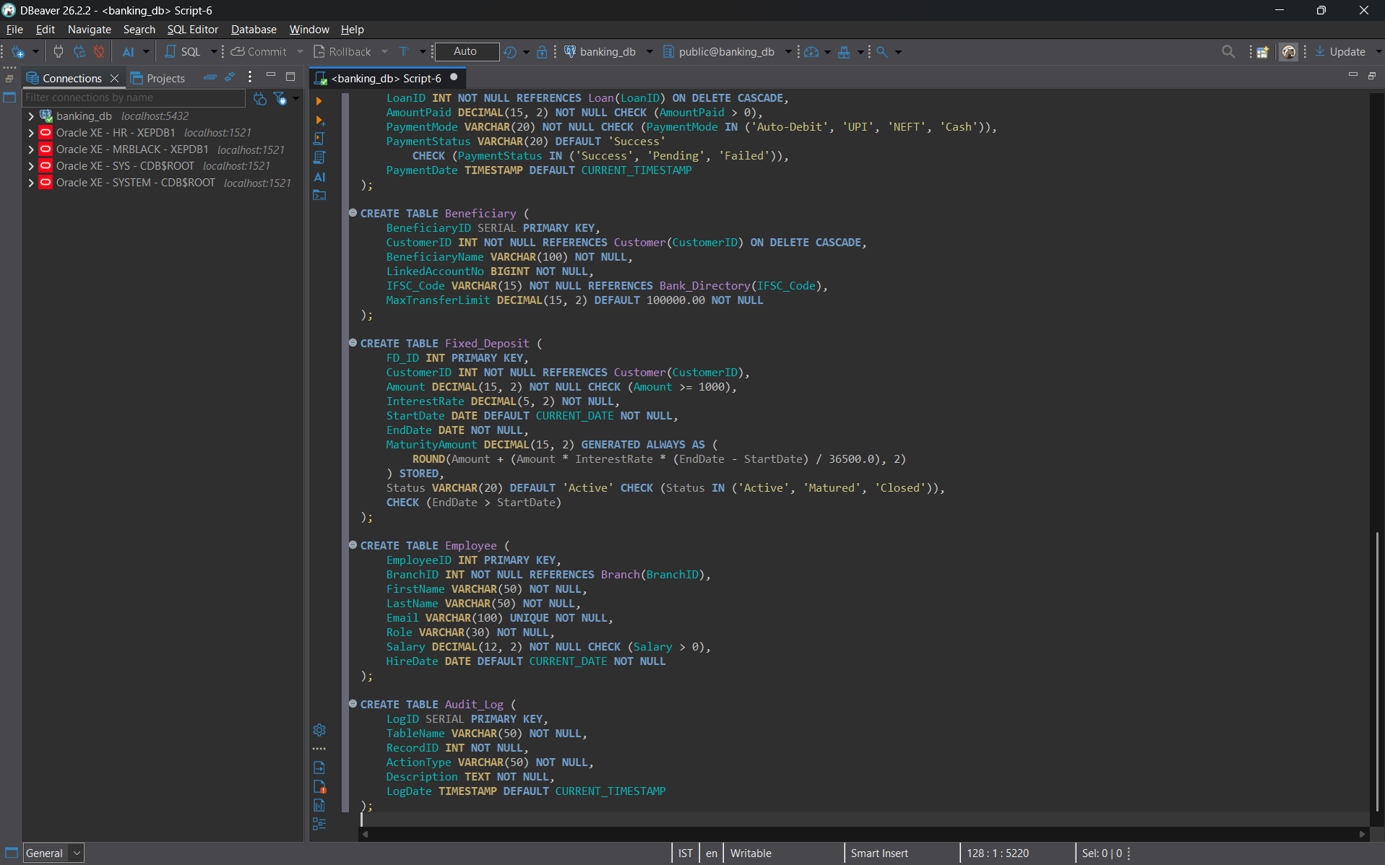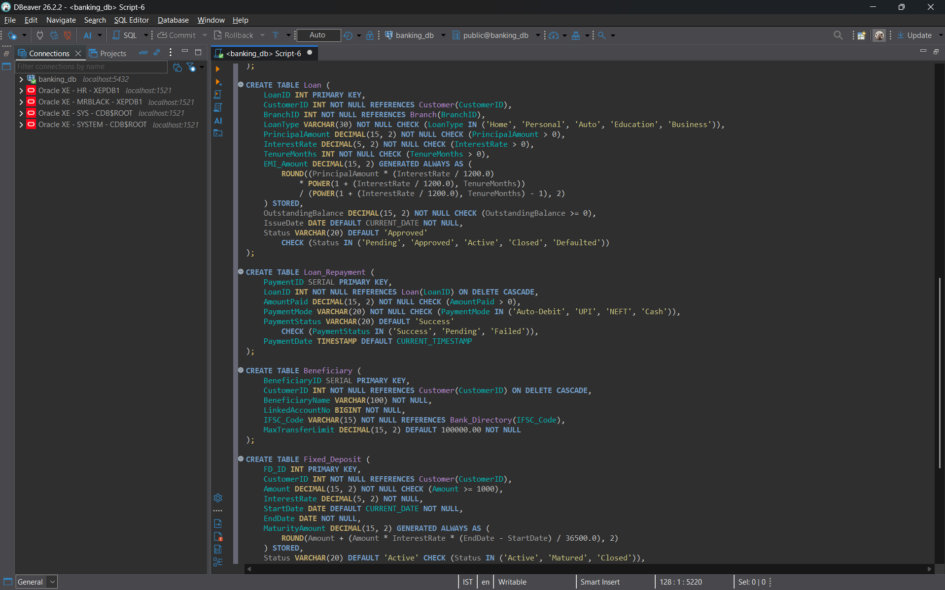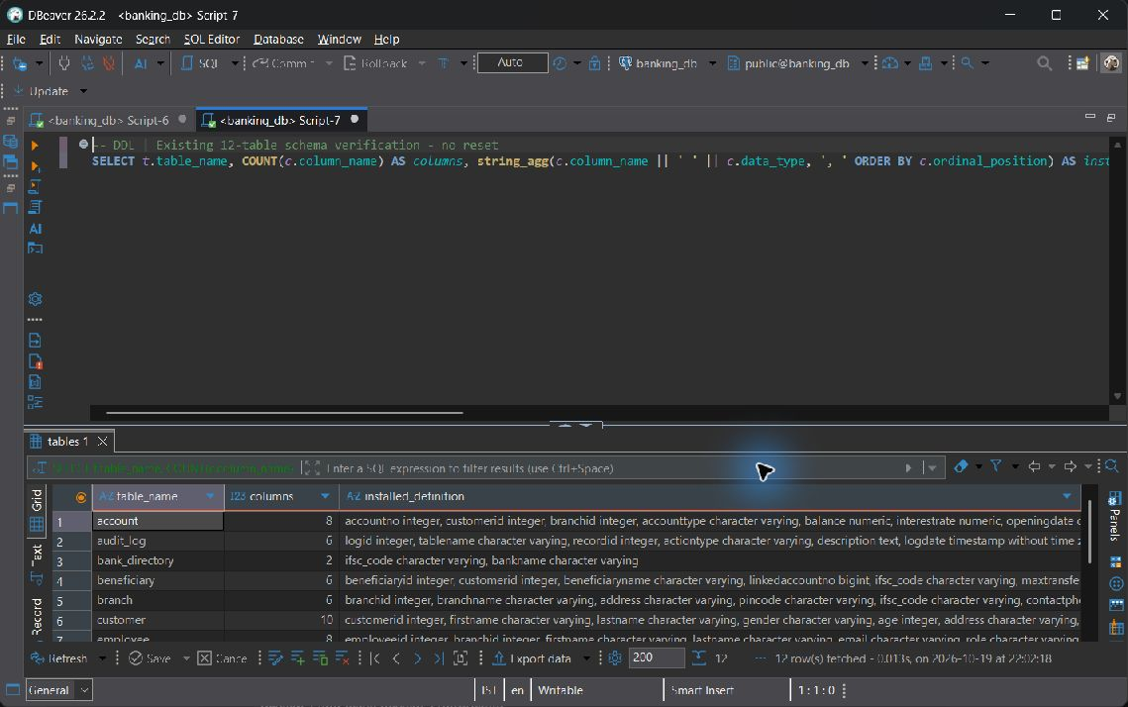

7 SQL Implementation
Category | Required coverage | Min queries
A Basic | SELECT, WHERE, ORDER BY, DISTINCT, BETWEEN, IN, LIKE, IS NULL | 6; implemented 6
B Aggregate | COUNT, SUM, AVG, MIN, MAX, GROUP BY, HAVING; WHERE versus HAVING | 5; implemented 5
C Joins | INNER, LEFT, RIGHT, FULL OUTER, SELF and meaningful CROSS | 6; implemented 6
D Subqueries | Scalar, single-row, multi-row IN/ANY/ALL, correlated, EXISTS, NOT EXISTS, NOT IN with NULL fix | 6; implemented 6
E Set operations | UNION, UNION ALL, INTERSECT, EXCEPT | 4; implemented 4
F Advanced functions | CASE, COALESCE, NULLIF, AGE/EXTRACT, UPPER/CONCAT, ROUND | 4-6; implemented 4
G Window and analytic | RANK/DENSE_RANK, ROW_NUMBER, running SUM, LAG/LEAD | 4; implemented 4

Category A Basic

A-01 SELECT the customer directory in a deterministic order
SELECT CustomerID, FirstName, LastName, KYC_Status
FROM Customer
ORDER BY CustomerID;

Execution output: 110 row(s).
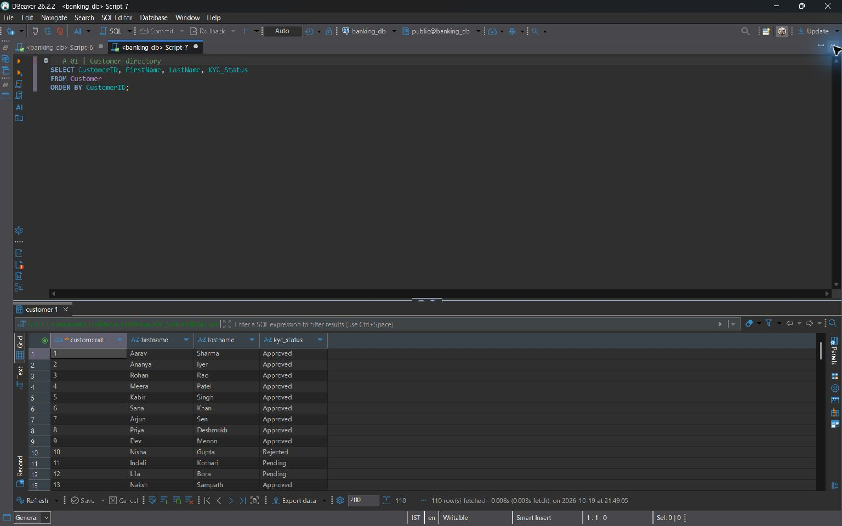
A-01

A-02 WHERE filters individual accounts; ORDER BY prioritizes balances
SELECT AccountNo, CustomerID, AccountType, Balance
FROM Account
WHERE Status = 'Active'
ORDER BY Balance DESC, AccountNo;

Execution output: 120 row(s).
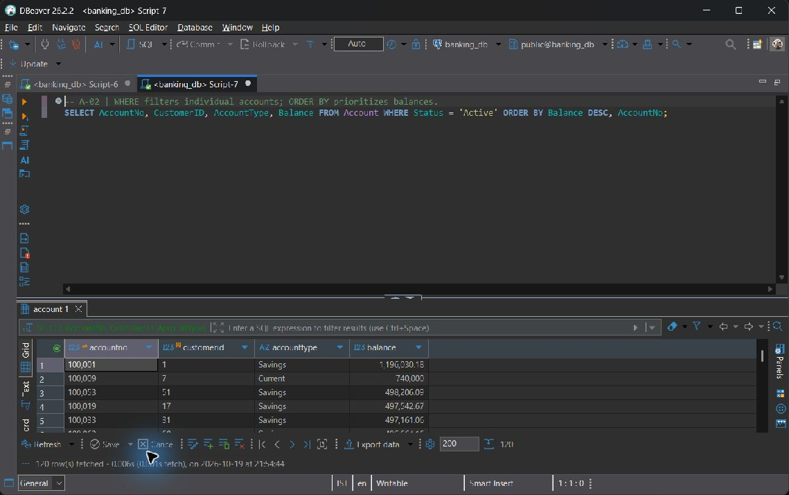
A-02

A-03 DISTINCT removes repeated account types
SELECT DISTINCT AccountType
FROM Account
ORDER BY AccountType;

Execution output: 3 row(s).
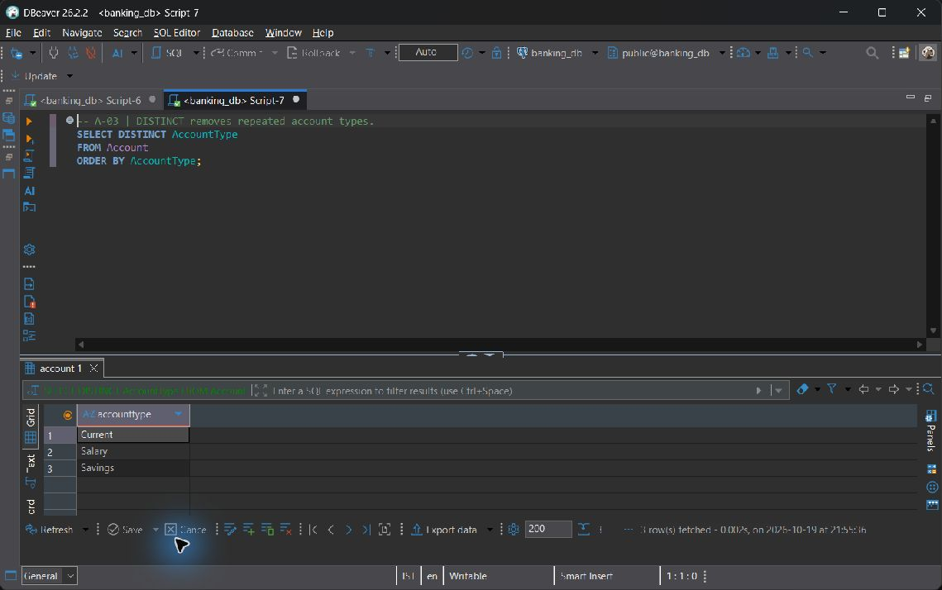
A-03

A-04 BETWEEN includes both endpoints of this balance range
SELECT AccountNo, Balance
FROM Account
WHERE Balance BETWEEN 50000 AND 250000
ORDER BY Balance, AccountNo;

Execution output: 59 row(s).
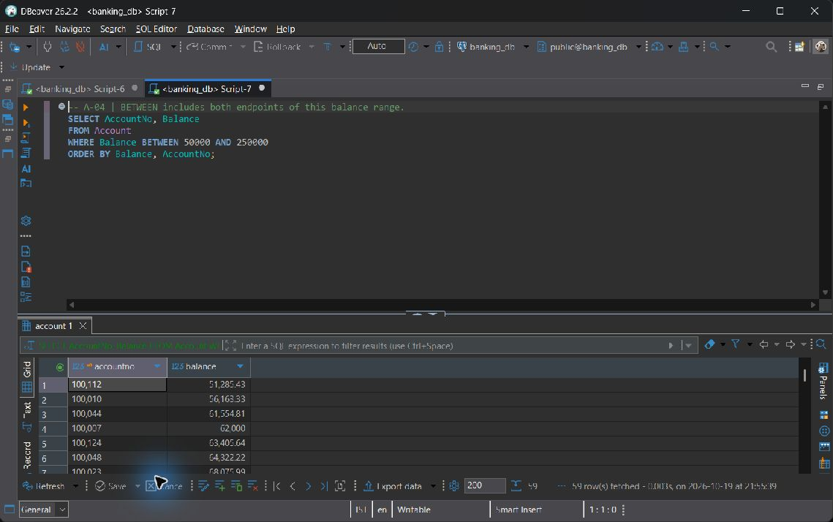
A-04

A-05 IN selects allowed KYC states; LIKE matches a name prefix
SELECT CustomerID, FirstName, LastName, KYC_Status
FROM Customer
WHERE KYC_Status IN ('Approved', 'Pending') AND FirstName LIKE 'A%'
ORDER BY FirstName, CustomerID;

Execution output: 12 row(s).
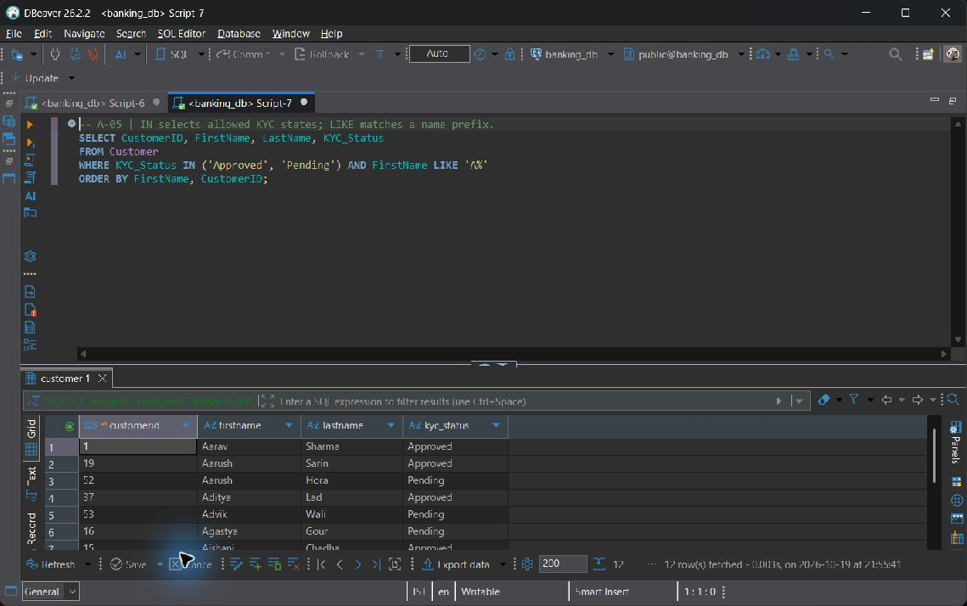
A-05

A-06 NULL must be tested with IS NULL, not equality
SELECT TransactionID, AccountNo, Amount, Remarks
FROM Transaction_History
WHERE Remarks IS NULL
ORDER BY TransactionID;

Execution output: 54 row(s).
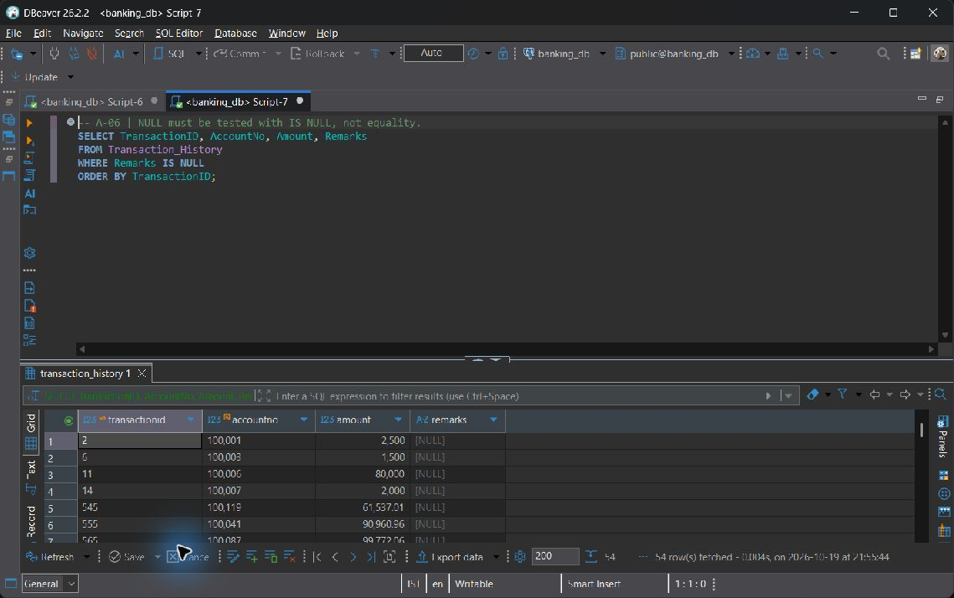
A-06

Category B Aggregate

B-01 COUNT(*) counts customers, including nullable KYC states if present
SELECT KYC_Status, COUNT(*) AS customer_count
FROM Customer
GROUP BY KYC_Status
ORDER BY KYC_Status NULLS LAST;

Execution output: 3 row(s).
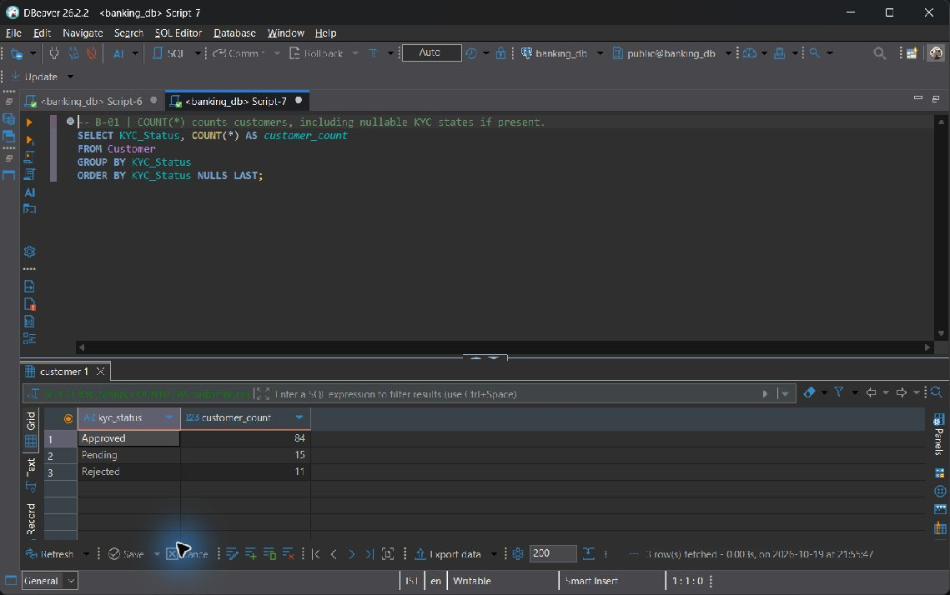
B-01

B-02 SUM reports balances by product, including all account statuses
SELECT AccountType, SUM(Balance) AS total_balance
FROM Account
GROUP BY AccountType
ORDER BY AccountType;

Execution output: 3 row(s).
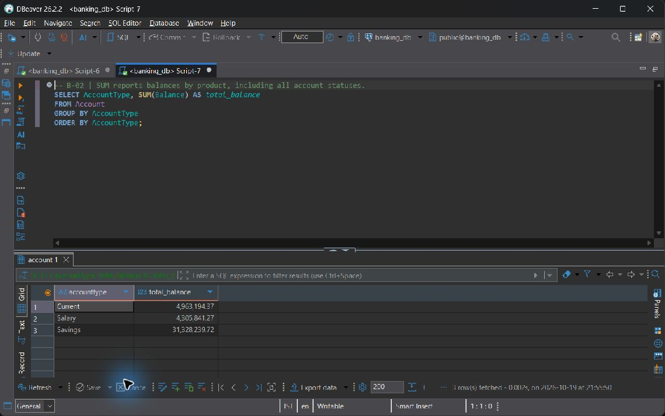
B-02

B-03 AVG, MIN, and MAX describe the range of staff salaries per role
SELECT Role, ROUND(AVG(Salary), 2) AS average_salary,
MIN(Salary) AS minimum_salary, MAX(Salary) AS maximum_salary
FROM Employee
GROUP BY Role
ORDER BY Role;

Execution output: 4 row(s).
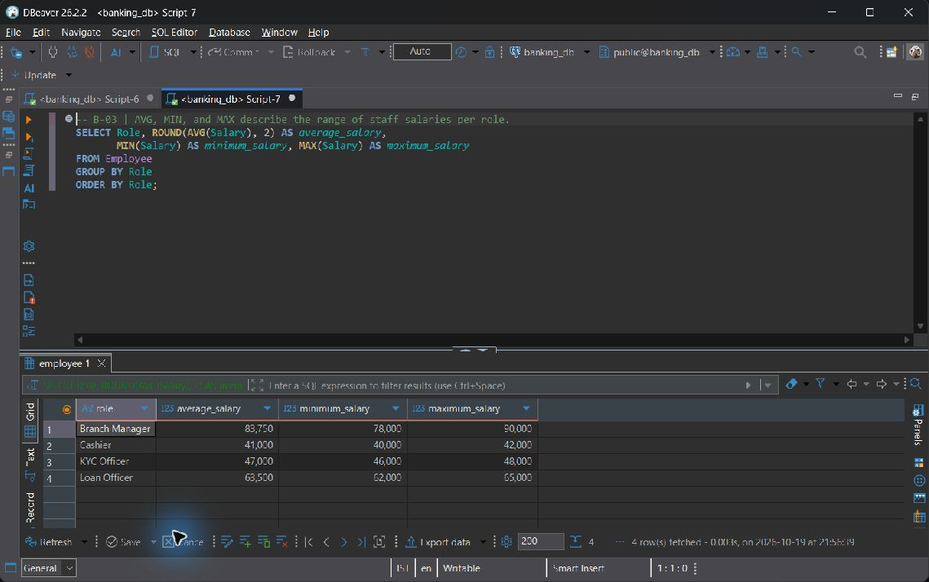
B-03

B-04 WHERE vs HAVING, explicitly contrasted:
WHERE filters individual rows before GROUP BY. HAVING filters the aggregate branch groups afterward. Removing non-Active accounts with HAVING alone would let their balances enter the sum; applying SUM(Balance) in WHERE is invalid at that query level.
SELECT BranchID, COUNT(*) AS active_account_count,
SUM(Balance) AS active_balance
FROM Account
WHERE Status = 'Active'
GROUP BY BranchID
HAVING SUM(Balance) >= 100000
ORDER BY active_balance DESC, BranchID;

Execution output: 8 row(s).
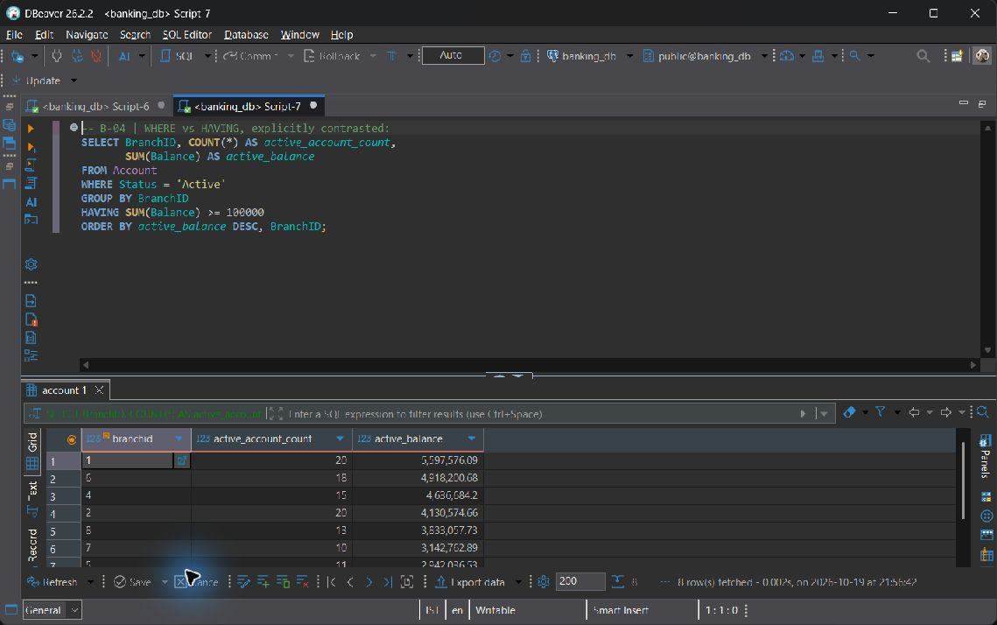
B-04

B-05 Count and sum observed transaction events per payment channel
SELECT PaymentMode, COUNT(*) AS transaction_count,
SUM(Amount) AS gross_amount, ROUND(AVG(Amount), 2) AS average_amount
FROM Transaction_History
GROUP BY PaymentMode
ORDER BY gross_amount DESC, PaymentMode;

Execution output: 6 row(s).
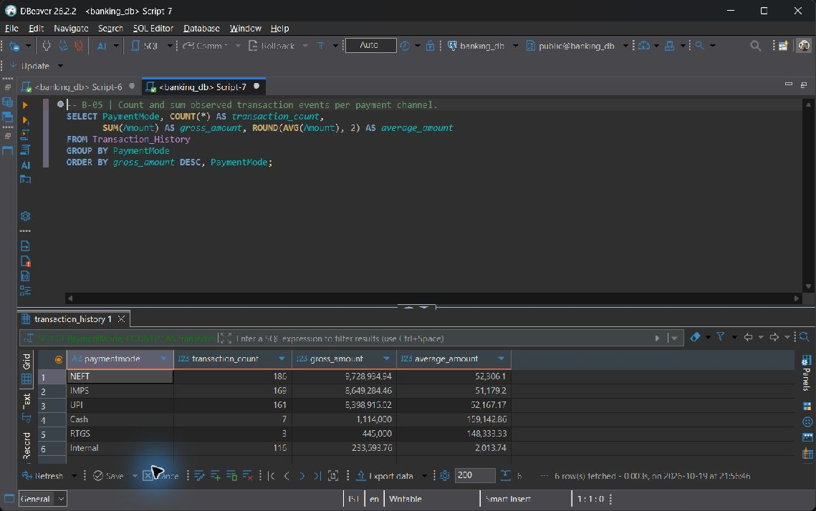
B-05

Category C Joins

C-01 INNER JOIN returns accounts with their owners and servicing branches
SELECT a.AccountNo, c.FirstName, c.LastName, b.BranchName, a.Balance
FROM Account a
INNER JOIN Customer c ON c.CustomerID = a.CustomerID
INNER JOIN Branch b ON b.BranchID = a.BranchID
ORDER BY a.AccountNo;

Execution output: 162 row(s).
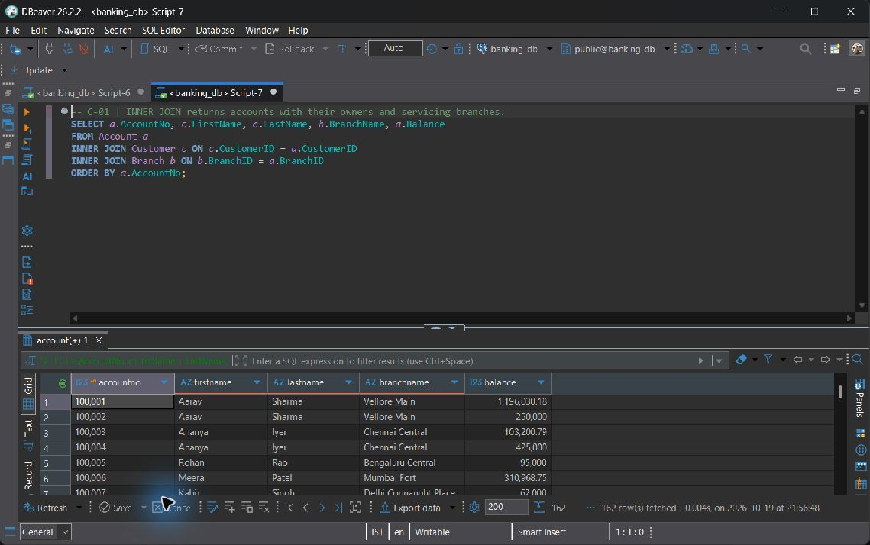
C-01

C-02 LEFT JOIN preserves customers who have never borrowed
SELECT c.CustomerID, c.FirstName, l.LoanID, l.LoanType, l.Status
FROM Customer c
LEFT JOIN Loan l ON l.CustomerID = c.CustomerID
ORDER BY c.CustomerID, l.LoanID;

Execution output: 110 row(s).
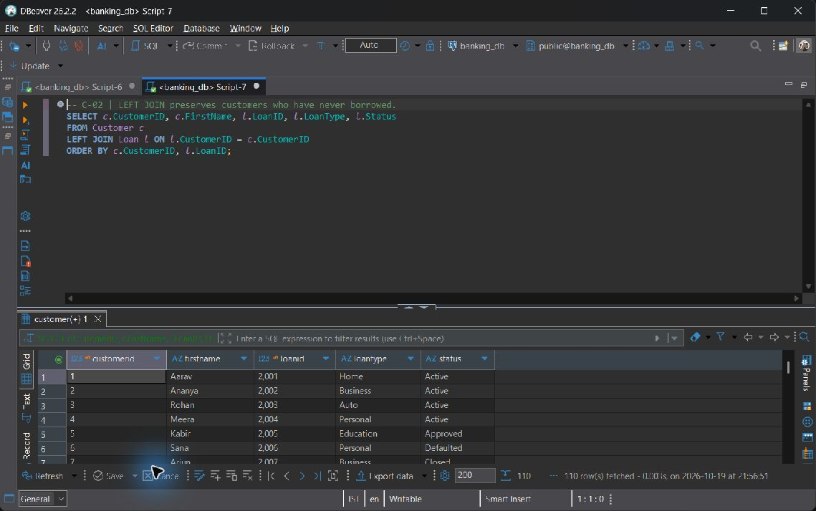
C-02

C-03 RIGHT JOIN preserves every branch, including branches without loans
SELECT b.BranchID, b.BranchName, l.LoanID, l.OutstandingBalance
FROM Loan l
RIGHT JOIN Branch b ON b.BranchID = l.BranchID
ORDER BY b.BranchID, l.LoanID;

Execution output: 58 row(s).
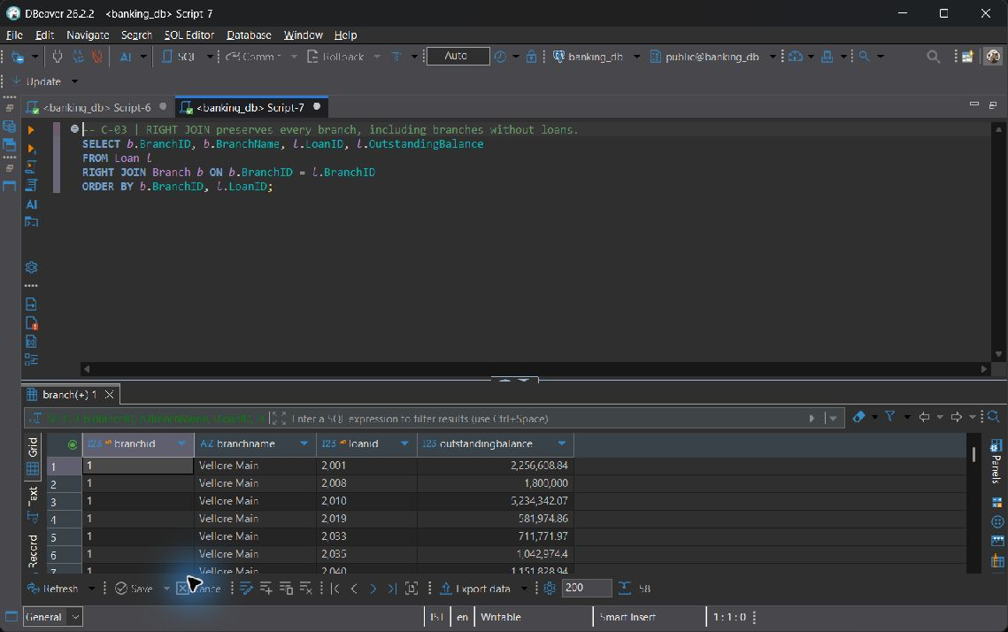
C-03

C-04 FULL OUTER JOIN reconciles directory entries and local branches
SELECT d.IFSC_Code AS directory_ifsc, d.BankName,
b.IFSC_Code AS branch_ifsc, b.BranchName
FROM Bank_Directory d
FULL OUTER JOIN Branch b ON b.IFSC_Code = d.IFSC_Code
ORDER BY COALESCE(d.IFSC_Code, b.IFSC_Code);

Execution output: 10 row(s).
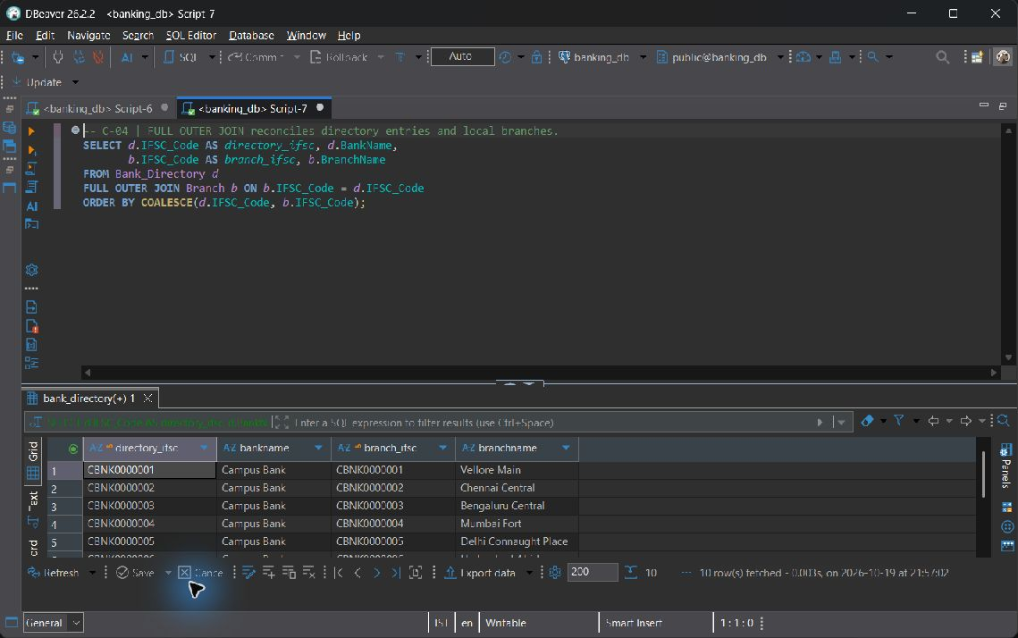
C-04

C-05 SELF JOIN finds distinct account pairs belonging to one customer
SELECT a.CustomerID, a.AccountNo AS first_account, a.AccountType AS first_type,
other.AccountNo AS second_account, other.AccountType AS second_type
FROM Account a
JOIN Account other ON other.CustomerID = a.CustomerID
AND a.AccountNo < other.AccountNo
ORDER BY a.CustomerID, a.AccountNo, other.AccountNo;

Execution output: 52 row(s).
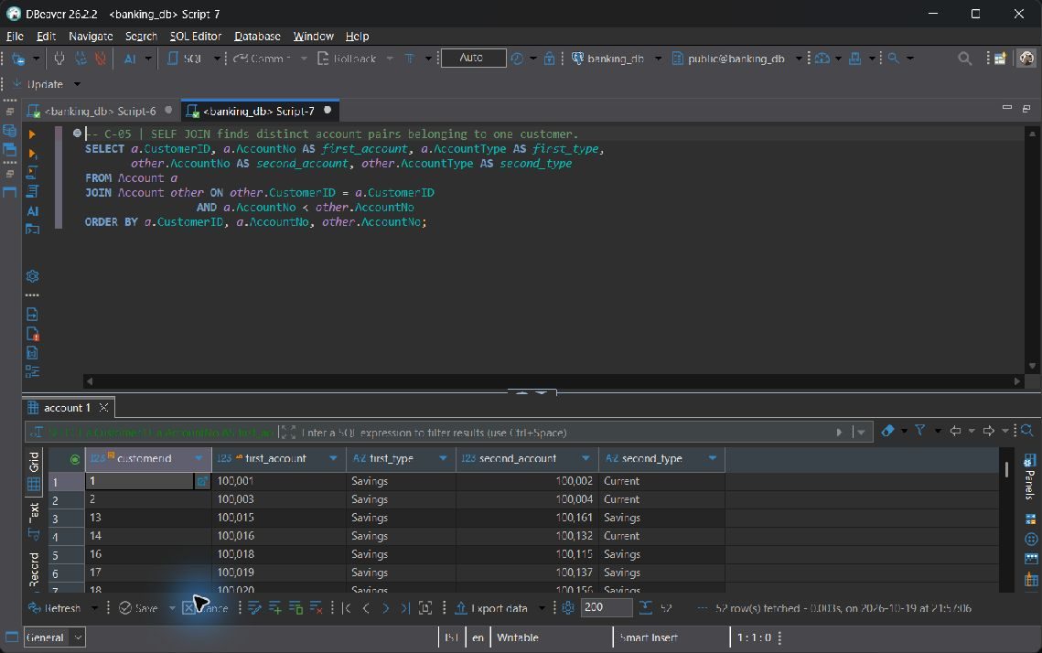
C-05

C-06 CROSS JOIN builds a branch/product coverage grid, including zeroes
SELECT b.BranchID, b.BranchName, product.AccountType,
COUNT(a.AccountNo) AS account_count
FROM Branch b
CROSS JOIN (SELECT DISTINCT AccountType FROM Account) product
LEFT JOIN Account a ON a.BranchID = b.BranchID
AND a.AccountType = product.AccountType
GROUP BY b.BranchID, b.BranchName, product.AccountType
ORDER BY b.BranchID, product.AccountType;

Execution output: 24 row(s).
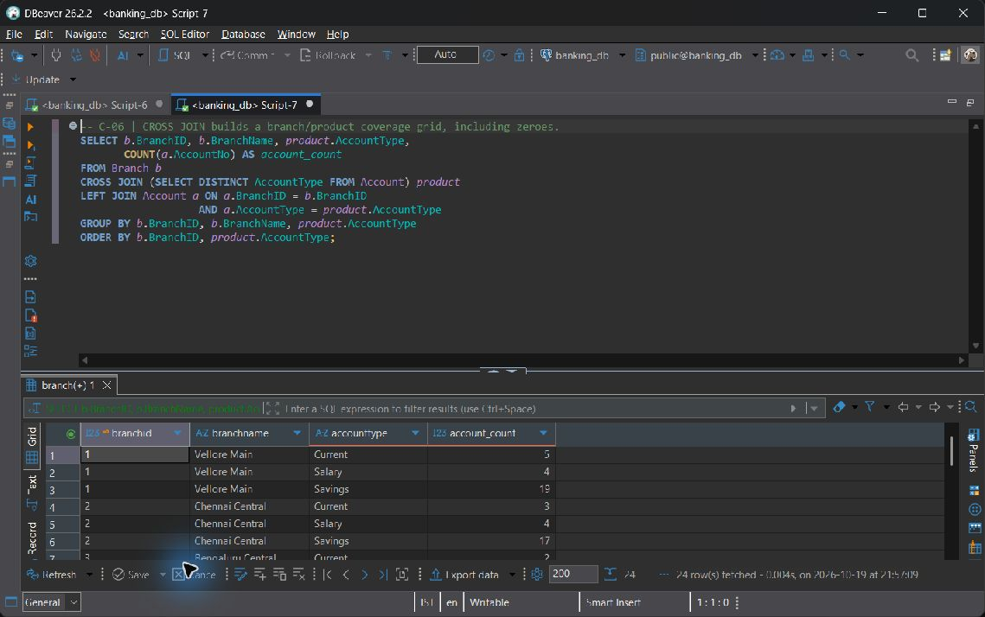
C-06

Category D Subqueries

D-01 An uncorrelated scalar aggregate subquery supplies one benchmark
SELECT AccountNo, Balance,
(SELECT ROUND(AVG(Balance), 2) FROM Account) AS bank_average_balance
FROM Account
ORDER BY Balance DESC, AccountNo;

Execution output: 162 row(s).
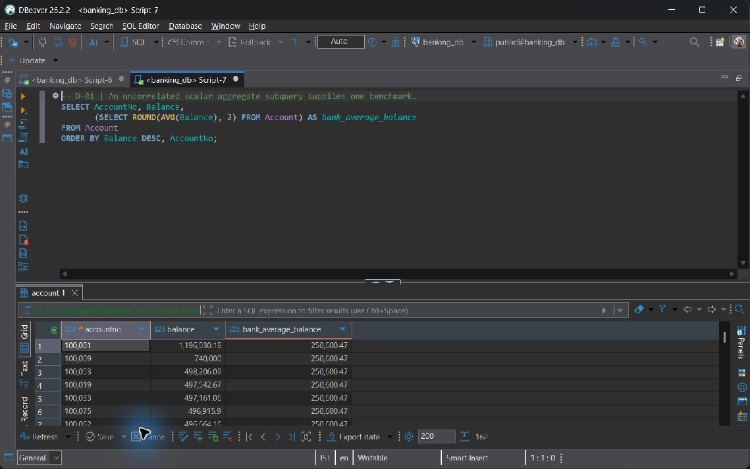
D-01

D-02 Single-row subquery identifies the highest-balance Savings account
SELECT CustomerID, FirstName, LastName
FROM Customer
WHERE CustomerID = (
SELECT CustomerID FROM Account
WHERE AccountType = 'Savings'
ORDER BY Balance DESC, AccountNo
LIMIT 1
)
ORDER BY CustomerID;

Execution output: 1 row(s).
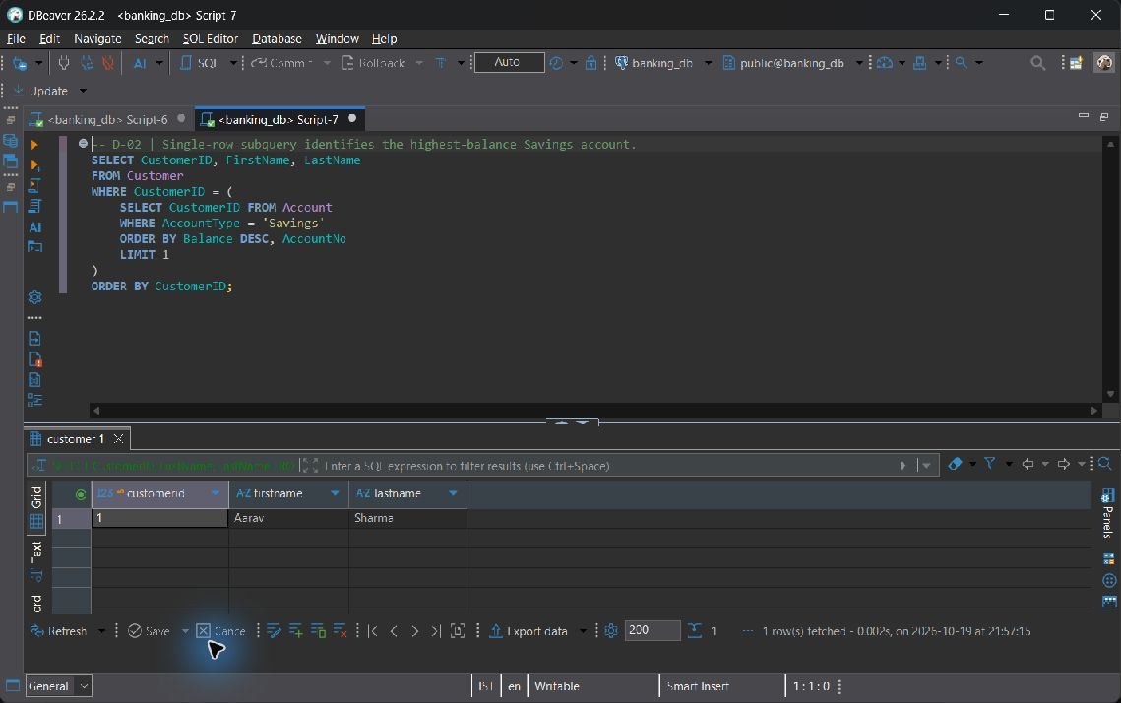
D-02

D-03 Multi-row IN, ANY, and ALL in one loan screening query
SELECT LoanID, CustomerID, LoanType, PrincipalAmount
FROM Loan
WHERE CustomerID IN (SELECT CustomerID FROM Account WHERE Status = 'Active')
AND PrincipalAmount > ANY (SELECT PrincipalAmount FROM Loan WHERE LoanType = 'Personal')
AND PrincipalAmount >= ALL (SELECT PrincipalAmount FROM Loan WHERE LoanType = 'Auto')
ORDER BY PrincipalAmount DESC, LoanID;

Execution output: 19 row(s).
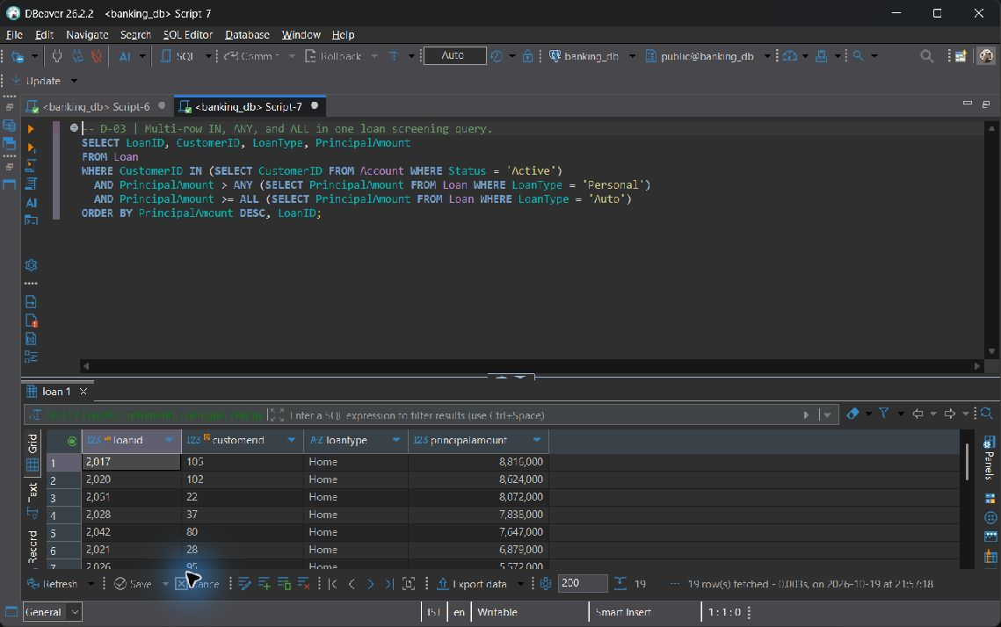
D-03

D-04 Correlated EXISTS tests each customer without multiplying rows for
SELECT c.CustomerID, c.FirstName, c.LastName
FROM Customer c
WHERE EXISTS (
SELECT 1 FROM Account a
WHERE a.CustomerID = c.CustomerID
AND a.Balance > (SELECT AVG(peer.Balance) FROM Account peer
WHERE peer.BranchID = a.BranchID)
)
ORDER BY c.CustomerID;

Execution output: 63 row(s).
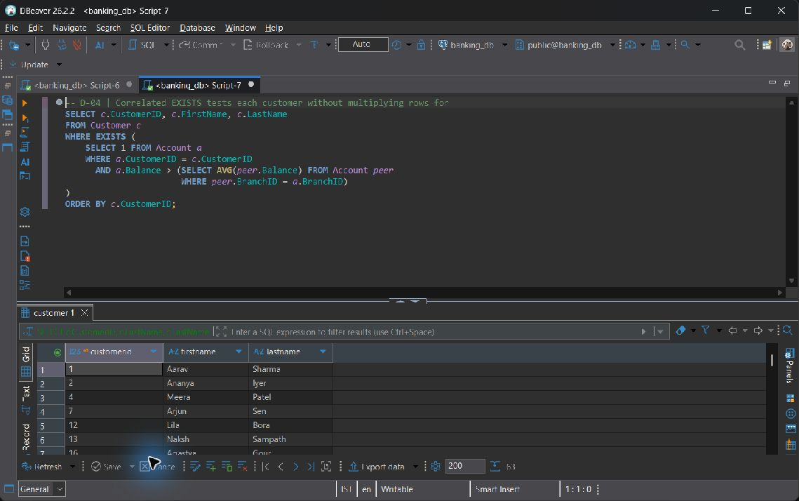
D-04

D-05 Correlated NOT EXISTS finds customers without either product
SELECT c.CustomerID, c.FirstName, c.LastName
FROM Customer c
WHERE NOT EXISTS (SELECT 1 FROM Loan l WHERE l.CustomerID = c.CustomerID)
AND NOT EXISTS (SELECT 1 FROM Fixed_Deposit f WHERE f.CustomerID = c.CustomerID)
ORDER BY c.CustomerID;

Execution output: 37 row(s).
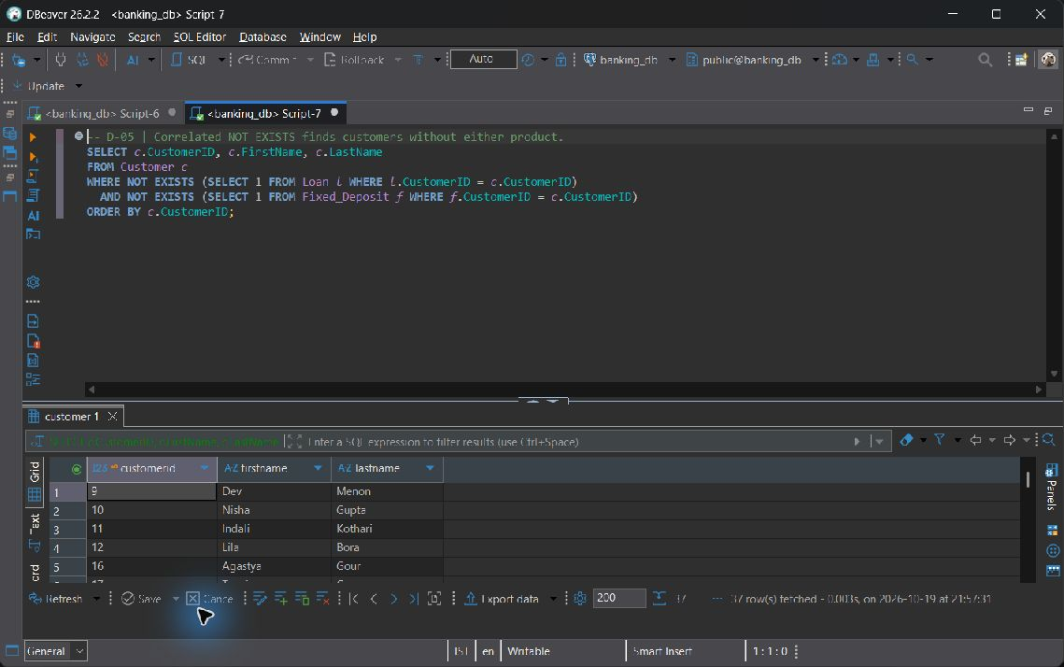
D-05

D-06 NOT IN NULL pitfall AND fix, executable as ONE statement
NULL pitfall: an unmatched value NOT IN a set containing NULL evaluates to UNKNOWN and is discarded by WHERE. Filtering inner NULLs restores the intended anti-membership test. The single statement prints the unsafe and corrected counts side by side.
WITH narratives AS (
SELECT DISTINCT Remarks FROM Transaction_History WHERE Remarks IS NOT NULL
)
SELECT '1. Unsafe NOT IN (NULL poisoned)' AS demonstration,
COUNT(*) AS matching_narratives
FROM narratives
WHERE Remarks NOT IN (
SELECT Remarks FROM Transaction_History WHERE TransactionType = 'Withdrawal'
)
UNION ALL
SELECT '2. Corrected NOT IN (NULL filtered)', COUNT(*)
FROM narratives
WHERE Remarks NOT IN (
SELECT Remarks FROM Transaction_History
WHERE TransactionType = 'Withdrawal' AND Remarks IS NOT NULL
)
ORDER BY demonstration;

Execution output: 2 row(s).
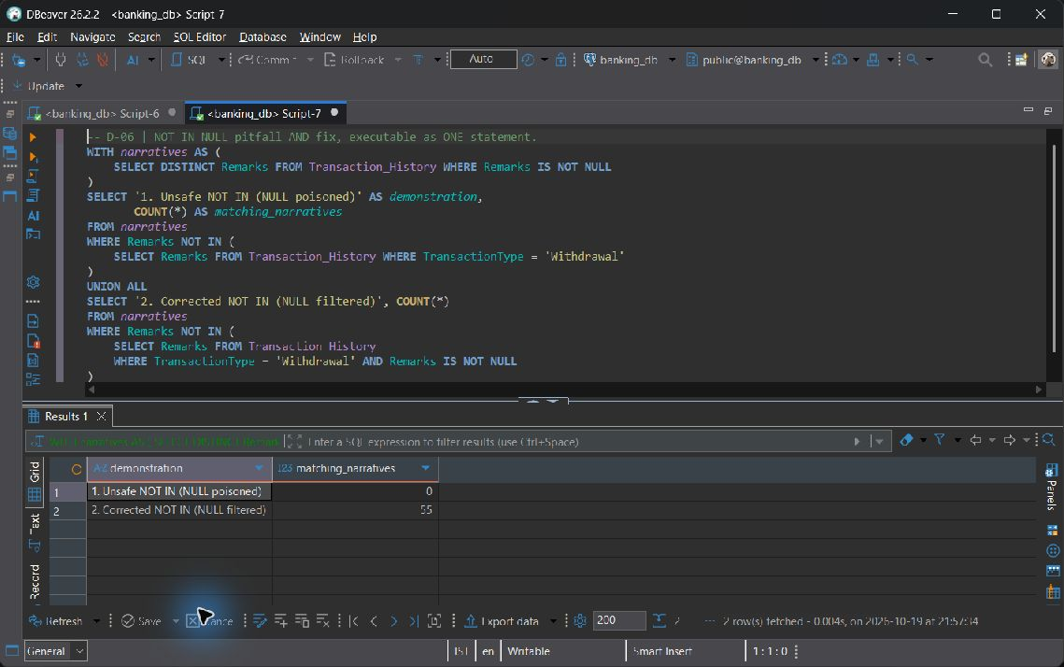
D-06

Category E Set operations

E-01 UNION removes duplicate customer IDs across the two product sets
SELECT CustomerID FROM Account WHERE AccountType = 'Savings'
UNION
SELECT CustomerID FROM Loan
ORDER BY CustomerID;

Execution output: 110 row(s).
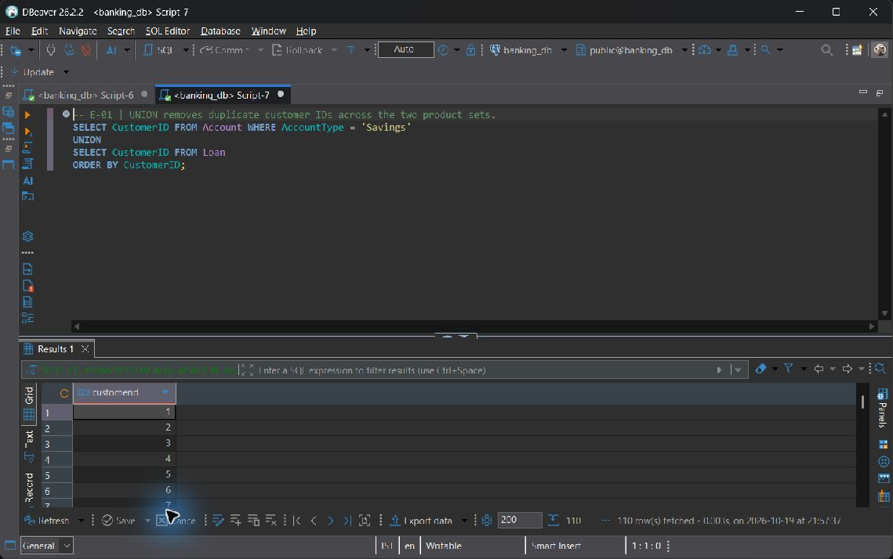
E-01

E-02 UNION ALL retains each individual product holding, even for an owner
SELECT CustomerID, 'Account' AS product, AccountNo AS product_id FROM Account
UNION ALL
SELECT CustomerID, 'Fixed Deposit', FD_ID FROM Fixed_Deposit
ORDER BY CustomerID, product, product_id;

Execution output: 210 row(s).
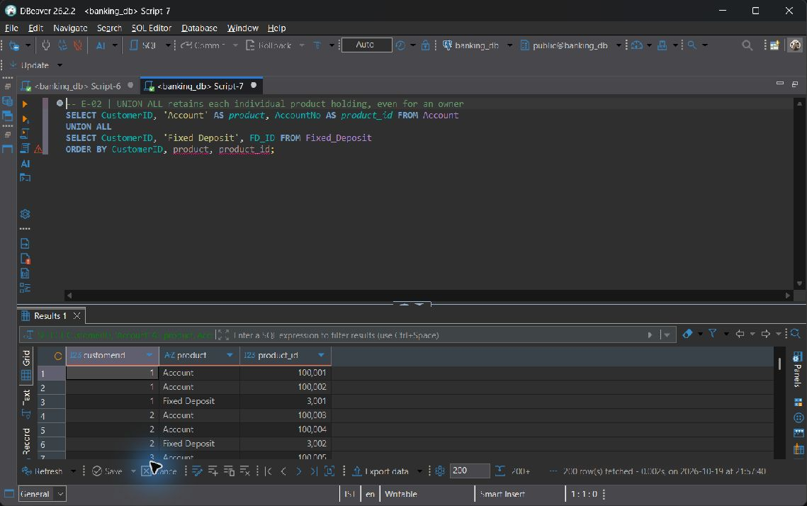
E-02

E-03 INTERSECT finds customers holding both Savings and Current accounts
SELECT CustomerID FROM Account WHERE AccountType = 'Savings'
INTERSECT
SELECT CustomerID FROM Account WHERE AccountType = 'Current'
ORDER BY CustomerID;

Execution output: 20 row(s).
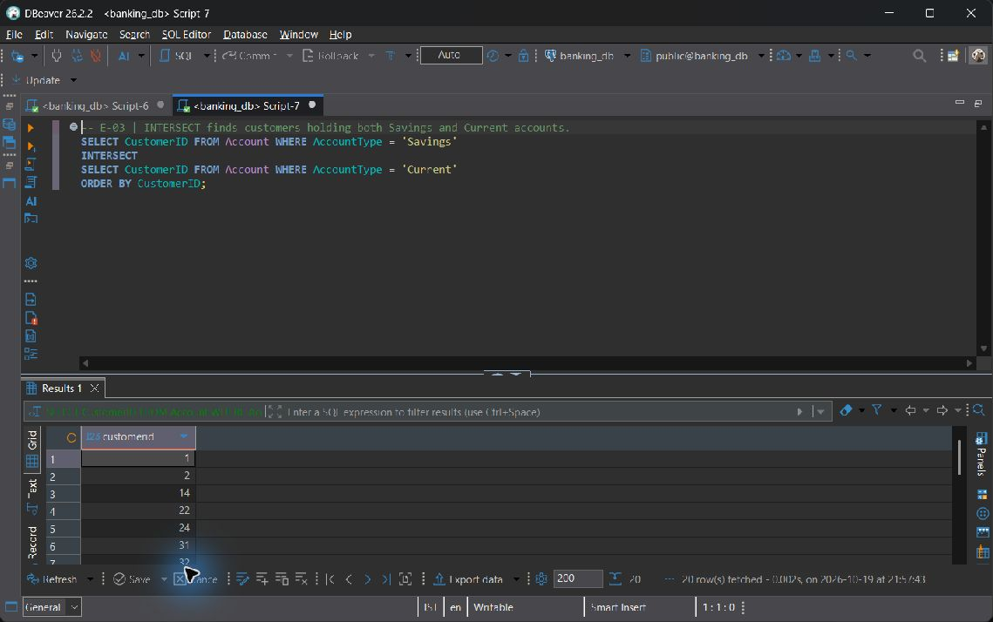
E-03

E-04 EXCEPT finds account holders who have no loan of any status
SELECT CustomerID FROM Account
EXCEPT
SELECT CustomerID FROM Loan
ORDER BY CustomerID;

Execution output: 52 row(s).
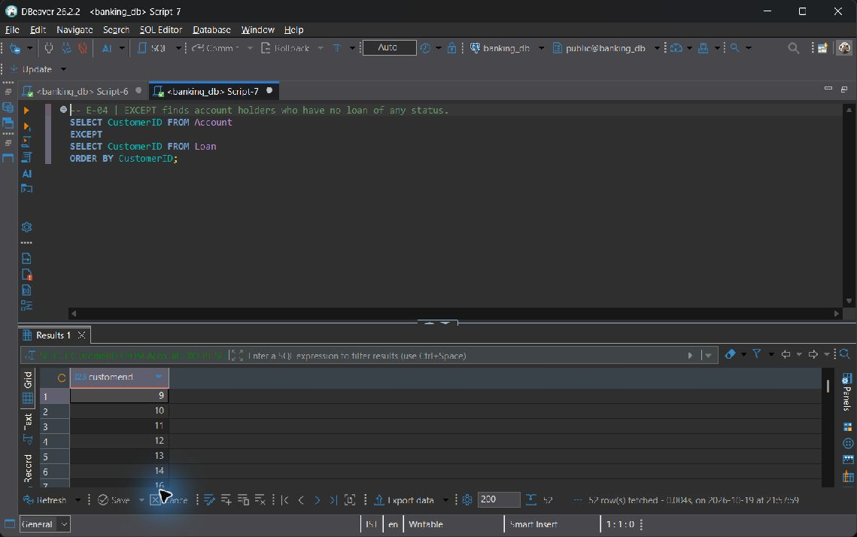
E-04

Category F Advanced functions

F-01 CASE assigns balance bands; ROUND computes a monthly interest estimate
SELECT AccountNo, Balance,
CASE WHEN Balance >= 250000 THEN 'High'
WHEN Balance >= 50000 THEN 'Medium' ELSE 'Low' END AS balance_band,
ROUND(Balance * InterestRate / 1200.0, 2) AS estimated_monthly_interest
FROM Account
ORDER BY AccountNo;

Execution output: 162 row(s).
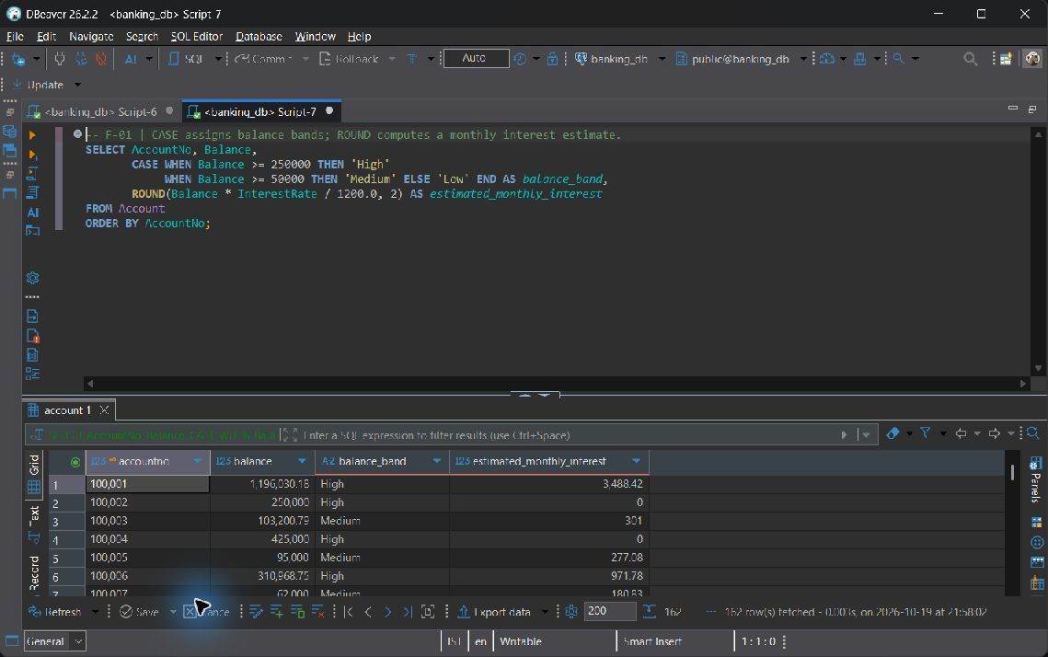
F-01

F-02 COALESCE substitutes a display value without changing stored NULLs
SELECT TransactionID, AccountNo, COALESCE(Remarks, 'No remarks provided') AS narrative
FROM Transaction_History
ORDER BY TransactionID;

Execution output: 642 row(s).
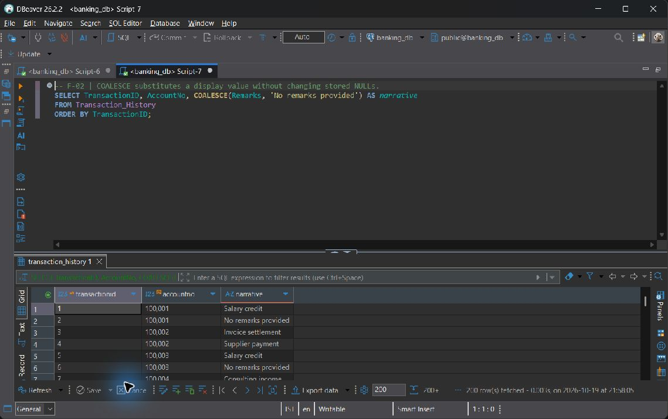
F-02

F-03 NULLIF turns a zero denominator into NULL, preventing division by zero
SELECT a.AccountNo, a.Balance,
COALESCE(SUM(t.Amount) FILTER (WHERE t.TransactionType = 'Withdrawal'), 0)
AS recorded_withdrawals,
ROUND(100.0 * COALESCE(SUM(t.Amount)
FILTER (WHERE t.TransactionType = 'Withdrawal'), 0)
/ NULLIF(a.Balance, 0), 2) AS withdrawals_to_current_balance_pct
FROM Account a
LEFT JOIN Transaction_History t ON t.AccountNo = a.AccountNo
GROUP BY a.AccountNo, a.Balance
ORDER BY a.AccountNo;

Execution output: 162 row(s).
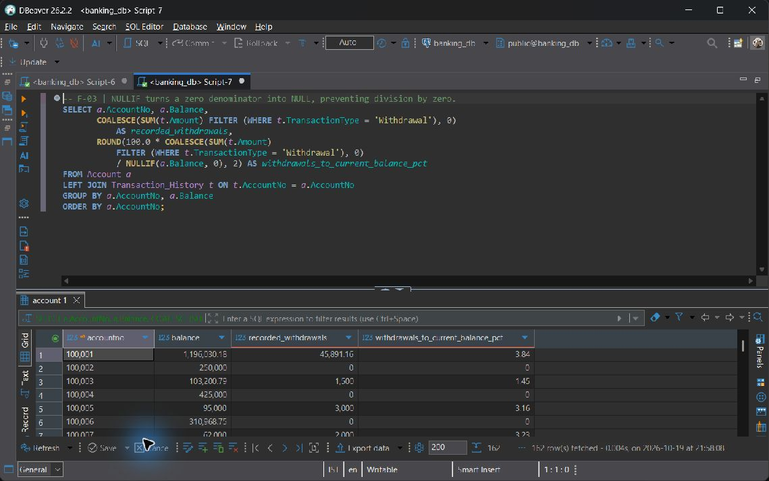
F-03

F-04 String formatting plus AGE/EXTRACT for customer account tenure
SELECT a.AccountNo, UPPER(CONCAT(c.FirstName, ' ', c.LastName)) AS display_name,
a.OpeningDate,
AGE(CURRENT_DATE::timestamp, a.OpeningDate::timestamp) AS account_tenure,
EXTRACT(YEAR FROM AGE(CURRENT_DATE::timestamp, a.OpeningDate::timestamp))
AS completed_years
FROM Account a
JOIN Customer c ON c.CustomerID = a.CustomerID
ORDER BY a.AccountNo;

Execution output: 162 row(s).
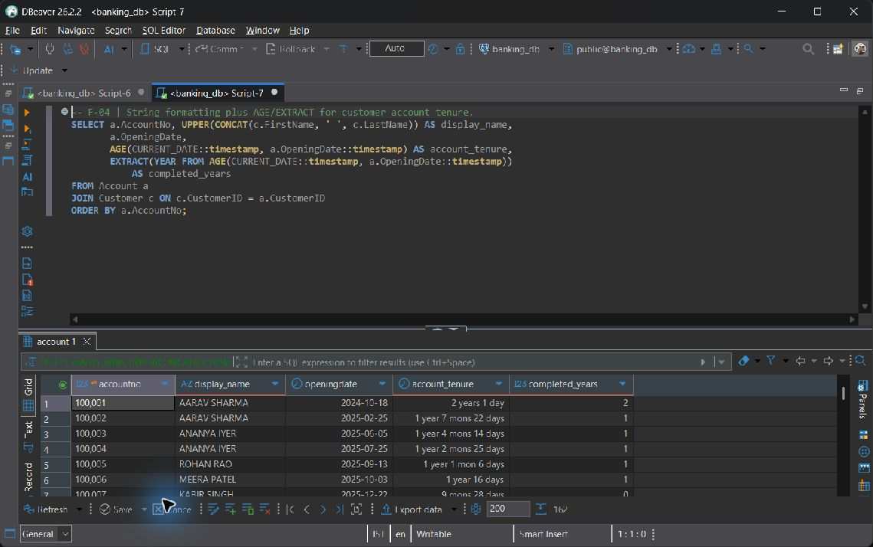
F-04

Category G Window and analytic

G-01 RANK leaves gaps after ties; DENSE_RANK does not
SELECT AccountNo, BranchID, Balance,
RANK() OVER (PARTITION BY BranchID ORDER BY Balance DESC) AS balance_rank,
DENSE_RANK() OVER (PARTITION BY BranchID ORDER BY Balance DESC) AS dense_balance_rank
FROM Account
ORDER BY BranchID, balance_rank, AccountNo;

Execution output: 162 row(s).
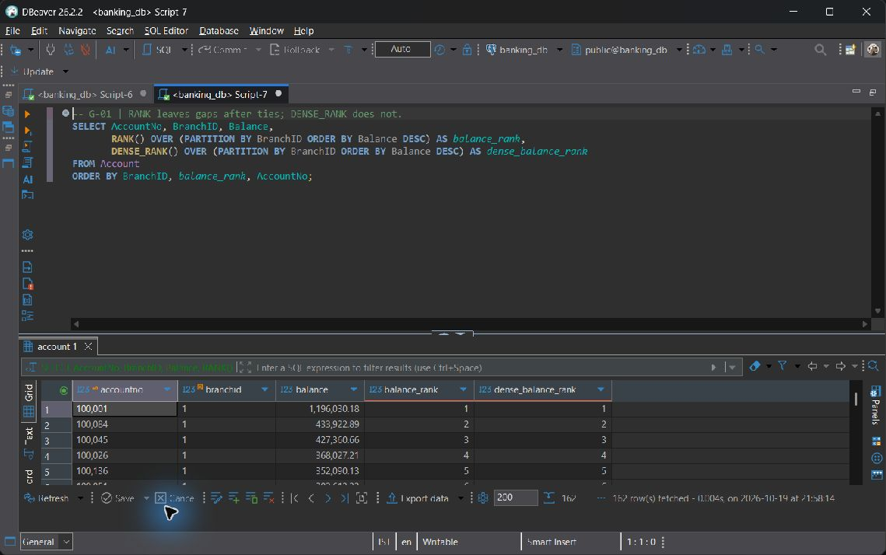
G-01

G-02 ROW_NUMBER assigns an unambiguous recency sequence per account
SELECT TransactionID, AccountNo, TransactionDate, Amount,
ROW_NUMBER() OVER (PARTITION BY AccountNo
ORDER BY TransactionDate DESC NULLS LAST, TransactionID DESC) AS recency_number
FROM Transaction_History
ORDER BY AccountNo, recency_number;

Execution output: 642 row(s).
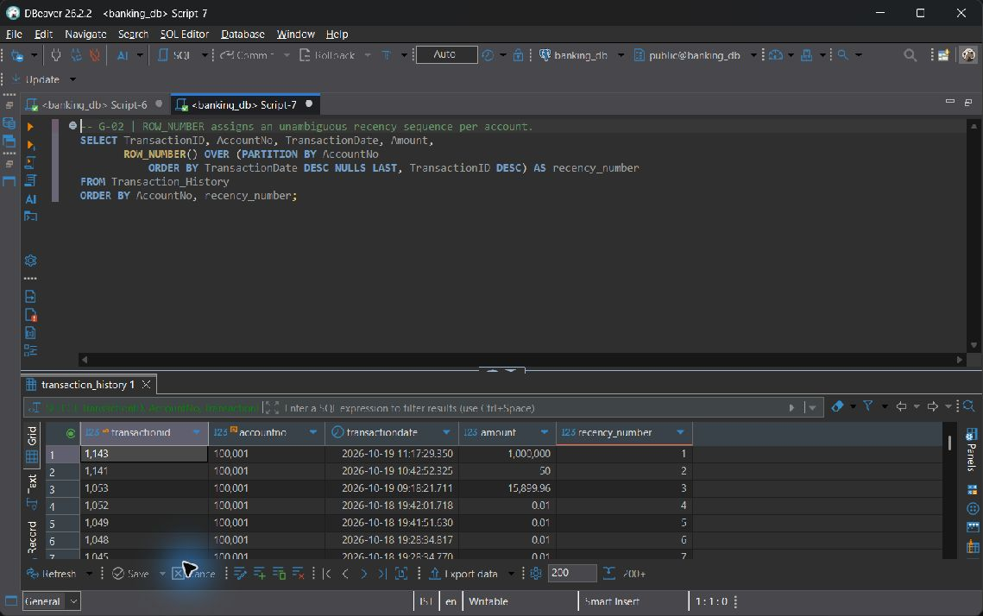
G-02

G-03 Explicit ROWS frame and ID tiebreaker make event-by-event totals stable
SELECT TransactionID, AccountNo, TransactionDate, Amount,
SUM(Amount) OVER (PARTITION BY AccountNo
ORDER BY TransactionDate NULLS LAST, TransactionID
ROWS BETWEEN UNBOUNDED PRECEDING AND CURRENT ROW) AS running_gross_volume
FROM Transaction_History
ORDER BY AccountNo, TransactionDate NULLS LAST, TransactionID;

Execution output: 642 row(s).
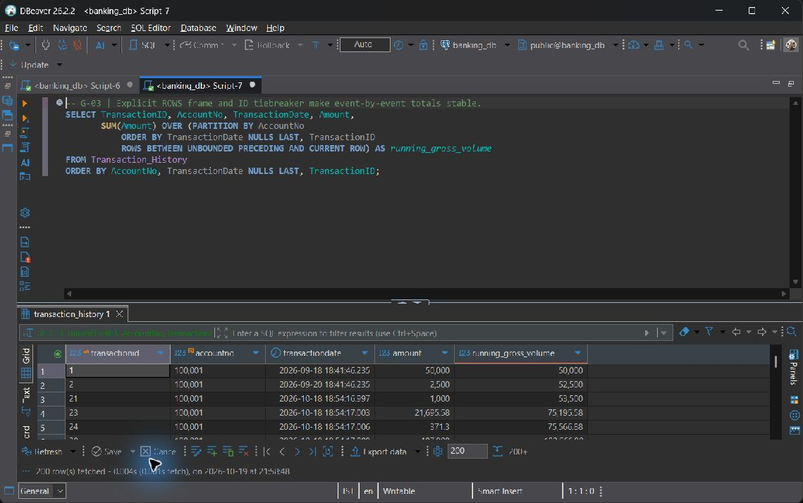
G-03

G-04 LAG and LEAD inspect adjacent account events; boundary rows yield NULL
SELECT TransactionID, AccountNo, TransactionDate, Amount,
LAG(Amount) OVER account_events AS previous_amount,
LEAD(TransactionDate) OVER account_events AS next_transaction_date
FROM Transaction_History
WINDOW account_events AS (PARTITION BY AccountNo
ORDER BY TransactionDate NULLS LAST, TransactionID)
ORDER BY AccountNo, TransactionDate NULLS LAST, TransactionID;

Execution output: 642 row(s).
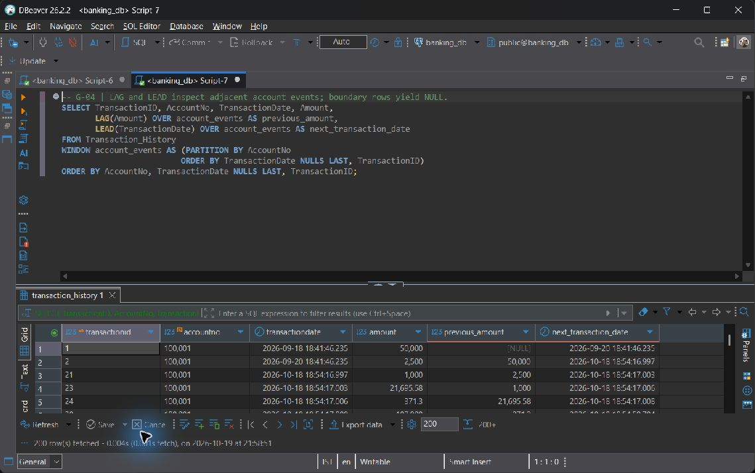
G-04

8 Advanced SQL Implementation

8.1 Complex Business Queries
Each CQ statement uses at least three base relations directly or through a multi-table CTE, with independent aggregation or analytic constructs where needed. The expected-output row states a hand-reasoned relational prediction; the actual-output row is the live result. Empty eligibility results are retained as valid evidence rather than filled with invented rows.

CQ-01
ID | CQ-01
Business question | Which borrowers have defaulted loans, and how much outstanding principal and failed-payment activity need branch follow-up?
SQL | SELECT l.LoanID, c.CustomerID, CONCAT(c.FirstName, ' ', c.LastName) AS borrower,  b.BranchName, l.OutstandingBalance AS defaulted_outstanding,  COUNT(r.PaymentID) FILTER (WHERE r.PaymentStatus = 'Failed') AS failed_attempts,  MAX(r.PaymentDate) FILTER (WHERE r.PaymentStatus = 'Success') AS last_successful_payment  FROM Loan l  JOIN Customer c ON c.CustomerID = l.CustomerID  JOIN Branch b ON b.BranchID = l.BranchID  LEFT JOIN Loan_Repayment r ON r.LoanID = l.LoanID  WHERE l.Status = 'Defaulted'  GROUP BY l.LoanID, c.CustomerID, c.FirstName, c.LastName, b.BranchID, b.BranchName  ORDER BY l.OutstandingBalance DESC, l.LoanID;
Expected output | One row per Defaulted loan, with the borrower, issuing branch and outstanding principal selected once. Failed-attempt count is zero when no failed attempt exists; a missing successful payment yields NULL. The result excludes all other loan statuses.
Actual output screenshot | Execution output: 5 row(s).  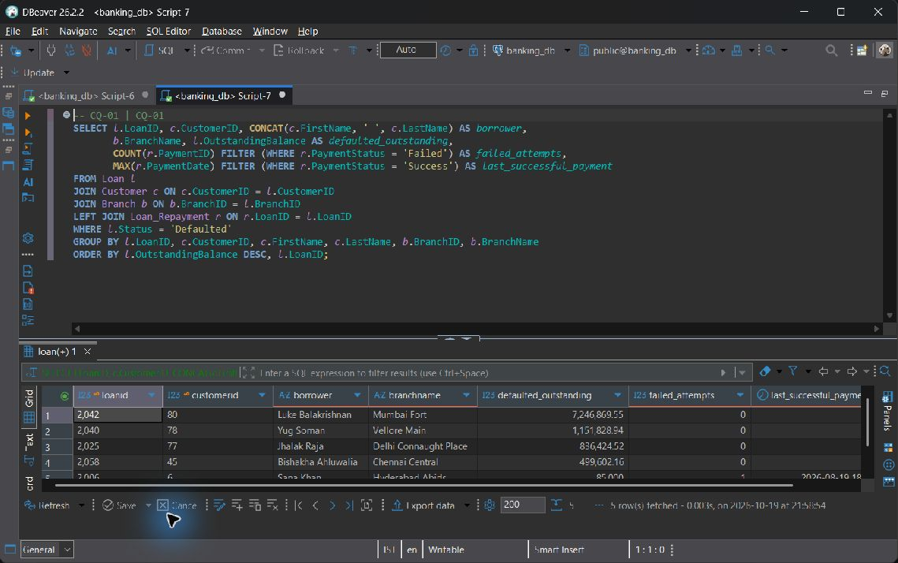  CQ-01
Explanation | Join Loan to Customer and the issuing Branch, then LEFT JOIN repayments and group them by loan. Select OutstandingBalance once for each loan; adding it across repayment rows would repeat the same debt. The schema uses 'Defaulted' as its NPA proxy. It has no repayment due-date schedule from which to calculate delinquency days.

CQ-02
ID | CQ-02
Business question | Which branches have the highest observed transaction activity during the last 365 days, and where are those branches located?
SQL | WITH activity AS (  SELECT b.BranchID, b.BranchName, p.City,  COUNT(t.TransactionID) AS transaction_count,  COALESCE(SUM(t.Amount), 0) AS gross_volume  FROM Branch b  JOIN Postal_Directory p ON p.Pincode = b.Pincode  LEFT JOIN Account a ON a.BranchID = b.BranchID  LEFT JOIN Transaction_History t ON t.AccountNo = a.AccountNo  AND t.TransactionDate >= CURRENT_TIMESTAMP - INTERVAL '365 days'  AND t.TransactionDate <= CURRENT_TIMESTAMP  GROUP BY b.BranchID, b.BranchName, p.City  ), ranked AS (  SELECT activity.*, DENSE_RANK() OVER (ORDER BY transaction_count DESC) AS activity_rank  FROM activity  )  SELECT * FROM ranked WHERE activity_rank <= 3  ORDER BY activity_rank, gross_volume DESC, BranchID;
Expected output | One activity total per branch is ranked by recorded events in the last 365 days. Up to the top three distinct ranks are returned, with ties retained and zero-activity branches preserved before ranking.
Actual output screenshot | Execution output: 3 row(s).  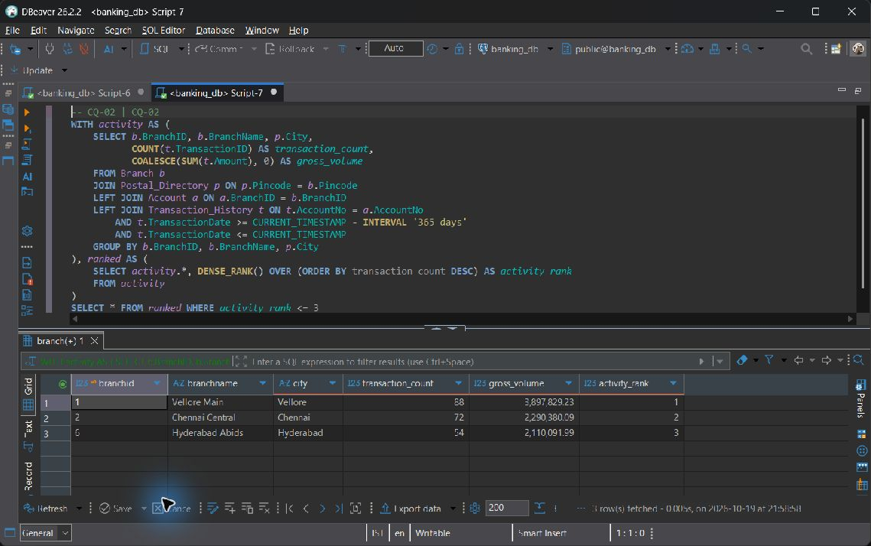  CQ-02
Explanation | Branch joins Postal_Directory to obtain the location. LEFT JOINs through Account and Transaction_History keep branches with no activity in the result. The time condition stays in ON to preserve those branches. Rank the event totals and display the top three ranks, including ties. Each event contributes once to the volume count.

CQ-03
ID | CQ-03
Business question | Which approved customers with Active fixed deposits and Active accounts have never borrowed, making them potential loan prospects?
SQL | WITH deposits AS (  SELECT CustomerID, COUNT(*) AS active_fd_count, SUM(Amount) AS fd_principal  FROM Fixed_Deposit WHERE Status = 'Active' GROUP BY CustomerID  ), accounts AS (  SELECT CustomerID, SUM(Balance) AS active_account_balance  FROM Account WHERE Status = 'Active' GROUP BY CustomerID  )  SELECT c.CustomerID, CONCAT(c.FirstName, ' ', c.LastName) AS customer_name,  c.Phone, d.active_fd_count, d.fd_principal, a.active_account_balance  FROM Customer c  JOIN deposits d ON d.CustomerID = c.CustomerID  JOIN accounts a ON a.CustomerID = c.CustomerID  WHERE c.KYC_Status = 'Approved'  AND NOT EXISTS (SELECT 1 FROM Loan l WHERE l.CustomerID = c.CustomerID)  ORDER BY d.fd_principal DESC, c.CustomerID;
Expected output | An Approved customer qualifies only when both an Active FD and an Active account exist and no Loan of any status exists. Separate product aggregates prevent an FD amount from being multiplied by account count.
Actual output screenshot | Execution output: 15 row(s).  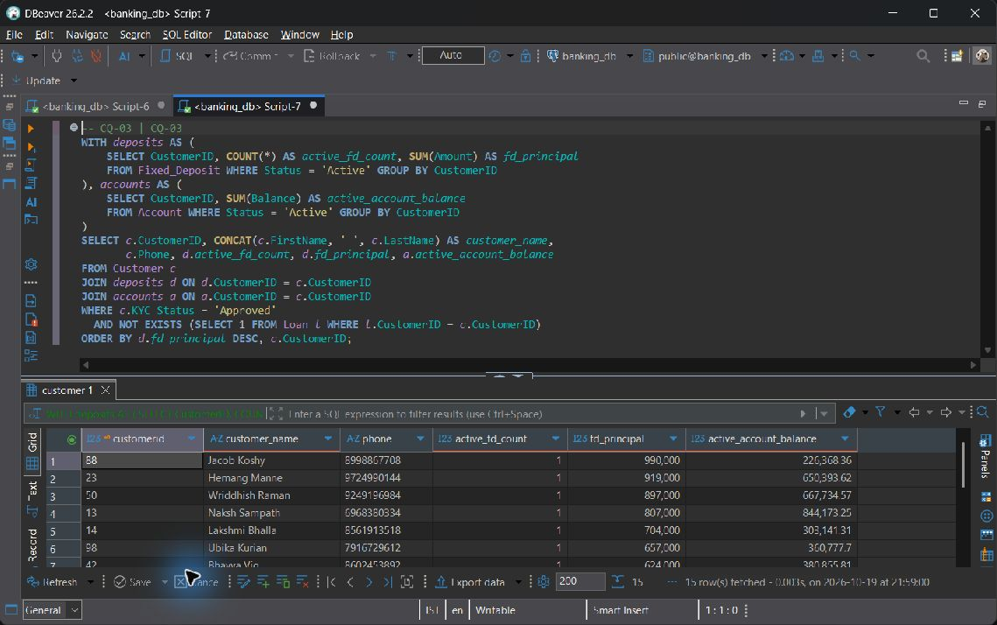  CQ-03
Explanation | Aggregate Fixed_Deposit and Account holdings separately before joining them to Customer. A correlated NOT EXISTS check excludes customers with a Loan. Each FD is therefore counted once, even when its owner has several accounts. Sprint 1 contains no qualifying customers, so an empty result is expected until one is onboarded.

CQ-04
ID | CQ-04
Business question | Which calendar days have the highest bank-wide gross transaction volume, and how many branches contributed on each day?
SQL | WITH daily AS (  SELECT t.TransactionDate::date AS transaction_day,  COUNT(*) AS event_count, COUNT(DISTINCT b.BranchID) AS contributing_branches,  SUM(t.Amount) AS gross_volume  FROM Transaction_History t  JOIN Account a ON a.AccountNo = t.AccountNo  JOIN Branch b ON b.BranchID = a.BranchID  WHERE t.TransactionDate IS NOT NULL  GROUP BY t.TransactionDate::date  ), ranked AS (  SELECT daily.*, DENSE_RANK() OVER (ORDER BY gross_volume DESC) AS volume_rank  FROM daily  )  SELECT * FROM ranked WHERE volume_rank <= 3  ORDER BY volume_rank, transaction_day;
Expected output | One row per non-NULL stored transaction date is ranked by gross event amount. Only the three highest distinct volume ranks remain. Two history events for one internal transfer contribute twice to gross volume, not net funds moved.
Actual output screenshot | Execution output: 3 row(s).  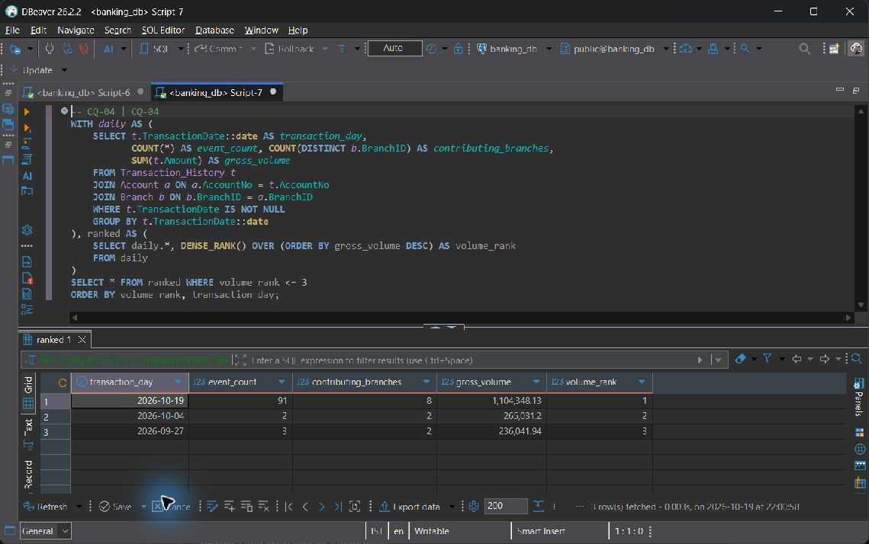  CQ-04
Explanation | Join Transaction_History to Account and Branch, then group the events by their stored timestamp date. Apply DENSE_RANK to the daily SUM(Amount) and display the top three volume ranks, retaining ties. Dates use the stored local timestamp convention. A NULL timestamp cannot be assigned to a calendar day.

CQ-05
ID | CQ-05
Business question | What is each customer's indicative net position across account balances, Active FDs, and outstanding issued loans?
SQL | WITH balances AS (  SELECT CustomerID, SUM(Balance) AS account_balance  FROM Account WHERE Status IN ('Active', 'Dormant', 'Frozen') GROUP BY CustomerID  ), deposits AS (  SELECT CustomerID, SUM(Amount) AS fd_principal  FROM Fixed_Deposit WHERE Status = 'Active' GROUP BY CustomerID  ), debt AS (  SELECT CustomerID, SUM(OutstandingBalance) AS loan_outstanding  FROM Loan WHERE Status IN ('Approved', 'Active', 'Defaulted') GROUP BY CustomerID  )  SELECT c.CustomerID, CONCAT(c.FirstName, ' ', c.LastName) AS customer_name,  COALESCE(a.account_balance, 0) AS account_balance,  COALESCE(f.fd_principal, 0) AS active_fd_principal,  COALESCE(l.loan_outstanding, 0) AS loan_outstanding,  COALESCE(a.account_balance, 0) + COALESCE(f.fd_principal, 0)  - COALESCE(l.loan_outstanding, 0) AS indicative_net_position  FROM Customer c  LEFT JOIN balances a ON a.CustomerID = c.CustomerID  LEFT JOIN deposits f ON f.CustomerID = c.CustomerID  LEFT JOIN debt l ON l.CustomerID = c.CustomerID  ORDER BY indicative_net_position DESC, c.CustomerID;
Expected output | Every customer remains visible. Missing product totals become zero; indicative net position equals non-Closed account balances plus Active FD principal minus issued loan outstanding. Pending and Closed loans are excluded here.
Actual output screenshot | Execution output: 110 row(s).  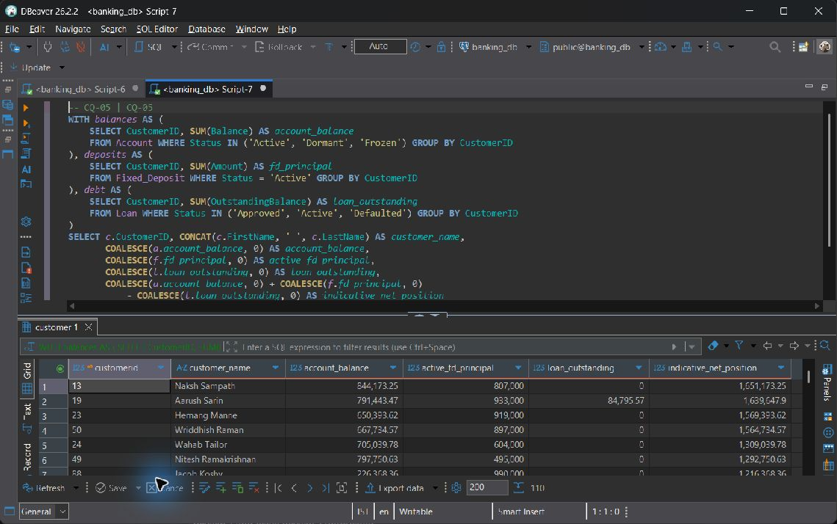  CQ-05
Explanation | Calculate the Account, Fixed_Deposit and Loan totals independently for each customer, then LEFT JOIN them to Customer. This avoids product fan-out and includes customers who hold no products. The measure uses FD principal, excluding future maturity interest, and omits Closed accounts and Pending/Closed loans. It indicates product exposure and does not include accrued loan interest in a valuation.

CQ-06
ID | CQ-06
Business question | Which Active FDs are due for maturity, and which account branch could contact the owner about reinvestment?
SQL | WITH contact_accounts AS (  SELECT a.CustomerID, a.AccountNo, b.BranchName,  ROW_NUMBER() OVER (PARTITION BY a.CustomerID  ORDER BY a.OpeningDate, a.AccountNo) AS preference  FROM Account a  JOIN Branch b ON b.BranchID = a.BranchID  WHERE a.Status = 'Active'  )  SELECT f.FD_ID, c.CustomerID, CONCAT(c.FirstName, ' ', c.LastName) AS customer_name,  c.Phone, f.EndDate, CURRENT_DATE - f.EndDate AS days_since_maturity,  f.MaturityAmount, a.AccountNo AS suggested_contact_account,  a.BranchName AS suggested_contact_branch  FROM Fixed_Deposit f  JOIN Customer c ON c.CustomerID = f.CustomerID  LEFT JOIN contact_accounts a ON a.CustomerID = c.CustomerID AND a.preference = 1  WHERE f.Status = 'Active' AND f.EndDate <= CURRENT_DATE  ORDER BY f.EndDate, f.FD_ID;
Expected output | Only Active FDs whose EndDate is today or earlier appear. The oldest Active account supplies a suggested contact branch; a customer without an Active account still has a due FD row with NULL contact fields.
Actual output screenshot | Execution output: 0 row(s).  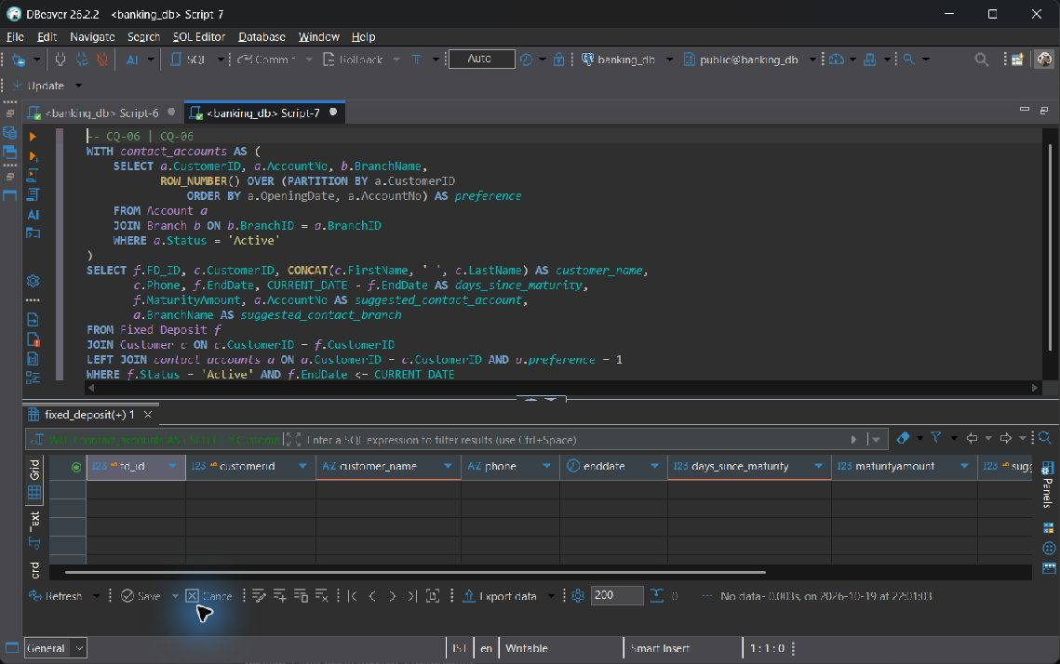  CQ-06
Explanation | Link Fixed_Deposit and Customer to Account and Branch through a ranked account CTE. The owner's oldest Active account supplies a suggested contact branch, avoiding duplicate FD rows for customers with several accounts. LEFT JOIN also retains due FDs whose owners have no Active account. Since FD has no BranchID, the contact branch does not establish where the deposit was issued.

CQ-07
ID | CQ-07
Business question | How do branch staffing costs compare with their deposit balances, and how many customers does each staff member support?
SQL | WITH staffing AS (  SELECT BranchID, COUNT(*) AS staff_count, SUM(Salary) AS monthly_payroll  FROM Employee GROUP BY BranchID  ), holdings AS (  SELECT BranchID, COUNT(DISTINCT CustomerID) AS customer_count,  SUM(Balance) AS deposit_balance  FROM Account WHERE Status IN ('Active', 'Dormant', 'Frozen') GROUP BY BranchID  )  SELECT b.BranchID, b.BranchName, p.City,  COALESCE(s.staff_count, 0) AS staff_count,  COALESCE(s.monthly_payroll, 0) AS monthly_payroll,  COALESCE(h.deposit_balance, 0) AS deposit_balance,  ROUND(COALESCE(h.customer_count, 0)::numeric / NULLIF(s.staff_count, 0), 2)  AS customers_per_employee,  ROUND(COALESCE(h.deposit_balance, 0) / NULLIF(s.monthly_payroll, 0), 2)  AS balance_to_monthly_payroll_ratio  FROM Branch b  JOIN Postal_Directory p ON p.Pincode = b.Pincode  LEFT JOIN staffing s ON s.BranchID = b.BranchID  LEFT JOIN holdings h ON h.BranchID = b.BranchID  ORDER BY customers_per_employee DESC NULLS LAST, b.BranchID;
Expected output | All branches are shown once with independently aggregated payroll and deposits. Customers are distinct within the branch. Ratios become NULL where staff count or payroll is zero.
Actual output screenshot | Execution output: 8 row(s).  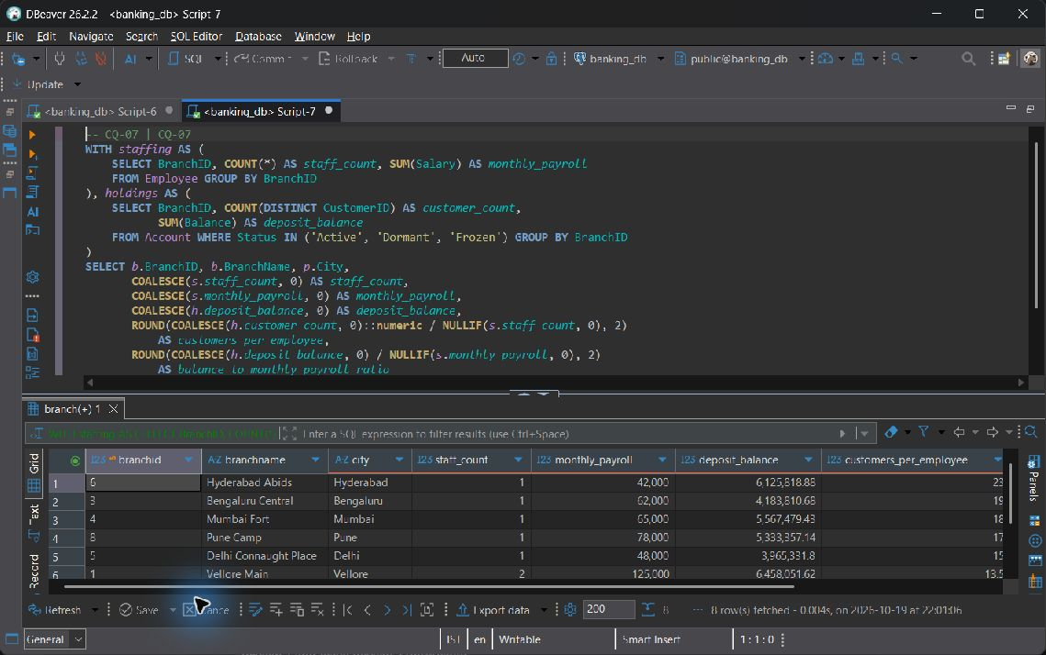  CQ-07
Explanation | Calculate Employee and Account totals independently, then join them to Branch and Postal_Directory. Count each customer once within a branch and avoid multiplying salaries by account rows. NULLIF protects the ratios where staff count or payroll is zero. The result is a workload proxy, not a profitability calculation.

CQ-08
ID | CQ-08
Business question | Which customers registered the largest potential daily beneficiary limits, and how are those limits distributed by destination bank?
SQL | WITH exposure AS (  SELECT c.CustomerID, CONCAT(c.FirstName, ' ', c.LastName) AS customer_name,  d.BankName, COUNT(*) AS beneficiary_count,  SUM(b.MaxTransferLimit) AS configured_limit_sum  FROM Customer c  JOIN Beneficiary b ON b.CustomerID = c.CustomerID  JOIN Bank_Directory d ON d.IFSC_Code = b.IFSC_Code  GROUP BY c.CustomerID, c.FirstName, c.LastName, d.BankName  )  SELECT exposure.*,  DENSE_RANK() OVER (PARTITION BY BankName ORDER BY configured_limit_sum DESC)  AS limit_rank_within_bank  FROM exposure  ORDER BY BankName, limit_rank_within_bank, CustomerID;
Expected output | There is one customer and destination-bank group, ranked within that bank by the sum of configured per-beneficiary caps. This is configured exposure, not executed transfer value or a customer-wide enforcement rule.
Actual output screenshot | Execution output: 10 row(s).  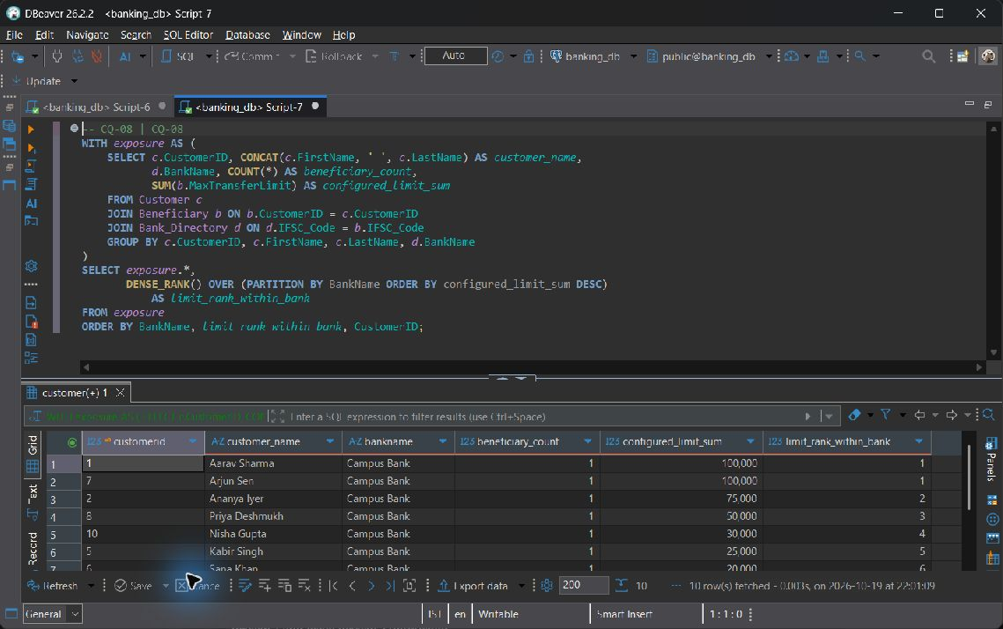  CQ-08
Explanation | Join Customer to Beneficiary and Bank_Directory. Total the configured beneficiary limits for each customer and destination bank, then rank customers within that bank. The schema does not link executed transfers to beneficiaries or enforce these sums as customer-wide limits. The figures represent configured per-beneficiary exposure.

CQ-09
ID | CQ-09
Business question | How much has each loan collected successfully, and which borrowers have failed or pending repayment attempts requiring follow-up?
SQL | SELECT l.LoanID, CONCAT(c.FirstName, ' ', c.LastName) AS borrower,  b.BranchName, l.Status AS loan_status, l.OutstandingBalance,  COALESCE(SUM(r.AmountPaid) FILTER (WHERE r.PaymentStatus = 'Success'), 0)  AS successful_collections,  COUNT(r.PaymentID) FILTER (WHERE r.PaymentStatus = 'Pending') AS pending_attempts,  COUNT(r.PaymentID) FILTER (WHERE r.PaymentStatus = 'Failed') AS failed_attempts,  MAX(r.PaymentDate) FILTER (WHERE r.PaymentStatus = 'Success') AS latest_collection  FROM Loan l  JOIN Customer c ON c.CustomerID = l.CustomerID  JOIN Branch b ON b.BranchID = l.BranchID  LEFT JOIN Loan_Repayment r ON r.LoanID = l.LoanID  GROUP BY l.LoanID, c.CustomerID, c.FirstName, c.LastName, b.BranchID, b.BranchName  ORDER BY failed_attempts DESC, pending_attempts DESC, l.LoanID;
Expected output | Each loan is preserved even with no repayments. Only Success amounts enter collections; Pending and Failed counts remain separate. Principal and outstanding balances are never summed across installment rows.
Actual output screenshot | Execution output: 58 row(s).  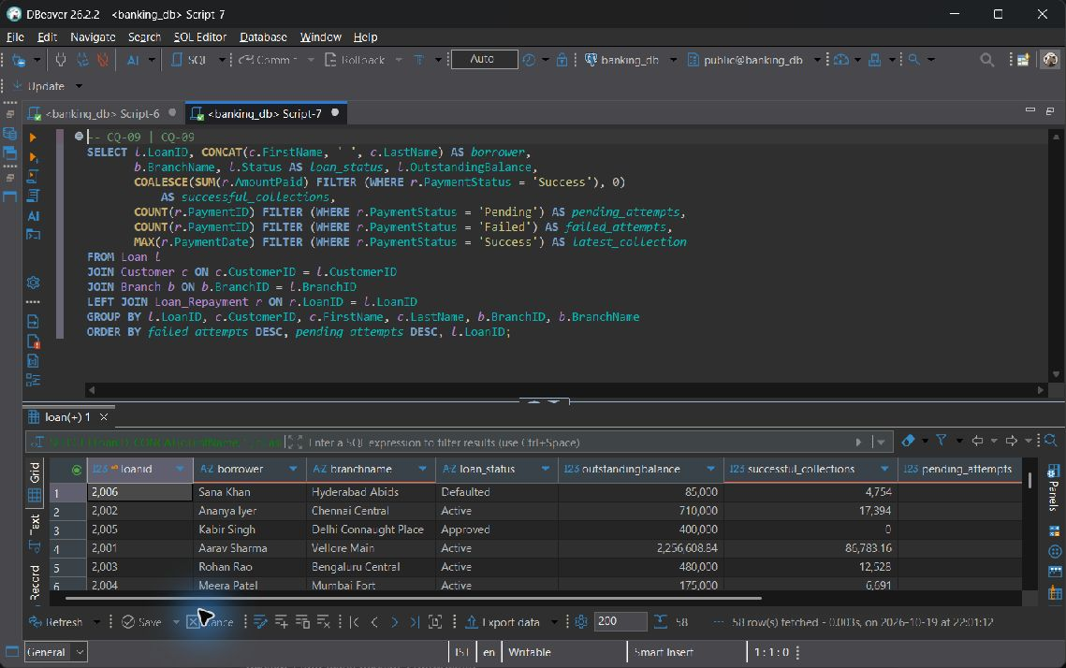  CQ-09
Explanation | Join Loan to Customer and Branch, then LEFT JOIN Loan_Repayment. FILTER separates successful collections from pending and failed attempts. Select loan principal and outstanding debt without summing them across repayment rows. The seed repayments are illustrative and do not reconcile the principal balance.

CQ-10
ID | CQ-10
Business question | Which accounts need a KYC or account-status review, what activity has been recorded, and what is their most recent account audit entry?
SQL | WITH activity AS (  SELECT AccountNo, COUNT(*) AS historical_events, MAX(TransactionDate) AS last_event  FROM Transaction_History GROUP BY AccountNo  )  SELECT c.CustomerID, CONCAT(c.FirstName, ' ', c.LastName) AS customer_name,  c.KYC_Status, a.AccountNo, a.Status AS account_status, a.Balance,  b.BranchName, COALESCE(t.historical_events, 0) AS historical_events,  t.last_event, audit.ActionType AS latest_audit_action,  audit.Description AS latest_audit_description, audit.LogDate AS latest_audit_date  FROM Customer c  JOIN Account a ON a.CustomerID = c.CustomerID  JOIN Branch b ON b.BranchID = a.BranchID  LEFT JOIN activity t ON t.AccountNo = a.AccountNo  LEFT JOIN LATERAL (  SELECT al.ActionType, al.Description, al.LogDate  FROM Audit_Log al  WHERE LOWER(al.TableName) = 'account' AND al.RecordID = a.AccountNo  ORDER BY al.LogDate DESC NULLS LAST, al.LogID DESC  LIMIT 1  ) audit ON TRUE  WHERE c.KYC_Status IS DISTINCT FROM 'Approved'  OR a.Status IN ('Dormant', 'Frozen')  ORDER BY b.BranchID, c.CustomerID, a.AccountNo;
Expected output | Accounts with unapproved or NULL KYC, Dormant status, or Frozen status appear with historical event totals. At most one latest Account audit is attached through both TableName and RecordID. Historical activity alone does not prove a post-freeze breach.
Actual output screenshot | Execution output: 42 row(s).  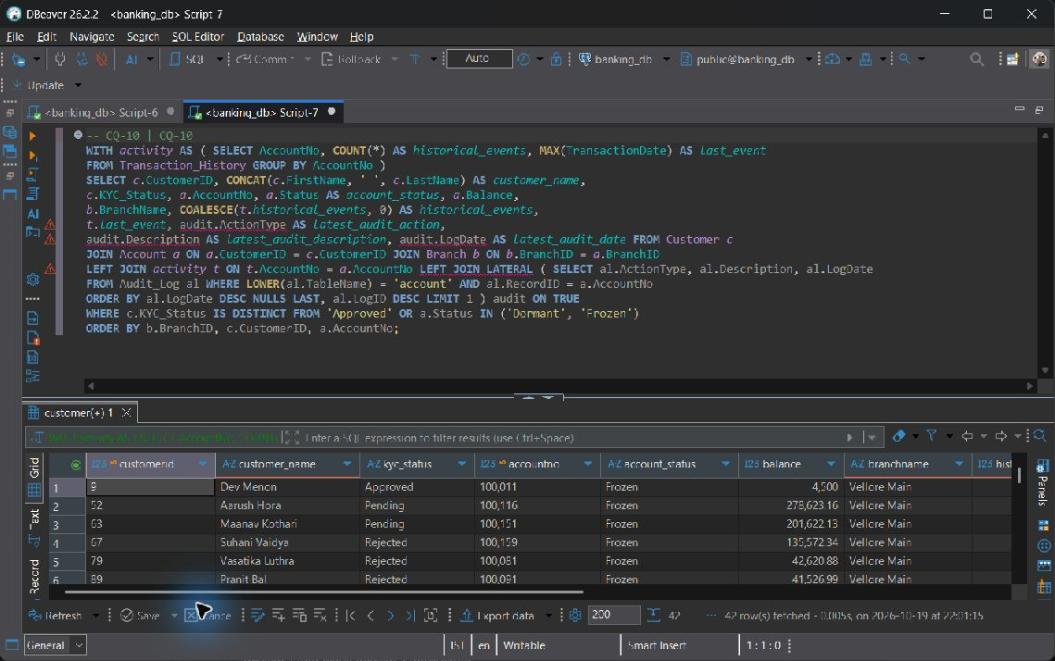  CQ-10
Explanation | Join Customer, Account and Branch, then LEFT JOIN history already aggregated per account. LEFT JOIN LATERAL selects at most one Audit_Log entry using both the Account table discriminator and matching RecordID, since audit targets are polymorphic. IS DISTINCT FROM also flags NULL KYC status. The activity provides historical context; without a status-change timestamp, it cannot prove a post-freeze violation. Sprint 1 audits are explicit SEED rows.

8.2 Database Views

vw_customer_passbook
Purpose | Readable passbook joining Customer, Account, Branch and Transaction_History. COALESCE replaces missing narrative only for display.
CREATE VIEW statement | CREATE OR REPLACE VIEW vw_customer_passbook AS  SELECT a.AccountNo, CONCAT(c.FirstName, ' ', c.LastName) AS Name,  b.BranchName, t.TransactionDate AS Date, t.TransactionType AS Type,  t.Amount, COALESCE(t.Remarks, 'No remarks provided') AS Remarks  FROM Customer c  JOIN Account a ON a.CustomerID = c.CustomerID  JOIN Branch b ON b.BranchID = a.BranchID  JOIN Transaction_History t ON t.AccountNo = a.AccountNo;
Query using the view | SELECT * FROM vw_customer_passbook ORDER BY AccountNo;
Screenshot / Live Output | 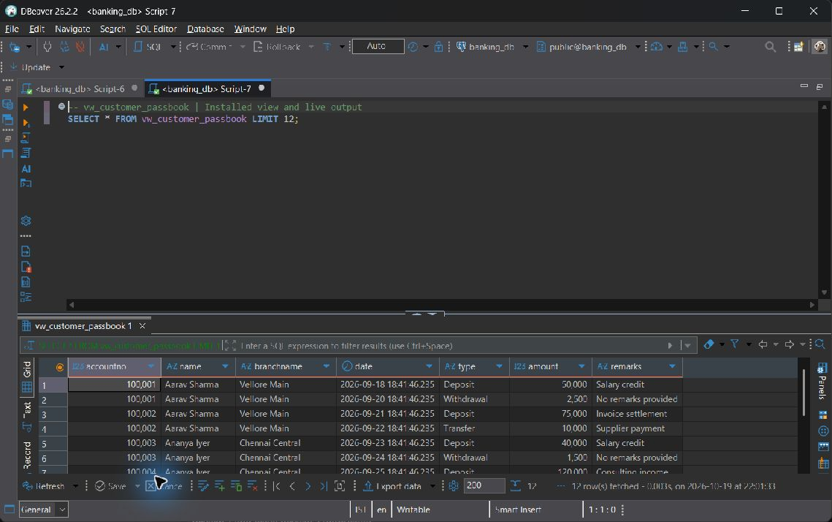  vw_customer_passbook
Why useful | This view is not automatically updatable. Its top-level FROM joins four relations, and some output columns contain expressions. PostgreSQL cannot unambiguously direct arbitrary writes through the view to one base table.

vw_branch_financial_summary
Purpose | One row per branch, independently aggregated Active account count, stored loan outstanding and Active FD maturity attribution.
CREATE VIEW statement | CREATE OR REPLACE VIEW vw_branch_financial_summary AS  WITH active_accounts AS (  SELECT BranchID, COUNT(*) AS total_active_accounts  FROM Account WHERE Status = 'Active' GROUP BY BranchID  ), loan_totals AS (  SELECT BranchID, SUM(OutstandingBalance) AS total_loan_outstanding  FROM Loan GROUP BY BranchID  ), primary_branch AS (  SELECT DISTINCT ON (CustomerID) CustomerID, BranchID  FROM Account  ORDER BY CustomerID, (Status = 'Active') DESC NULLS LAST,  (AccountType = 'Savings') DESC, OpeningDate, AccountNo  ), fd_totals AS (  SELECT p.BranchID, SUM(f.MaturityAmount) AS total_fd_maturity_amounts  FROM Fixed_Deposit f JOIN primary_branch p ON p.CustomerID = f.CustomerID  WHERE f.Status = 'Active'  GROUP BY p.BranchID  )  SELECT b.BranchID, b.BranchName,  COALESCE(a.total_active_accounts, 0) AS total_active_accounts,  COALESCE(l.total_loan_outstanding, 0) AS total_loan_outstanding,  COALESCE(f.total_fd_maturity_amounts, 0) AS total_fd_maturity_amounts  FROM Branch b  LEFT JOIN active_accounts a ON a.BranchID = b.BranchID  LEFT JOIN loan_totals l ON l.BranchID = b.BranchID  LEFT JOIN fd_totals f ON f.BranchID = b.BranchID;
Query using the view | SELECT * FROM vw_branch_financial_summary ORDER BY BranchID;
Screenshot / Live Output | Execution output: 8 row(s).  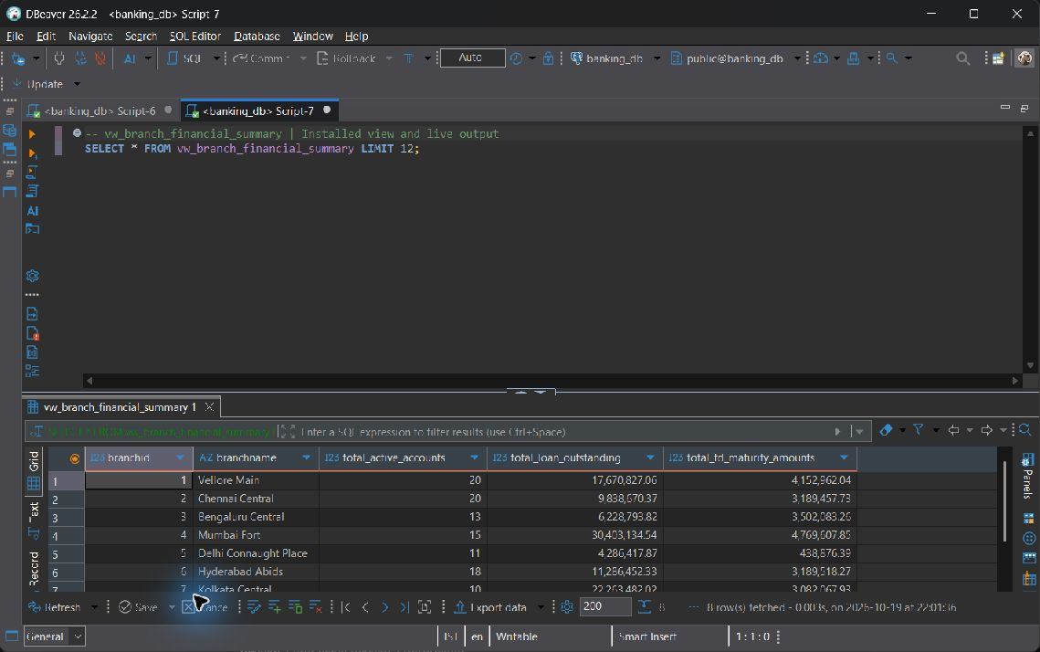  vw_branch_financial_summary
Why useful | This view is not automatically updatable. GROUP BY aggregates, CTEs and several joined sources calculate a branch summary rather than expose one directly writable relation.

vw_active_vellore_accounts
Purpose | Restrict visible Account rows to Active accounts serviced by a branch whose postal city is Vellore. security_barrier and CASCADED CHECK OPTION protect the predicate boundary.
CREATE VIEW statement | CREATE OR REPLACE VIEW vw_active_vellore_accounts  WITH (security_barrier = true) AS  SELECT a.AccountNo, a.CustomerID, a.BranchID, a.AccountType, a.Balance,  a.InterestRate, a.OpeningDate, a.Status  FROM Account a  WHERE a.Status = 'Active'  AND EXISTS (  SELECT 1 FROM Branch b  JOIN Postal_Directory p ON p.Pincode = b.Pincode  WHERE b.BranchID = a.BranchID AND p.City = 'Vellore'  )  WITH CASCADED CHECK OPTION;
Query using the view | SELECT * FROM vw_active_vellore_accounts ORDER BY AccountNo;
Screenshot / Live Output | Execution output: 20 row(s).  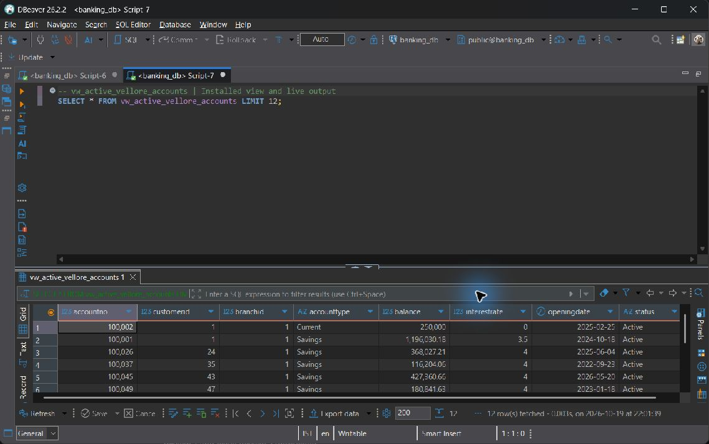  vw_active_vellore_accounts
Why useful | This view is automatically updatable because its top-level FROM contains only Account and its output columns directly reference that table. Branch and Postal_Directory are checked through an EXISTS semi-join. CASCADED CHECK OPTION rejects writes that would leave the view's permitted rows. The catalogue reports is_updatable=YES, but the view alone does not provide a complete access-control policy.

8.3 Stored Procedures

sp_transfer_funds
Purpose: Validate two different Active accounts, a finite positive paise-accurate amount, an allowed payment mode and sufficient funds. Lock accounts in ascending AccountNo order, debit and credit once, write two history events, and explicitly COMMIT.
CREATE OR REPLACE PROCEDURE sp_transfer_funds(
p_sender INT, p_receiver INT, p_amount DECIMAL,
p_mode VARCHAR, p_remarks VARCHAR
) LANGUAGE plpgsql AS $$
DECLARE
v_sender Account%ROWTYPE;
v_receiver Account%ROWTYPE;
BEGIN
IF p_sender IS NULL OR p_receiver IS NULL OR p_sender = p_receiver THEN
RAISE EXCEPTION 'Transfer requires two different account numbers'
USING ERRCODE = '22023';
END IF;
IF p_amount IS NULL OR p_amount <= 0 OR p_amount <> ROUND(p_amount, 2)
OR p_amount::text IN ('NaN', 'Infinity', '-Infinity') THEN
RAISE EXCEPTION 'Transfer amount must be finite, positive, and at most two decimal places'
USING ERRCODE = '22023';
END IF;
IF p_mode IS NULL OR p_mode NOT IN ('UPI', 'NEFT', 'RTGS', 'IMPS', 'Cash', 'Internal') THEN
RAISE EXCEPTION 'Invalid payment mode: %', p_mode USING ERRCODE = '22023';
END IF;
PERFORM AccountNo FROM Account WHERE AccountNo IN (p_sender, p_receiver)
ORDER BY AccountNo FOR UPDATE;
SELECT * INTO v_sender FROM Account WHERE AccountNo = p_sender;
IF NOT FOUND THEN
RAISE EXCEPTION 'Sender account % does not exist', p_sender USING ERRCODE = '22023';
END IF;
SELECT * INTO v_receiver FROM Account WHERE AccountNo = p_receiver;
IF NOT FOUND THEN
RAISE EXCEPTION 'Receiver account % does not exist', p_receiver USING ERRCODE = '22023';
END IF;
IF v_sender.Status IS DISTINCT FROM 'Active'
OR v_receiver.Status IS DISTINCT FROM 'Active' THEN
RAISE EXCEPTION 'Both transfer accounts must be Active' USING ERRCODE = '22023';
END IF;
IF v_sender.Balance < p_amount THEN
RAISE EXCEPTION 'Insufficient balance in sender account %', p_sender
USING ERRCODE = '22023';
END IF;
UPDATE Account SET Balance = Balance - p_amount WHERE AccountNo = p_sender;
UPDATE Account SET Balance = Balance + p_amount WHERE AccountNo = p_receiver;
INSERT INTO Transaction_History (AccountNo, Amount, TransactionType, PaymentMode, Remarks)
VALUES
(p_sender, p_amount, 'Transfer', p_mode,
LEFT(FORMAT('Debit to %s: %s', p_receiver, COALESCE(p_remarks, 'Fund transfer')), 255)),
(p_receiver, p_amount, 'Transfer', p_mode,
LEFT(FORMAT('Credit from %s: %s', p_sender, COALESCE(p_remarks, 'Fund transfer')), 255));
COMMIT;
END;
$$;

Rejected transfer and rollback
CALL public.sp_transfer_funds(100001,100003,1196031.18,'Internal','Report rejection proof');
Insufficient funds cause a validation exception before COMMIT. The rejected operation leaves both balances and related records unchanged.
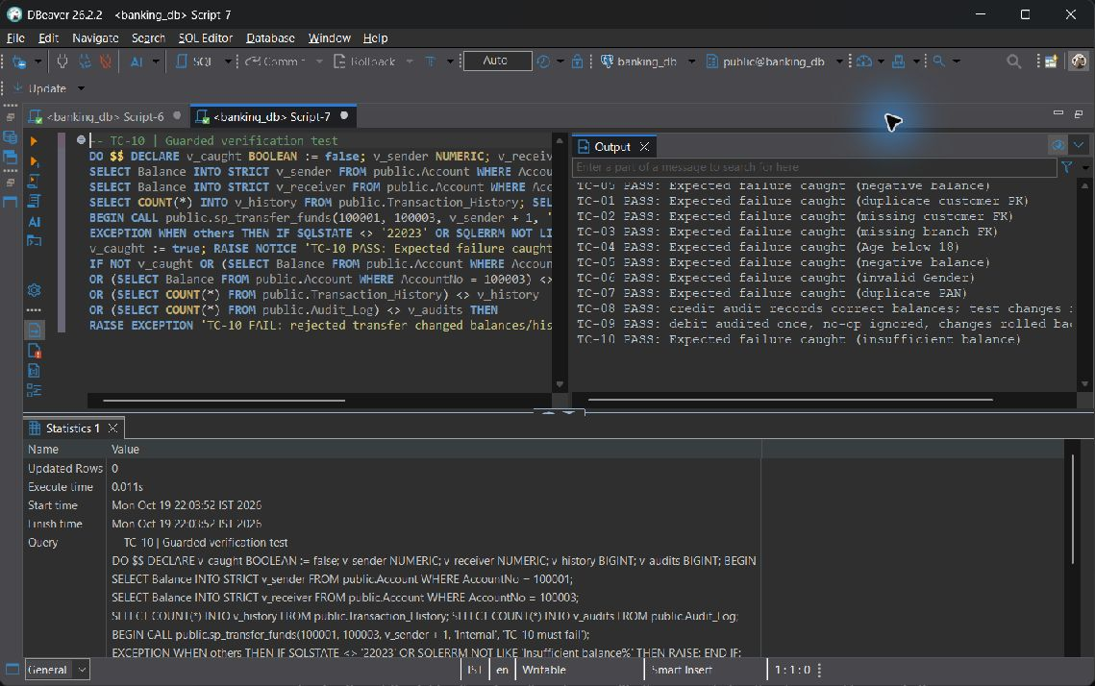
Insufficient funds validation
Successful committed transfer
The successful transfer demonstration uses banking_report_demo, an isolated copy of banking_db with the installed procedures and triggers. Account balances were recorded immediately before and after CALL. The screenshots show the committed debit and credit, the corresponding history entries and the automatic audits.
CALL public.sp_transfer_funds(100001,100003,1000,'UPI','Report transfer demonstration');
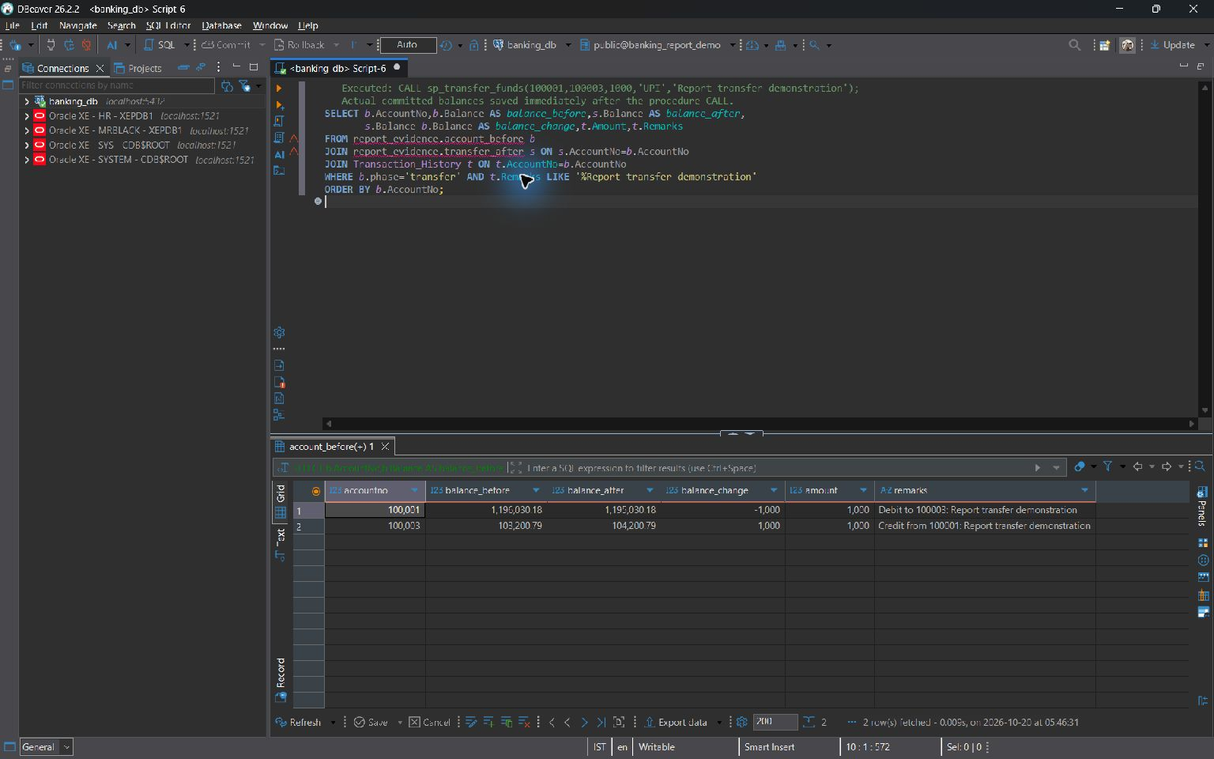
Successful transfer and committed account balances
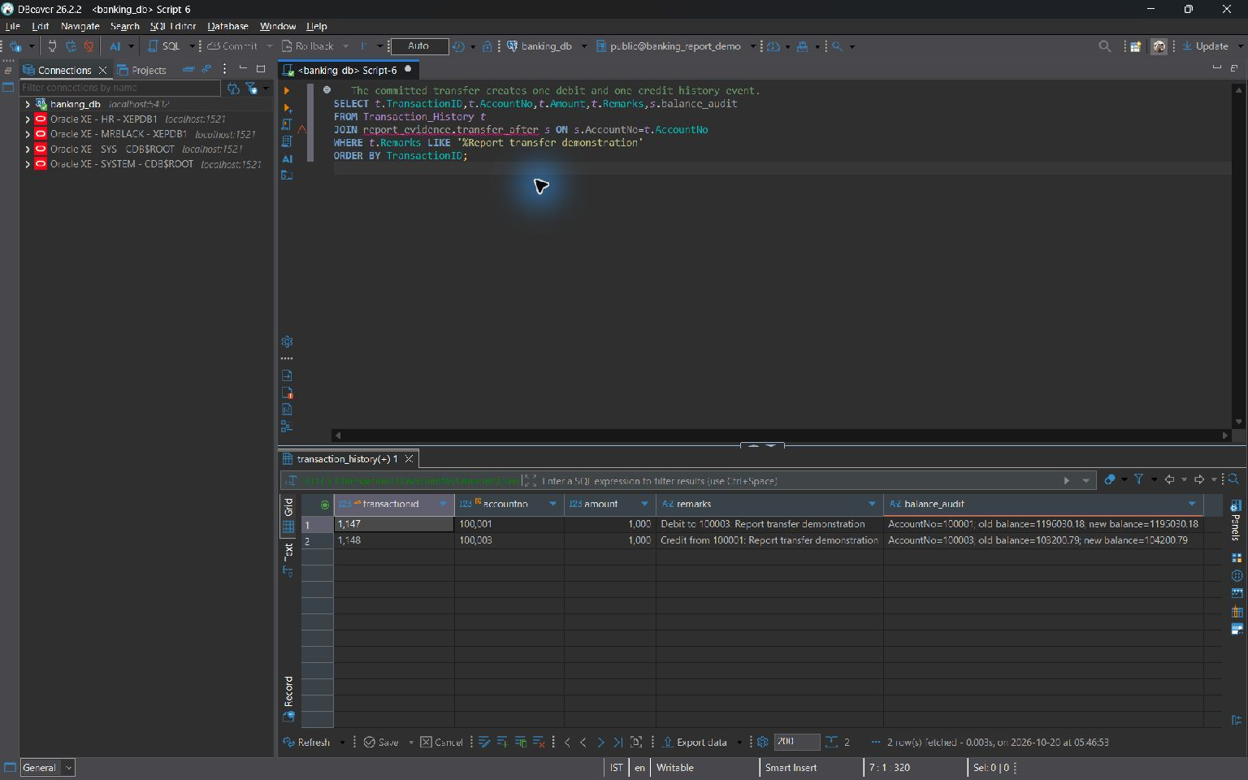
Transfer history and automatic balance audits
Integrity and transaction benefit: One atomic transaction includes both account updates, two history entries and the audit trigger inserts. Call the procedure through a top-level autocommit CALL because it explicitly issues COMMIT. Validation errors occur before that commit. Locking both rows in a deterministic order reduces deadlocks between transfers in opposite directions.

sp_pay_loan_emi
Purpose: Lock the owned Active account and the repayable owned loan, deduct LEAST(EMI_Amount, OutstandingBalance), log a withdrawal and insert a successful repayment. The repayment trigger changes debt and closes the final installment.
CREATE OR REPLACE PROCEDURE sp_pay_loan_emi(
p_customer_id INT, p_loan_id INT, p_account_no INT
) LANGUAGE plpgsql AS $$
DECLARE
v_account Account%ROWTYPE;
v_loan Loan%ROWTYPE;
v_payment NUMERIC(15, 2);
BEGIN
SELECT * INTO v_account FROM Account WHERE AccountNo = p_account_no FOR UPDATE;
IF NOT FOUND OR v_account.CustomerID IS DISTINCT FROM p_customer_id
OR v_account.Status IS DISTINCT FROM 'Active' THEN
RAISE EXCEPTION 'Active account % must belong to customer %', p_account_no, p_customer_id
USING ERRCODE = '22023';
END IF;
SELECT * INTO v_loan FROM Loan WHERE LoanID = p_loan_id FOR UPDATE;
IF NOT FOUND OR v_loan.CustomerID IS DISTINCT FROM p_customer_id
OR v_loan.Status IS NULL OR v_loan.Status NOT IN ('Approved', 'Active', 'Defaulted')
OR v_loan.OutstandingBalance <= 0 THEN
RAISE EXCEPTION 'Loan % is not repayable by customer %', p_loan_id, p_customer_id
USING ERRCODE = '22023';
END IF;
v_payment := LEAST(v_loan.EMI_Amount, v_loan.OutstandingBalance);
IF v_payment IS NULL OR v_payment <= 0 OR v_account.Balance < v_payment THEN
RAISE EXCEPTION 'Insufficient balance or invalid EMI for account %', p_account_no
USING ERRCODE = '22023';
END IF;
UPDATE Account SET Balance = Balance - v_payment WHERE AccountNo = p_account_no;
INSERT INTO Transaction_History (AccountNo, Amount, TransactionType, PaymentMode, Remarks)
VALUES (p_account_no, v_payment, 'Withdrawal', 'Internal', FORMAT('Loan EMI: %s', p_loan_id));
INSERT INTO Loan_Repayment (LoanID, AmountPaid, PaymentMode, PaymentStatus)
VALUES (p_loan_id, v_payment, 'Auto-Debit', 'Success');
END;
$$;

Live banking_db verification
BEGIN;
CALL public.sp_pay_loan_emi(1,2001,100001);
SELECT LoanID,EMI_Amount,OutstandingBalance,Status FROM Loan WHERE LoanID=2001;
ROLLBACK;

Verification runs inside a transaction and is rolled back after inspection.
Execution output: 1 row(s).
Test execution
CALL sp_pay_loan_emi(1,2001,100001);

Execution context: Disposable verification database; exact 01, 02, 05 scripts. These outputs are isolated commit/trigger demonstrations; live read-only evidence elsewhere remains from banking_db.
Execution output: 1 row(s).
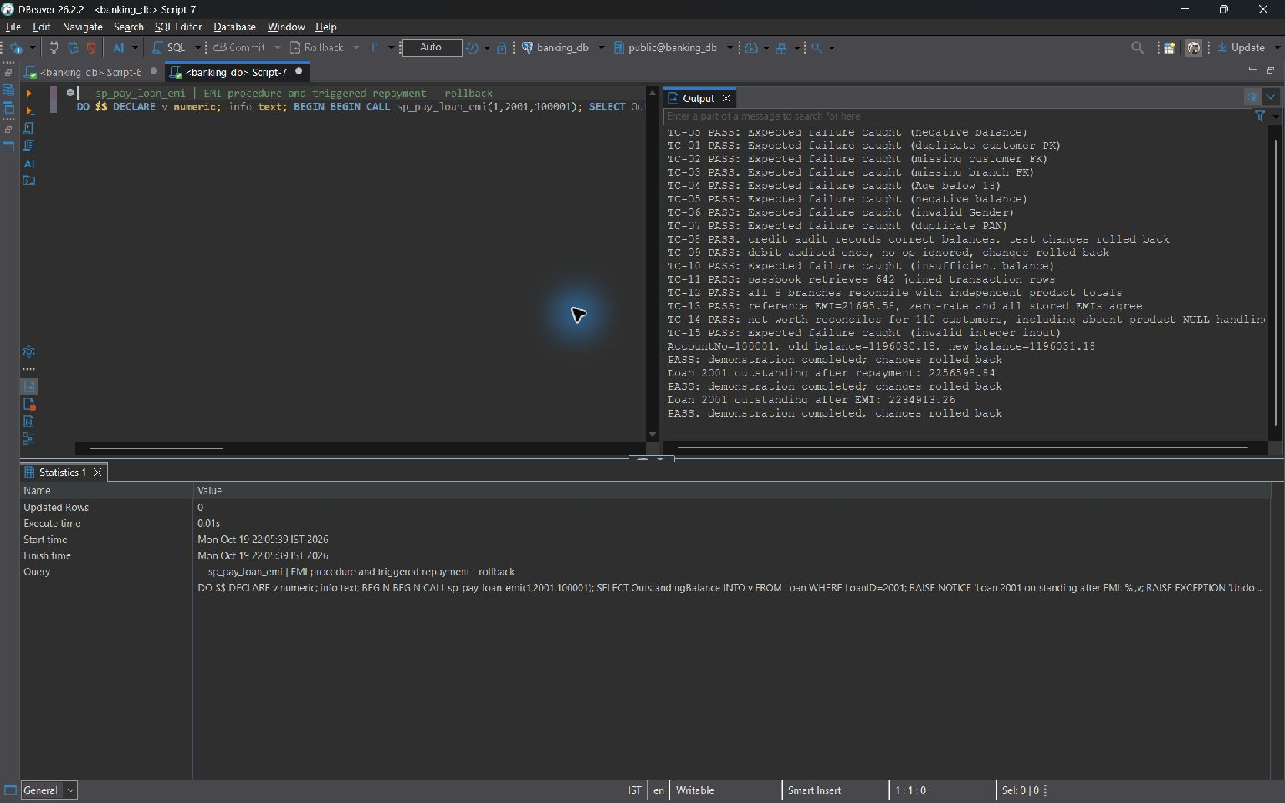
sp_pay_loan_emi
Integrity and transaction benefit: The account debit, withdrawal event, repayment row and triggered debt reduction take place in one transaction. The final payment cannot exceed the outstanding balance. This lab deducts the full installment from principal and has no table for allocating payments between interest and principal.

8.4 User Defined Functions

fn_calculate_emi
Purpose: Return the rounded monthly compound-interest installment using P*r*(1+r)^n / ((1+r)^n-1), r=annual percent/1200. Reject invalid finite inputs; extend the function to zero interest as P/n.
CREATE OR REPLACE FUNCTION fn_calculate_emi(
p_principal DECIMAL, p_rate DECIMAL, p_months INT
) RETURNS DECIMAL
LANGUAGE plpgsql IMMUTABLE AS $$
DECLARE
v_rate NUMERIC;
v_factor NUMERIC;
BEGIN
IF p_principal IS NULL OR p_principal <= 0
OR p_principal::text IN ('NaN', 'Infinity', '-Infinity')
OR p_rate IS NULL OR p_rate < 0
OR p_rate::text IN ('NaN', 'Infinity', '-Infinity')
OR p_months IS NULL OR p_months <= 0 THEN
RAISE EXCEPTION 'EMI requires finite positive principal/months and nonnegative rate'
USING ERRCODE = '22023';
END IF;
IF p_rate = 0 THEN
RETURN ROUND(p_principal / p_months, 2);
END IF;
v_rate := p_rate / 1200.0;
v_factor := POWER(1 + v_rate, p_months);
RETURN ROUND(p_principal * v_rate * v_factor / (v_factor - 1), 2);
END;
$$;

Test execution against banking_db
SELECT fn_calculate_emi(2500000,8.50,240), fn_calculate_emi(12000,0,12);

Execution output: 1 row(s).
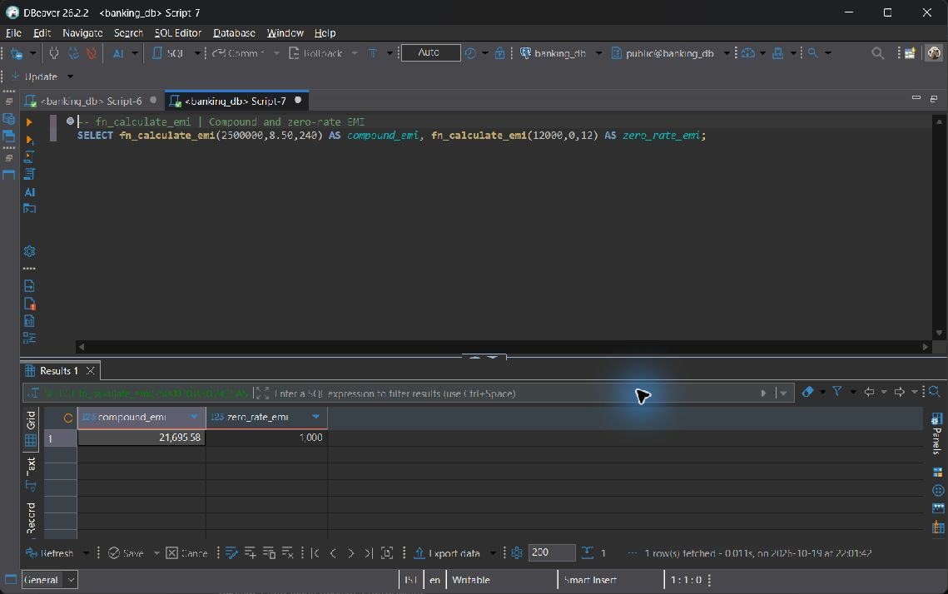
fn_calculate_emi
Integrity and transaction benefit: IMMUTABLE fits this function because its result depends only on the inputs. Loan requires positive interest, while the UDF also handles the mathematically valid zero-rate case. TC-13 compares the stored Loan.EMI_Amount with the function result.

fn_customer_net_worth
Purpose: Return account balances plus Active FD principal minus all stored loan outstanding for an existing customer. Independent aggregates and COALESCE prevent join fan-out and NULL arithmetic.
CREATE OR REPLACE FUNCTION fn_customer_net_worth(p_customer_id INT)
RETURNS DECIMAL LANGUAGE plpgsql STABLE AS $$
BEGIN
IF p_customer_id IS NULL OR NOT EXISTS (
SELECT 1 FROM Customer WHERE CustomerID = p_customer_id
) THEN
RAISE EXCEPTION 'Customer % does not exist', p_customer_id
USING ERRCODE = '22023';
END IF;
RETURN COALESCE((SELECT SUM(Balance) FROM Account
WHERE CustomerID = p_customer_id), 0)
+ COALESCE((SELECT SUM(Amount) FROM Fixed_Deposit
WHERE CustomerID = p_customer_id AND Status = 'Active'), 0)
- COALESCE((SELECT SUM(OutstandingBalance) FROM Loan
WHERE CustomerID = p_customer_id), 0);
END;
$$;

Test execution against banking_db
SELECT fn_customer_net_worth(1);

Execution output: 1 row(s).
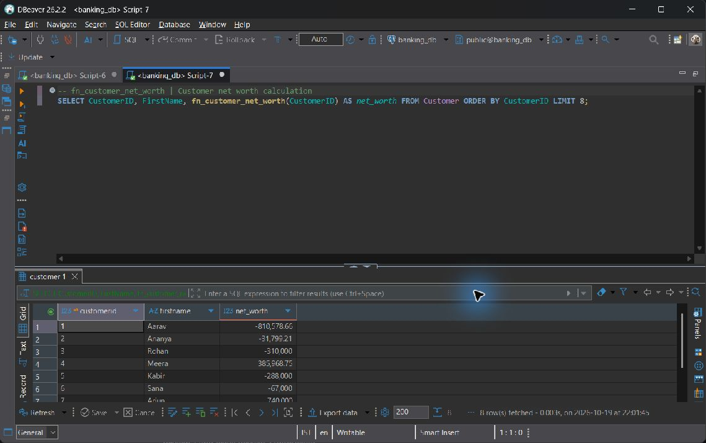
fn_customer_net_worth
Integrity and transaction benefit: STABLE provides a consistent statement snapshot, and missing product rows contribute zero. This function includes all stored loan statuses and every account balance. Its result therefore differs from the metric in CQ-05; the two measures are not treated as equivalent.

8.5 Triggers

trg_audit_account_changes
Purpose: AFTER UPDATE OF Balance on Account, write exactly one old/new balance audit when the values are distinct. A no-op update creates no audit; a rolled-back update also rolls back its audit.
CREATE OR REPLACE FUNCTION tg_audit_account_changes()
RETURNS TRIGGER LANGUAGE plpgsql AS $$
BEGIN
INSERT INTO Audit_Log (TableName, RecordID, ActionType, Description)
VALUES ('Account', NEW.AccountNo, 'BALANCE_UPDATE',
FORMAT('AccountNo=%s; old balance=%s; new balance=%s',
NEW.AccountNo, OLD.Balance, NEW.Balance));
RETURN NEW;
END;
$$;

CREATE OR REPLACE TRIGGER trg_audit_account_changes
AFTER UPDATE OF Balance ON Account
FOR EACH ROW WHEN (OLD.Balance IS DISTINCT FROM NEW.Balance)
EXECUTE FUNCTION tg_audit_account_changes();

Live banking_db verification
BEGIN;
UPDATE public.Account SET Balance=Balance+1 WHERE AccountNo=100001;
SELECT TableName,RecordID,ActionType,Description FROM Audit_Log ORDER BY LogID DESC LIMIT 1;
ROLLBACK;

Verification runs inside a transaction and is rolled back after inspection.
Execution output: 1 row(s).
Test execution
BEGIN;
UPDATE Account SET Balance=Balance+1 WHERE AccountNo=100001;
SELECT * FROM Audit_Log ORDER BY LogID DESC LIMIT 1;
ROLLBACK;

Execution context: Disposable verification database; rolled back after observation. These outputs are isolated commit/trigger demonstrations; live read-only evidence elsewhere remains from banking_db.
Execution output: 1 row(s).
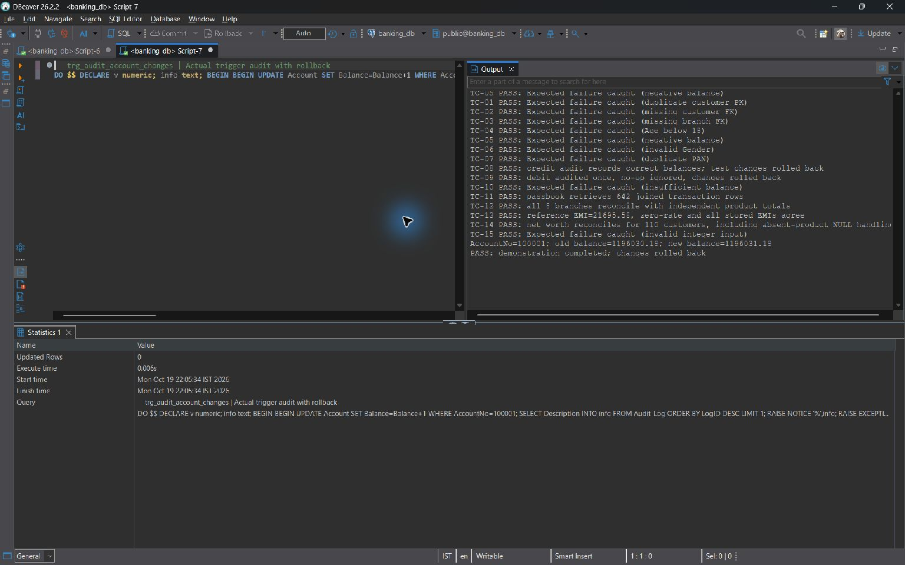
trg_audit_account_changes
Integrity and transaction benefit: The WHEN predicate prevents audit records for no-op balance updates. The audit entry and balance change share the same transaction. SQL script 06 makes the support function SECURITY DEFINER with a fixed search_path, allowing permitted manager updates to generate audit entries in the protected log.

trg_loan_repayment
Purpose: AFTER INSERT on Loan_Repayment, act only on Success. Lock the loan FOR NO KEY UPDATE, reject overpayment, reduce outstanding, and change Status to Closed when the balance reaches zero.
CREATE OR REPLACE FUNCTION tg_loan_repayment()
RETURNS TRIGGER LANGUAGE plpgsql AS $$
DECLARE
v_loan Loan%ROWTYPE;
v_remaining NUMERIC(15, 2);
BEGIN
IF NEW.PaymentStatus IS DISTINCT FROM 'Success' THEN
RETURN NEW;
END IF;
SELECT * INTO v_loan FROM Loan WHERE LoanID = NEW.LoanID FOR NO KEY UPDATE;
IF NOT FOUND OR v_loan.Status IS NULL
OR v_loan.Status NOT IN ('Approved', 'Active', 'Defaulted')
OR v_loan.OutstandingBalance <= 0 THEN
RAISE EXCEPTION 'Loan % is not repayable', NEW.LoanID USING ERRCODE = '22023';
END IF;
IF NEW.AmountPaid > v_loan.OutstandingBalance THEN
RAISE EXCEPTION 'Repayment exceeds outstanding balance for loan %', NEW.LoanID
USING ERRCODE = '22023';
END IF;
v_remaining := v_loan.OutstandingBalance - NEW.AmountPaid;
UPDATE Loan
SET OutstandingBalance = GREATEST(v_remaining, 0),
Status = CASE WHEN v_remaining <= 0 THEN 'Closed' ELSE Status END
WHERE LoanID = NEW.LoanID;
RETURN NEW;
END;
$$;

CREATE OR REPLACE TRIGGER trg_loan_repayment
AFTER INSERT ON Loan_Repayment
FOR EACH ROW EXECUTE FUNCTION tg_loan_repayment();

Live banking_db verification
BEGIN;
INSERT INTO public.Loan_Repayment(LoanID,AmountPaid,PaymentMode,PaymentStatus) VALUES(2001,10,'UPI','Success');
SELECT LoanID,OutstandingBalance,Status FROM Loan WHERE LoanID=2001;
ROLLBACK;

Verification runs inside a transaction and is rolled back after inspection.
Execution output: 1 row(s).
Test execution
BEGIN;
INSERT INTO Loan_Repayment(LoanID,AmountPaid,PaymentMode,PaymentStatus)
VALUES(2001,10,'UPI','Success');
SELECT LoanID,OutstandingBalance,Status FROM Loan WHERE LoanID=2001;
ROLLBACK;

Execution context: Disposable verification database; rolled back after observation. These outputs are isolated commit/trigger demonstrations; live read-only evidence elsewhere remains from banking_db.
Execution output: 1 row(s).
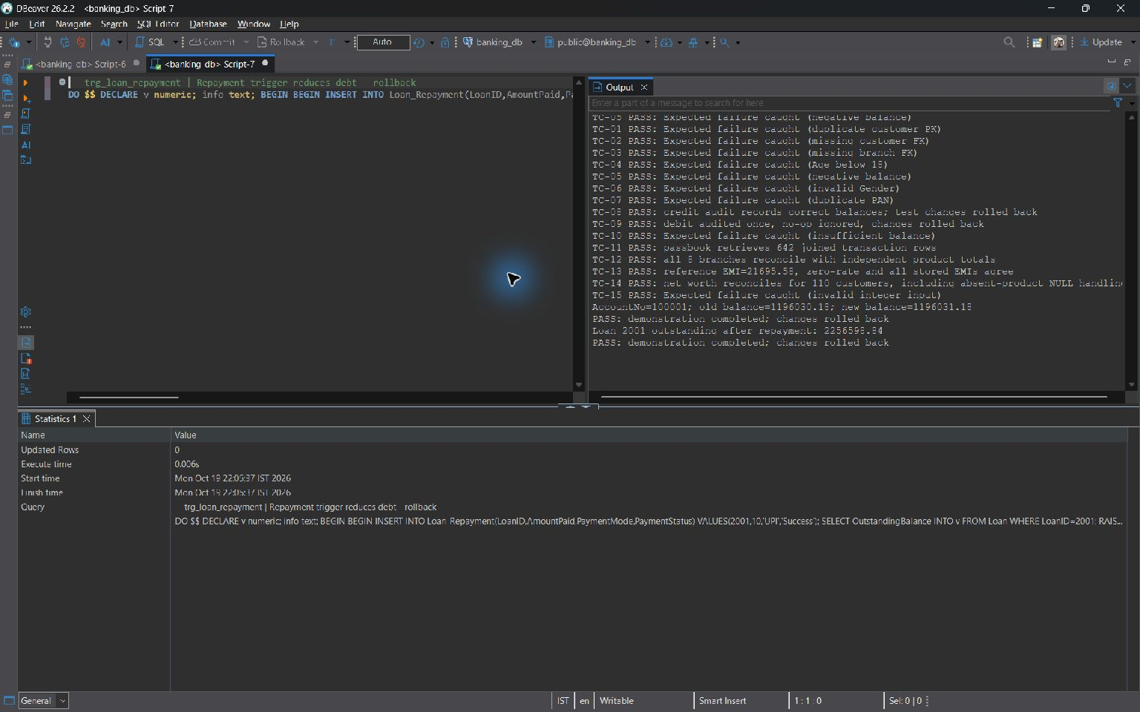
trg_loan_repayment
Integrity and transaction benefit: Only successful repayment attempts reduce debt. FOR NO KEY UPDATE serializes debt changes without conflicting with another repayment insert's foreign-key key-share lock. An overpayment is rejected rather than silently discarded.

8.6 Explicit Cursors

sp_batch_credit_savings_interest
Purpose: Use a bound explicit savings_cursor FOR loop over Active Savings accounts under row locks. Post rounded Balance*InterestRate/1200 as Deposit/Internal, with Monthly Interest Credit remarks. Skip accounts already posted in the current calendar month.
CREATE OR REPLACE PROCEDURE sp_batch_credit_savings_interest()
LANGUAGE plpgsql AS $$
DECLARE
savings_cursor CURSOR FOR
SELECT AccountNo, Balance, InterestRate FROM Account
WHERE Status = 'Active' AND AccountType = 'Savings'
ORDER BY AccountNo FOR UPDATE;
v_account RECORD;
v_interest NUMERIC(15, 2);
v_month TIMESTAMP := DATE_TRUNC('month', CURRENT_TIMESTAMP)::timestamp;
BEGIN
FOR v_account IN savings_cursor LOOP
IF EXISTS (
SELECT 1 FROM Transaction_History
WHERE AccountNo = v_account.AccountNo AND TransactionType = 'Deposit'
AND Remarks = 'Monthly Interest Credit'
AND TransactionDate >= v_month
AND TransactionDate < v_month + INTERVAL '1 month'
) THEN
CONTINUE;
END IF;
IF v_account.InterestRate < 0 THEN
RAISE EXCEPTION 'Negative savings rate on account %', v_account.AccountNo
USING ERRCODE = '22023';
END IF;
v_interest := ROUND((v_account.Balance * v_account.InterestRate / 100) / 12, 2);
IF v_interest <= 0 THEN
CONTINUE; -- Transaction_History requires strictly positive Amount.
END IF;
UPDATE Account SET Balance = Balance + v_interest
WHERE AccountNo = v_account.AccountNo;
INSERT INTO Transaction_History (AccountNo, Amount, TransactionType, PaymentMode, Remarks)
VALUES (v_account.AccountNo, v_interest, 'Deposit', 'Internal', 'Monthly Interest Credit');
END LOOP;
END;
$$;

Successful batch execution in the demo database
A dedicated Active Savings account in banking_report_demo has no current-month interest posting. The screenshot verifies the monthly calculation, credited transaction and resulting balance. A repeated batch call creates no duplicate posting.
CALL public.sp_batch_credit_savings_interest();
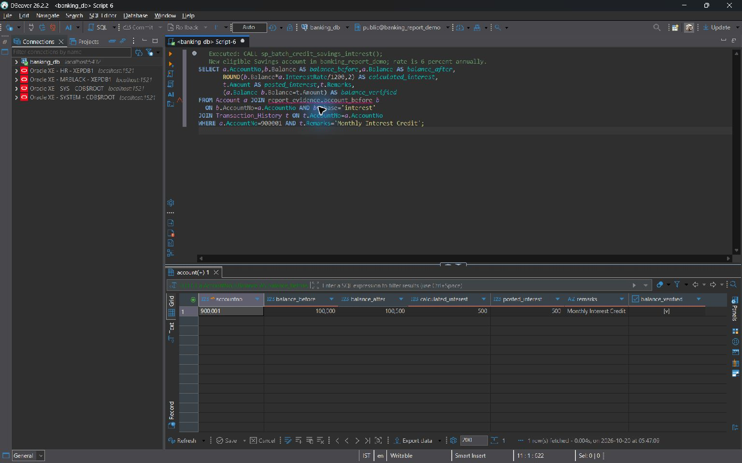
Savings interest calculation and credited balance
Integrity and transaction benefit: The bound FOR loop opens, fetches from and closes the explicit cursor. Account locks and a fresh posting check prevent a second credit in the same month. The whole batch runs in one transaction without a per-row COMMIT.

sp_batch_mature_fixed_deposits
Purpose: Use a bound explicit maturity_cursor FOR loop for Active FDs due by CURRENT_DATE. Credit the oldest Active Savings account, mark the FD Matured, record history and an FD_MATURED audit. Abort the entire batch if an eligible payout account is absent.
CREATE OR REPLACE PROCEDURE sp_batch_mature_fixed_deposits()
LANGUAGE plpgsql AS $$
DECLARE
maturity_cursor CURSOR FOR
SELECT FD_ID, CustomerID, MaturityAmount FROM Fixed_Deposit
WHERE Status = 'Active' AND EndDate <= CURRENT_DATE
ORDER BY FD_ID FOR UPDATE;
v_fd RECORD;
v_account_no INT;
BEGIN
FOR v_fd IN maturity_cursor LOOP
SELECT AccountNo INTO v_account_no FROM Account
WHERE CustomerID = v_fd.CustomerID AND AccountType = 'Savings' AND Status = 'Active'
ORDER BY OpeningDate, AccountNo LIMIT 1 FOR UPDATE;
IF NOT FOUND THEN
RAISE EXCEPTION 'No Active savings account for FD % customer %', v_fd.FD_ID, v_fd.CustomerID
USING ERRCODE = '22023';
END IF;
IF v_fd.MaturityAmount IS NULL OR v_fd.MaturityAmount <= 0 THEN
RAISE EXCEPTION 'Invalid maturity amount on FD %', v_fd.FD_ID USING ERRCODE = '22023';
END IF;
UPDATE Fixed_Deposit SET Status = 'Matured' WHERE FD_ID = v_fd.FD_ID;
UPDATE Account SET Balance = Balance + v_fd.MaturityAmount WHERE AccountNo = v_account_no;
INSERT INTO Transaction_History (AccountNo, Amount, TransactionType, PaymentMode, Remarks)
VALUES (v_account_no, v_fd.MaturityAmount, 'Deposit', 'Internal',
FORMAT('FD Maturity Credit: %s', v_fd.FD_ID));
INSERT INTO Audit_Log (TableName, RecordID, ActionType, Description)
VALUES ('Fixed_Deposit', v_fd.FD_ID, 'FD_MATURED',
FORMAT('Maturity amount %s credited to AccountNo=%s', v_fd.MaturityAmount, v_account_no));
END LOOP;
END;
$$;

Successful batch execution in the demo database
A dedicated Active FD in banking_report_demo has reached its EndDate. The screenshot verifies its Matured status, the savings-account credit and the FD_MATURED audit. A repeated batch call creates no duplicate payout.
CALL public.sp_batch_mature_fixed_deposits();
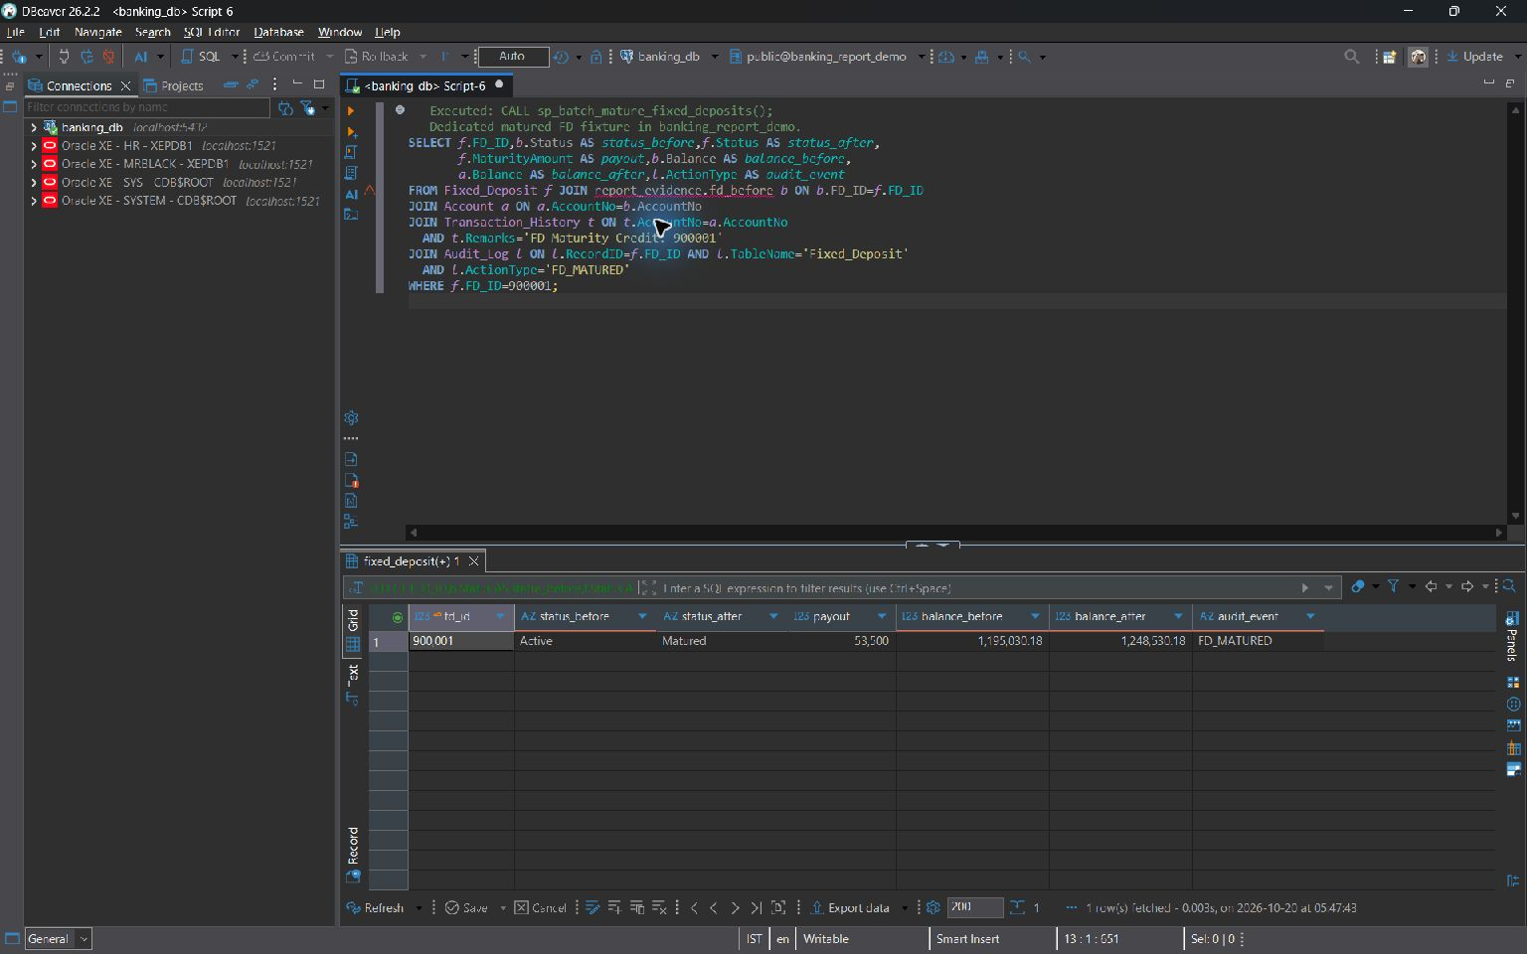
FD maturity payout and automatic audit
Integrity and transaction benefit: The Matured status and enclosing transaction prevent repeat payouts. The primary savings account must be Active and is selected by the oldest OpeningDate, then AccountNo. If no eligible account exists, the batch rolls back earlier loop changes as well as the current FD.

8.7 SQL Security Implementation
The deployed sql/06_security_concurrency.sql hardens the Review 2 logic. It replaces sp_transfer_funds with a SECURITY INVOKER wrapper calling the narrow SECURITY DEFINER _bank_transfer_atomic helper, then COMMIT. The COMMIT-bearing wrapper cannot itself be SECURITY DEFINER or have a SET clause. The helper uses explicit public names and a fixed pg_catalog, public, pg_temp search_path, is owned by the non-superuser bank_admin role, and is explicitly granted only for the transfer operation.
The following source is the deployed wrapper and helper; it supplements, rather than contradicts, the original full procedure source in Section 8.3.
CREATE OR REPLACE FUNCTION public._bank_transfer_atomic(p_sender integer, p_receiver integer, p_amount numeric, p_mode character varying, p_remarks character varying)
RETURNS void
LANGUAGE plpgsql
SECURITY DEFINER
SET search_path TO 'pg_catalog', 'public', 'pg_temp'
AS $function$
DECLARE
v_sender public.Account%ROWTYPE;
v_receiver public.Account%ROWTYPE;
BEGIN
IF p_sender IS NULL OR p_receiver IS NULL OR p_sender = p_receiver THEN
RAISE EXCEPTION 'Transfer requires two different account numbers' USING ERRCODE = '22023';
END IF;
IF p_amount IS NULL OR p_amount <= 0 OR p_amount <> ROUND(p_amount, 2)
OR p_amount::text IN ('NaN', 'Infinity', '-Infinity') THEN
RAISE EXCEPTION 'Transfer amount must be finite, positive, and at most two decimal places'
USING ERRCODE = '22023';
END IF;
IF p_mode IS NULL OR p_mode NOT IN ('UPI', 'NEFT', 'RTGS', 'IMPS', 'Cash', 'Internal') THEN
RAISE EXCEPTION 'Invalid payment mode: %', p_mode USING ERRCODE = '22023';
END IF;
PERFORM AccountNo FROM public.Account WHERE AccountNo IN (p_sender, p_receiver)
ORDER BY AccountNo FOR UPDATE;
SELECT * INTO v_sender FROM public.Account WHERE AccountNo = p_sender;
IF NOT FOUND THEN
RAISE EXCEPTION 'Sender account % does not exist', p_sender USING ERRCODE = '22023';
END IF;
SELECT * INTO v_receiver FROM public.Account WHERE AccountNo = p_receiver;
IF NOT FOUND THEN
RAISE EXCEPTION 'Receiver account % does not exist', p_receiver USING ERRCODE = '22023';
END IF;
IF v_sender.Status IS DISTINCT FROM 'Active' OR v_receiver.Status IS DISTINCT FROM 'Active' THEN
RAISE EXCEPTION 'Both transfer accounts must be Active' USING ERRCODE = '22023';
END IF;
IF v_sender.Balance < p_amount THEN
RAISE EXCEPTION 'Insufficient balance in sender account %', p_sender USING ERRCODE = '22023';
END IF;
UPDATE public.Account SET Balance = Balance - p_amount WHERE AccountNo = p_sender;
UPDATE public.Account SET Balance = Balance + p_amount WHERE AccountNo = p_receiver;
INSERT INTO public.Transaction_History (AccountNo, Amount, TransactionType, PaymentMode, Remarks)
VALUES
(p_sender, p_amount, 'Transfer', p_mode,
LEFT(FORMAT('Debit to %s: %s', p_receiver, COALESCE(p_remarks, 'Fund transfer')), 255)),
(p_receiver, p_amount, 'Transfer', p_mode,
LEFT(FORMAT('Credit from %s: %s', p_sender, COALESCE(p_remarks, 'Fund transfer')), 255));
END;
$function$

CREATE OR REPLACE PROCEDURE public.sp_transfer_funds(IN p_sender integer, IN p_receiver integer, IN p_amount numeric, IN p_mode character varying, IN p_remarks character varying)
LANGUAGE plpgsql
AS $procedure$
BEGIN
PERFORM public._bank_transfer_atomic(p_sender, p_receiver, p_amount, p_mode, p_remarks);
COMMIT;
END;
$procedure$

Create >= 3 users/roles | DROP ROLE IF EXISTS bank_teller;  DROP ROLE IF EXISTS branch_manager;  DROP ROLE IF EXISTS bank_admin;  CREATE ROLE bank_admin NOLOGIN NOSUPERUSER NOCREATEDB NOCREATEROLE NOREPLICATION;  CREATE ROLE branch_manager NOLOGIN NOSUPERUSER NOCREATEDB NOCREATEROLE NOREPLICATION;  CREATE ROLE bank_teller NOLOGIN NOSUPERUSER NOCREATEDB NOCREATEROLE NOREPLICATION;  Observed installed role catalogue; role creation was not rerun against shared cluster roles.  Execution output: 3 row(s).
GRANT privileges per role matrix | GRANT ALL PRIVILEGES ON DATABASE banking_db TO bank_admin;  GRANT ALL PRIVILEGES ON SCHEMA public TO bank_admin;  GRANT ALL PRIVILEGES ON ALL TABLES IN SCHEMA public TO bank_admin;  GRANT ALL PRIVILEGES ON ALL SEQUENCES IN SCHEMA public TO bank_admin;  GRANT ALL PRIVILEGES ON ALL ROUTINES IN SCHEMA public TO bank_admin;  ALTER FUNCTION public._bank_transfer_atomic(INT, INT, NUMERIC, VARCHAR, VARCHAR) OWNER TO bank_admin;  ALTER FUNCTION public.tg_audit_account_changes() OWNER TO bank_admin;  ALTER PROCEDURE public.sp_pay_loan_emi(INT, INT, INT) OWNER TO bank_admin;  ALTER PROCEDURE public.sp_batch_credit_savings_interest() OWNER TO bank_admin;  ALTER PROCEDURE public.sp_batch_mature_fixed_deposits() OWNER TO bank_admin;  -- GRANT matrix (existing objects):  -- Role Tables/views Routines  -- bank_admin ALL tables/views + sequence ALL ALL  -- branch_manager SELECT/INSERT/UPDATE Customer, all 4 procedures;  -- Account, Loan transfer helper EXECUTE  -- bank_teller SELECT vw_customer_passbook only transfer + its helper  -- No memberships in bank_admin are granted to the other roles.  GRANT SELECT, INSERT, UPDATE ON public.Customer, public.Account, public.Loan TO branch_manager;  GRANT EXECUTE ON ALL PROCEDURES IN SCHEMA public TO branch_manager;  GRANT SELECT ON public.vw_customer_passbook TO bank_teller;  GRANT EXECUTE ON PROCEDURE public.sp_transfer_funds(INT, INT, NUMERIC, VARCHAR, VARCHAR) TO bank_teller;  REVOKE ALL ON FUNCTION public._bank_transfer_atomic(INT, INT, NUMERIC, VARCHAR, VARCHAR) FROM PUBLIC;  GRANT EXECUTE ON FUNCTION public._bank_transfer_atomic(INT, INT, NUMERIC, VARCHAR, VARCHAR)  TO branch_manager, bank_teller;  Execution output: 3 row(s).
REVOKE demonstration | GRANT DELETE ON public.Account TO bank_teller;  REVOKE DELETE ON public.Account FROM bank_teller;  DELETE is granted and immediately revoked. The demonstration runs inside a transaction that restores the existing permissions afterward.
Least privilege proof | DO $$  DECLARE v_denied BOOLEAN := false;  BEGIN  SET LOCAL ROLE bank_teller;  BEGIN  DELETE FROM public.Account WHERE false;  EXCEPTION WHEN insufficient_privilege THEN  v_denied := true;  RAISE NOTICE 'PASS: bank_teller DELETE denied (SQLSTATE %)', SQLSTATE;  END;  RESET ROLE;  IF NOT v_denied THEN RAISE EXCEPTION 'Least privilege failed: teller can DELETE Account'; END IF;  IF HAS_TABLE_PRIVILEGE('bank_teller', 'public.Account', 'UPDATE')  OR HAS_TABLE_PRIVILEGE('bank_teller', 'public.Account', 'SELECT')  OR HAS_FUNCTION_PRIVILEGE('bank_teller', 'public.fn_customer_net_worth(integer)', 'EXECUTE') THEN  RAISE EXCEPTION 'Teller inherited unintended base-table or routine access';  END IF;  SET LOCAL ROLE bank_teller;  PERFORM * FROM public.vw_customer_passbook LIMIT 1;  RESET ROLE;  RAISE NOTICE 'PASS: teller can read passbook while base Account access remains denied';  END;  $$;
Secure exposure | ALTER PROCEDURE public.sp_pay_loan_emi(INT, INT, INT) SECURITY DEFINER;  ALTER PROCEDURE public.sp_pay_loan_emi(INT, INT, INT) SET search_path = pg_catalog, public, pg_temp;  ALTER PROCEDURE public.sp_batch_credit_savings_interest() SECURITY DEFINER;  ALTER PROCEDURE public.sp_batch_credit_savings_interest() SET search_path = pg_catalog, public, pg_temp;  ALTER PROCEDURE public.sp_batch_mature_fixed_deposits() SECURITY DEFINER;  ALTER PROCEDURE public.sp_batch_mature_fixed_deposits() SET search_path = pg_catalog, public, pg_temp;  -- Direct manager Account updates must still write protected audit records.  ALTER FUNCTION public.tg_audit_account_changes() SECURITY DEFINER;  ALTER FUNCTION public.tg_audit_account_changes() SET search_path = pg_catalog, public, pg_temp;  REVOKE CREATE ON SCHEMA public FROM PUBLIC;  REVOKE ALL PRIVILEGES ON ALL TABLES IN SCHEMA public FROM PUBLIC;  REVOKE ALL PRIVILEGES ON ALL SEQUENCES IN SCHEMA public FROM PUBLIC;  REVOKE EXECUTE ON ALL ROUTINES IN SCHEMA public FROM PUBLIC;  GRANT SELECT ON public.vw_customer_passbook TO bank_teller;  GRANT EXECUTE ON PROCEDURE public.sp_transfer_funds  (INT,INT,NUMERIC,VARCHAR,VARCHAR) TO bank_teller;  Restricted roles use explicitly permitted views and routines. The helper EXECUTE grant supports the invoker transfer wrapper; it does not grant general access to the underlying tables.

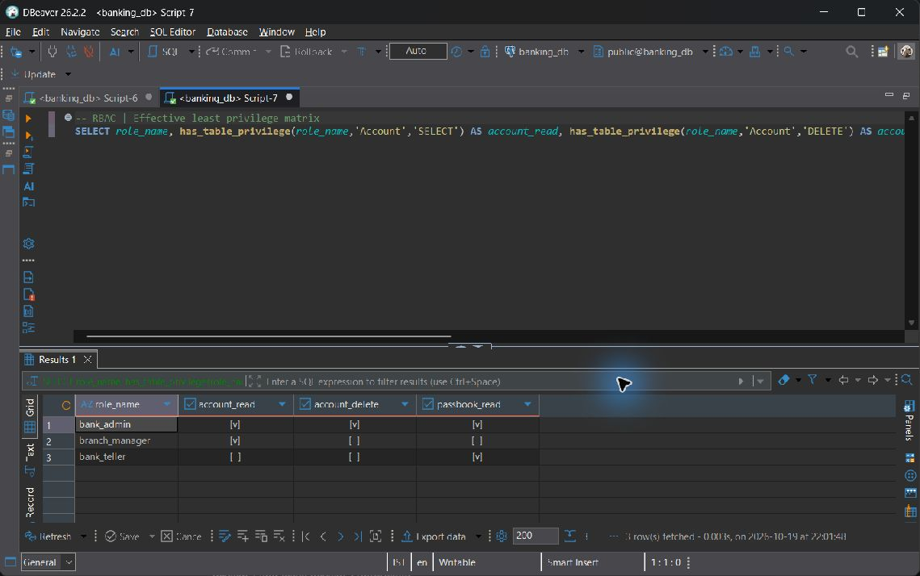
RBAC
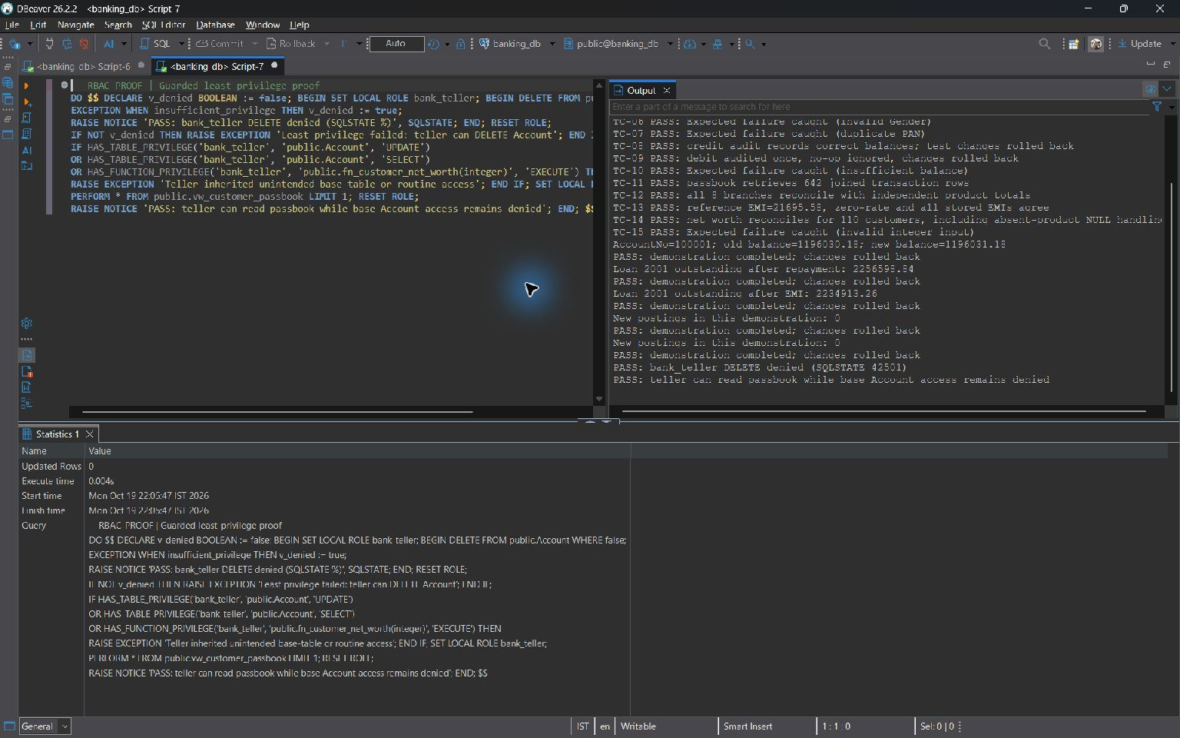
RBAC-PROOF
Security boundary: bank_admin, branch_manager and bank_teller are NOLOGIN group roles. A trusted session uses SET ROLE for the test. Employee.Role is descriptive staff information and does not automatically create a database login or role membership. FastAPI connects as postgres and uses simulated portal identity selection. These grants therefore do not establish application route authorization or branch-limited access.

8.8 Transactions Indexing and Query Optimization
PostgreSQL does not permit literal SAVEPOINT and ROLLBACK TO SAVEPOINT commands inside a PL/pgSQL DO body. The script demonstrates those commands at the top level. A separate BEGIN/EXCEPTION block shows the supported equivalent using an implicit subtransaction.
BEGIN;
SAVEPOINT account_demo;
UPDATE public.Account SET Balance = Balance + 1 WHERE AccountNo = 100001;
ROLLBACK TO SAVEPOINT account_demo; -- also undoes the balance audit trigger
RELEASE SAVEPOINT account_demo;
COMMIT;
DO $$
DECLARE v_before NUMERIC;
BEGIN
SELECT Balance INTO STRICT v_before FROM public.Account WHERE AccountNo = 100001;
BEGIN -- implicit SAVEPOINT
UPDATE public.Account SET Balance = Balance + 1 WHERE AccountNo = 100001;
RAISE EXCEPTION 'Intentional subtransaction rollback' USING ERRCODE = 'Z0001';
EXCEPTION WHEN SQLSTATE 'Z0001' THEN
-- Equivalent to ROLLBACK TO SAVEPOINT for this inner block.
RAISE NOTICE 'PASS: inner update and trigger audit rolled back; outer DO continues';
END;
IF (SELECT Balance FROM public.Account WHERE AccountNo = 100001) IS DISTINCT FROM v_before THEN
RAISE EXCEPTION 'Subtransaction failed to restore balance';
END IF;
-- Outside the inner exception block, top-level DO may COMMIT.
COMMIT;
END;
$$;

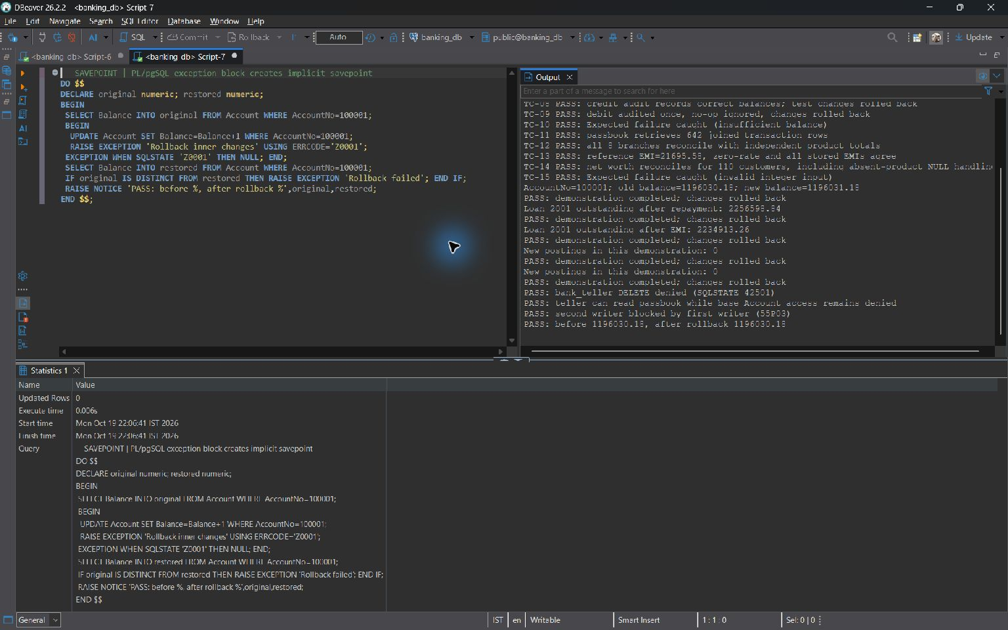
SAVEPOINT
The literal demonstration finishes with COMMIT after restoring the row and its audit. An EXCEPTION block rolls back the changes inside its inner block and lets the outer block continue. PostgreSQL does not reclaim SERIAL sequence values after a transactional rollback, so gaps do not imply missing business rows.
Three project indexes
CREATE INDEX idx_customer_name ON public.customer USING btree (lastname, firstname);

CREATE INDEX idx_loan_status ON public.loan USING btree (customerid, status);

CREATE INDEX idx_txn_account_date ON public.transaction_history USING btree (accountno, transactiondate);

The transaction index puts AccountNo first for equality searches and TransactionDate next for date ranges and ordering. The customer name index supports last-name/first-name access. The loan index uses customer equality followed by status. Indexes take storage space and add maintenance work to writes; their benefit depends on the workload.
-- Run in banking_report_demo only.
BEGIN;
DROP INDEX public.idx_txn_account_date;
EXPLAIN (ANALYZE, BUFFERS)
SELECT TransactionID,AccountNo,TransactionDate,Amount
FROM public.Transaction_History
WHERE AccountNo=100001
AND TransactionDate>=CURRENT_DATE-INTERVAL '365 days'
ORDER BY TransactionDate;
ROLLBACK; -- Restores the named index.
EXPLAIN (ANALYZE, BUFFERS)
SELECT TransactionID,AccountNo,TransactionDate,Amount
FROM public.Transaction_History
WHERE AccountNo=100001
AND TransactionDate>=CURRENT_DATE-INTERVAL '365 days'
ORDER BY TransactionDate;
Both screenshots use the same query and demo dataset. Only the availability of idx_txn_account_date changes.
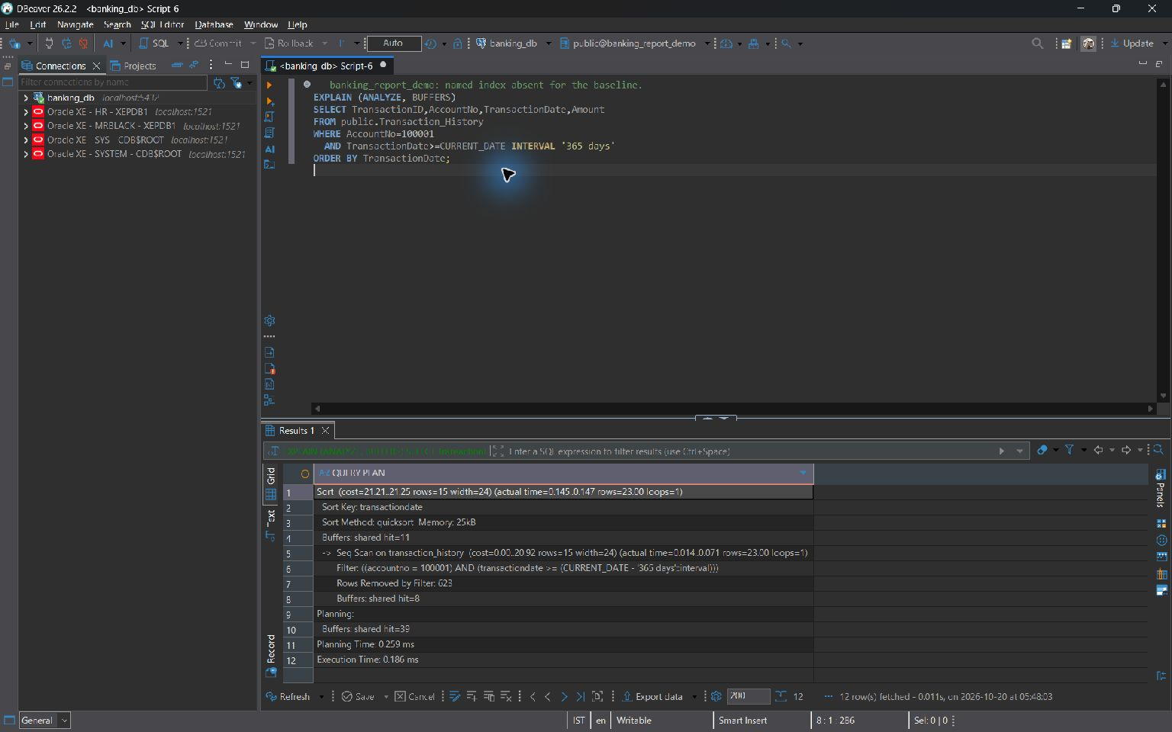
Search plan before indexing
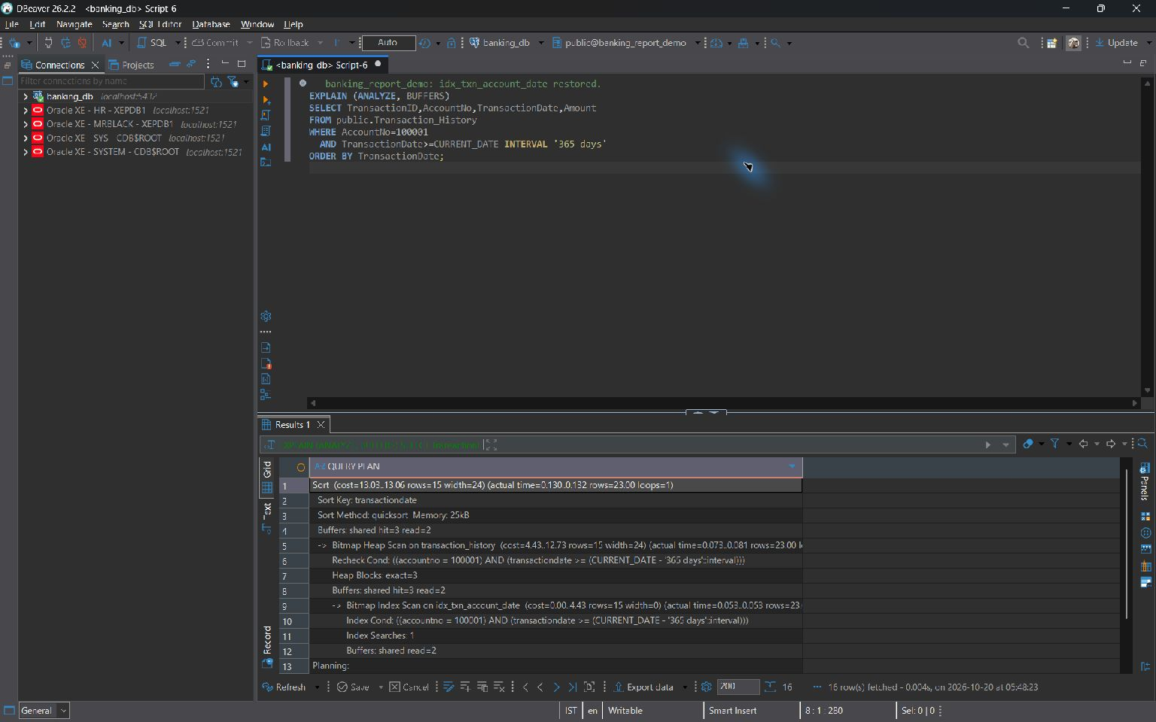
Search plan after indexing
Without the named index, the observed plan scans the table and filters matching rows. With the index available, it uses Bitmap Index Scan and Bitmap Heap Scan and still performs a sort. The screenshots allow comparison of the access methods, rows and buffers. Cache state and table size affect timings, so this example does not establish a general performance speedup.

9 Work Breakdown

Registration Number | Name | Work Assigned
24BDS0202 | MIRZA MOHAMMAD ABBAS | Core architecture and Twelve-table schema redesign and normalization; generated financial columns; sp_transfer_funds and sp_pay_loan_emi; trg_audit_account_changes and trg_loan_repayment; both explicit cursor batches; SAVEPOINT/ROLLBACK transaction design; three indexes and EXPLAIN ANALYZE comparison.
24BAI0128 | ADITYA KUMAR SAHU | Querying and data foundations. Categories A-D: basic, aggregate WHERE/HAVING contrast, all join forms and subqueries including the NOT IN NULL pitfall and fix. Three database views and atomic Faker bulk seeding through seed_bulk_data.py.
24BAI0001 | RISHAV MANJHI | Analytics and function verification. Categories E-G: set operations, advanced built-ins and window functions. CQ-01 through CQ-10 business-query verification; fn_calculate_emi and fn_customer_net_worth implementation and reference checks.

10 REVIEW EVALUATION
Faculty assessment. The original grading grid is preserved below; individual scores and signatures are reserved for the evaluator.
COMPONENT | MARKS | MEMBER 1 | MEMBER 2 | MEMBER 3
TOTAL | 10 MARKS

